2.07 Prime factorisations
Year 7 Maths · Worksheet · Level 2 · Core
Name: ____________________ Date: ______________
This worksheet practises writing numbers as products of primes, using factor trees or repeated division, and using index form. Tip: however you start, every number has only one prime factorisation, so all correct factor trees for a number end with the same primes.

 Understanding
- Which of these is the prime factorisation of 72? Answer: ______________
  - 8 × 9
  - $2^{3}$ × $3^{2}$
  - 2 × 36
  - $2^{2}$ × $3^{3}$
- Complete the factor tree for 90. Then write 90 as a product of primes in index form.
- 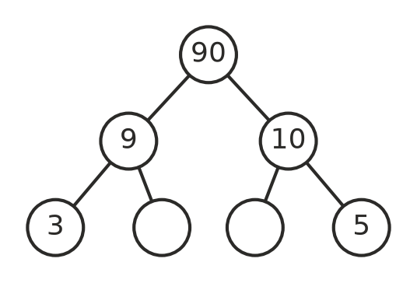
90 = ______________
- Another way to find a prime factorisation is repeated division. Divide by a prime, write the answer underneath, and keep going until you reach 1. Here is 60:
Divide by | Number
2 | 60
2 | 30
3 | 15
5 | 5
 | 1

So 60 = 2 × 2 × 3 × 5 = $2^{2}$ × 3 × 5. Complete the table for 84.
Divide by | Number
2 | 84
 | 1

84 = ______________

 Fluency
- Write each number as a product of primes in index form. Use a factor tree or repeated division.
  - 54 = ______________

  - 120 = ______________

  - 196 = ______________

  - 225 = ______________

  - 132 = ______________

  - 500 = ______________

- Find the number that has each prime factorisation.
  - $2^{2}$ × $3^{2}$ × 5 = ______________
  - $2^{4}$ × 7 = ______________
  - 3 × $5^{2}$ × 7 = ______________
  - $2^{3}$ × $3^{3}$ = ______________
- Find the missing index or prime.
  - 56 = $2^{□}$ × 7 □ = ______________
  - 45 = $3^{2}$ × □ □ = ______________
  - 288 = $2^{5}$ × $3^{□}$ □ = ______________
  - 1000 = $2^{□}$ × $5^{□}$ □ = ______________

 Reasoning
- Mia says the prime factorisation of 36 is $6^{2}$. Explain why she is wrong and give the correct answer.

- The prime factorisation of 120 is $2^{3}$ × 3 × 5.
  - Explain how this shows that 15 is a factor of 120.

  - Is 9 a factor of 120? Use the prime factorisation to explain.

 Problem solving
- A number has the prime factorisation $2^{2}$ × 3 × □, where □ is a prime number. The number is between 100 and 140. What is the prime, and what is the number? ______________
- Find the three different prime numbers that multiply to give each number.
  - 105 ______________
  - 286 ______________
- A rectangle has an area of 84 cm². Its side lengths are whole numbers of centimetres, and neither side is 1 cm. Use the prime factorisation of 84 to list all the possible side lengths. ______________

- What is the smallest number whose prime factorisation has three different primes, each with an index of 2? ______________

