2.07 Prime factorisations
Year 7 Maths · Worksheet · Level 1 · Warm-up
Name: ____________________ Date: ______________
This worksheet practises writing a number as a product of prime numbers using a factor tree. Tip: keep splitting each branch into two factors until every branch ends in a prime number. Circle the primes as you go.

 Understanding
- This factor tree shows 20 broken into prime factors. The primes are circled in orange.
- 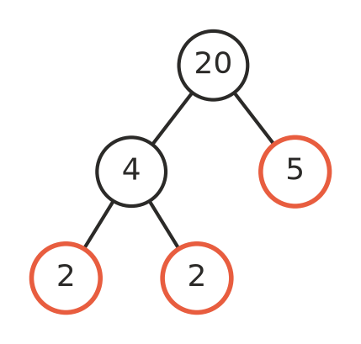
  - Which numbers at the ends of the branches are prime? ______________
  - Write 20 as a product of primes. 20 = ______________
  - Write your answer to part b) using index form. 20 = ______________
- Complete the factor tree for 36. Then write 36 as a product of primes in index form.
- 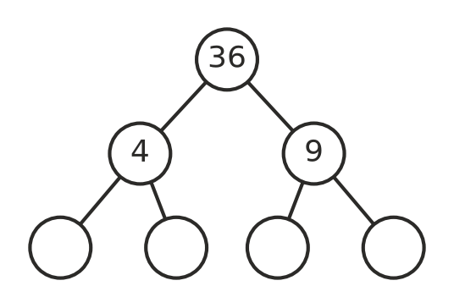
36 = ______________
- A prime factorisation uses only prime numbers. Is each one a prime factorisation? Write Yes or No in each empty box.
Product | Prime factorisation?
2 × 3 × 5
2 × 6
3 × 3 × 7
4 × 5
2 × 2 × 2 × 11

 Fluency
- Draw a factor tree for each number in the space. Then write the number as a product of primes in index form.
  - 18 = ______________

  - 30 = ______________

  - 28 = ______________

  - 50 = ______________

- Write each product in index form.
  - 2 × 2 × 2 × 3 = ______________
  - 3 × 3 × 5 × 5 = ______________
  - 2 × 2 × 7 × 7 × 7 = ______________
- Find the number that has each prime factorisation.
  - 2 × 3 × 7 = ______________
  - $2^{3}$ × 5 = ______________
  - $3^{2}$ × 11 = ______________

 Reasoning
- Ben says the prime factorisation of 12 is 2 × 6. Explain why he is not finished, and write the correct prime factorisation.

- Two students start a factor tree for 24 in different ways. One starts with 4 × 6 and the other starts with 3 × 8. Finish both trees. Do they end with the same primes?

- Explain why 7 does not need a factor tree.

 Problem solving
- A factor tree ends in the primes 2, 2, 3 and 5. What number did it start with? ______________
- Write 100 as a product of primes in index form. ______________
- Which number between 40 and 50 has a prime factorisation that uses only 2s and 3s? ______________

