2.07 Prime factorisations
Year 7 Maths · A5 question sheet · Level 1 · Warm-up
This worksheet practises writing a number as a product of prime numbers using a factor tree. Tip: keep splitting each branch into two factors until every branch ends in a prime number. Write down the primes as you go.

 Understanding
- This factor tree shows 20 broken into prime factors. The primes are circled in orange.
- 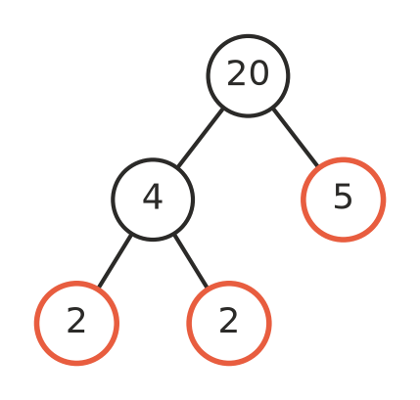
  - Which numbers at the ends of the branches are prime?
  - Write 20 as a product of primes. 20 =
  - Write your answer to part b) using index form. 20 =
- Copy and complete the factor tree for 36. Then write 36 as a product of primes in index form.
- 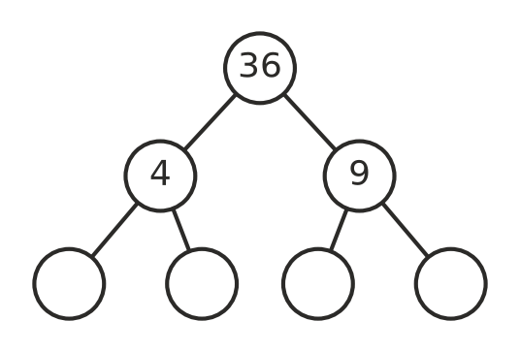
36 =
- A prime factorisation uses only prime numbers. Is each one a prime factorisation? Write Yes or No in your book.
Product
2 × 3 × 5
2 × 6
3 × 3 × 7
4 × 5
2 × 2 × 2 × 11

 Fluency
- Draw a factor tree for each number in your book. Then write the number as a product of primes in index form.
  - 18 =
  - 30 =
  - 28 =
  - 50 =
- Write each product in index form.
  - 2 × 2 × 2 × 3 =
  - 3 × 3 × 5 × 5 =
  - 2 × 2 × 7 × 7 × 7 =
- Find the number that has each prime factorisation.
  - 2 × 3 × 7 =
  - $2^{3}$ × 5 =
  - $3^{2}$ × 11 =

 Reasoning
- Ben says the prime factorisation of 12 is 2 × 6. Explain why he is not finished, and write the correct prime factorisation.
- Two students start a factor tree for 24 in different ways. One starts with 4 × 6 and the other starts with 3 × 8. Finish both trees. Do they end with the same primes?
- Explain why 7 does not need a factor tree.

 Problem solving
- A factor tree ends in the primes 2, 2, 3 and 5. What number did it start with?
- Write 100 as a product of primes in index form.
- Which number between 40 and 50 has a prime factorisation that uses only 2s and 3s?

