2.02 Square numbers
Year 7 Maths · A5 question sheet · Level 1 · Warm-up
This worksheet practises square numbers: the numbers you get when you multiply a whole number by itself. Tip: $5^{2}$ is read “5 squared” and means 5 × 5, not 5 × 2.

 Understanding
- The dots below show the first four square numbers.
- 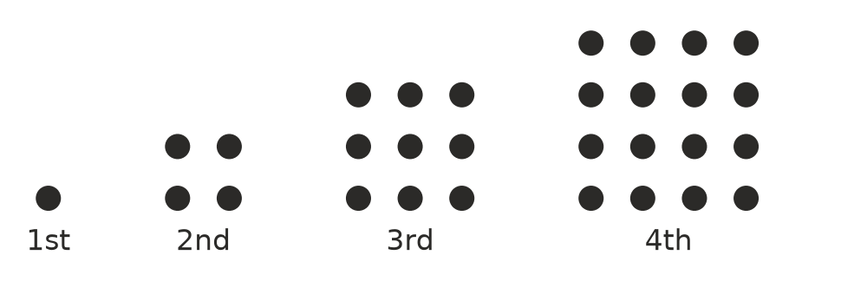
  - How many dots are in each picture?
  - How many dots would the 5th picture have?
  - How many dots would the 8th picture have?
- Copy and complete the table.
Number | Multiply it by itself
3 | 3 × 3
6
7
10

- Write each one using a small 2. For example, 4 × 4 = $4^{2}$.
  - 9 × 9 =
  - 15 × 15 =
  - “8 squared”

 Fluency
- Calculate.
  - $2^{2}$ =
  - $5^{2}$ =
  - $8^{2}$ =
  - ${11}^{2}$ =
  - ${12}^{2}$ =
  - ${20}^{2}$ =
- List the first ten square numbers.
- Is each number a square number? Write Yes or No in your book.
Number
36
40
49
50
81
100

- Calculate.
  - $3^{2}$ + $4^{2}$ =
  - $5^{2}$ − $2^{2}$ =
  - $2^{2}$ × 10 =

 Reasoning
- Mia says $6^{2}$ = 12. Explain her mistake and give the correct answer.
- Can 17 dots be arranged to make a square, like the pictures in Question 1? Explain how you know.

 Problem solving
- A square patio is paved with square tiles. There are 9 tiles along each side. How many tiles are there altogether?
- A square vegetable garden has sides that are 7 m long. What is its area?
- Which square number is between 60 and 70?

