Percentages: Practice test 3
Year 7 Maths · Test · Test 3
Name: ____________________ Date: ______________
Time: 45 minutes
Total: 40 marks
Show your working in the boxes. Then write each final answer on the answer sheet on the last page. Write fractions in simplest form.

 Section A: No calculator
- Write each percentage as a decimal.
  - 64% (1 mark)

  - 8% (1 mark)

  - 112.5% (1 mark)

- Write each number as a fraction in simplest form.
  - 45% (1 mark)

  - 0.24 (1 mark)

  - 2.5% (1 mark)

- Look at the number line.
- 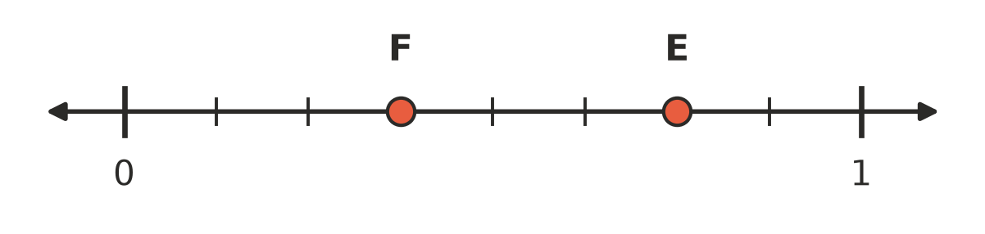
  - Write the number shown by point E as a percentage. (1 mark)

  - Write the number shown by point F as a fraction. (1 mark)

- The circle is divided into 8 equal parts. What percentage of the circle is shaded? (1 mark)
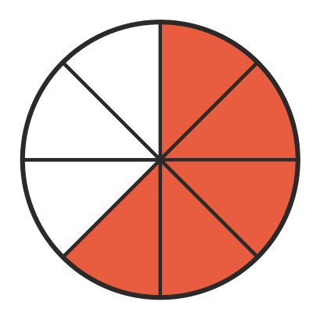

- Write <, > or = in each box to make the statement true.
  - $\frac{4}{5}$ □ 85% (1 mark)

  - 0.65 □ 6.5% (1 mark)

- Write these numbers in descending order (largest to smallest): 115%, 0.98, $1\frac{1}{8}$, 1.2 (2 marks)

- Write each quantity as a percentage.
  - 27 out of 30 (1 mark)

  - 40 cents out of $5 (1 mark)

- Work out each of these.
  - 1% of 3500 (1 mark)

  - 30% of 70 (1 mark)

  - 12.5% of 64 (1 mark)

- A wetsuit costs $240. The surf shop takes 25% off the price. What is the sale price? Show your working. (2 marks)

- In his first basketball game, Jack scored 12 of his 20 shots. In his second game, he scored 15 of his 25 shots. Jack says he shot better in the second game because he scored more baskets. Is Jack right? Explain, using percentages. (2 marks)

- Use a mental strategy to work out 35% of 180. Show your strategy. (2 marks)

- Mia gets $40 pocket money. She spends 25% of it on food. Then she saves 40% of the money she has left. How much does Mia save? Show your working. (2 marks)

- Find the missing number: □% of 80 = 20% of 60. Show your working. (2 marks)

 Section B: Calculator allowed
- Use a calculator to work out each of these.
  - 13% of 2780 (1 mark)

  - 6.25% of $315.20 (1 mark)

- A netball team scored 47 goals from 63 shots. What percentage of the shots were goals? Round your answer to the nearest whole percent. (1 mark)

- A farmer has 1350 sheep. She sells 18% of them at the market.
  - How many sheep does she sell? (1 mark)

  - How many sheep does she have left? (1 mark)

- A phone costs $899. A shop takes 12% off the price.
  - How much is the discount? (1 mark)

  - What is the sale price? (1 mark)

- A family is driving 1250 km from home to their holiday. So far they have driven 415 km.
  - What percentage of the trip have they driven? (1 mark)

  - What percentage of the trip do they still have to drive? (1 mark)

- A 750 g box of cereal costs $6.40 at two shops. Shop A sells a special box with 20% extra cereal for the same price. Shop B sells the 750 g box with 15% off.
  - How much cereal is in Shop A’s special box? (1 mark)

  - What is Shop B’s sale price? (1 mark)

  - Which shop gives better value? Show working to support your answer. (1 mark)

 Answer sheet
Name: ____________________
Write your final answer for each question in the table.
Question | Answer | Marks | Question | Answer | Marks
1a |  | /1 | 9 |  | /2
1b |  | /1 | 10 |  | /2
1c |  | /1 | 11 |  | /2
2a |  | /1 | 12 |  | /2
2b |  | /1 | 13 |  | /2
2c |  | /1 | 14a |  | /1
3a |  | /1 | 14b |  | /1
3b |  | /1 | 15 |  | /1
4 |  | /1 | 16a |  | /1
5a |  | /1 | 16b |  | /1
5b |  | /1 | 17a |  | /1
6 |  | /2 | 17b |  | /1
7a |  | /1 | 18a |  | /1
7b |  | /1 | 18b |  | /1
8a |  | /1 | 19a |  | /1
8b |  | /1 | 19b |  | /1
8c |  | /1 | 19c |  | /1
 |  |  |  | Total | /40

