6.04 Percentages of a quantity
Year 7 Maths · Worksheet · Level 1 · Warm-up
Name: ____________________ Date: ______________
This worksheet practises finding a percentage of an amount. Tip: 10% of an amount is the amount divided by 10. Once you know 10%, you can build up other percentages: 30% is 3 lots of 10%, and 5% is half of 10%.

 Understanding
- The bar shows 80, split into 10 equal parts.
- 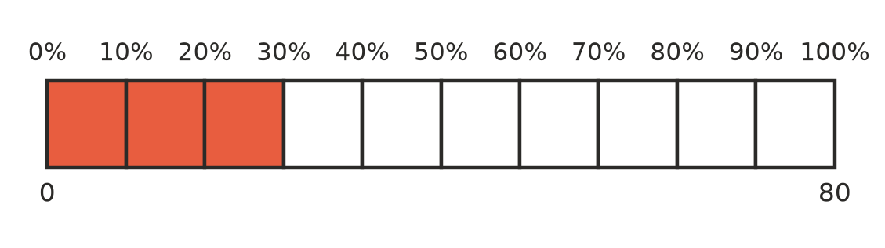
  - What is 10% of 80? ______________
  - What is 30% of 80? (This is the shaded part.) ______________
  - What is 100% of 80? ______________
- Use the rule in each part to find the percentage of 40.
  - 50% is half. 50% of 40 = ______________
  - 25% is a quarter. 25% of 40 = ______________
  - 10% means divide by 10. 10% of 40 = ______________

 Fluency
- Find:
  - 10% of 70 = ______________
  - 10% of 250 = ______________
  - 50% of 64 = ______________
  - 25% of 48 = ______________
  - 1% of 300 = ______________
  - 75% of 20 = ______________
- Find 10% first, then use it to find:
  - 20% of 60 = ______________
  - 30% of 90 = ______________
  - 40% of 150 = ______________
  - 5% of 80 = ______________
- Find:
  - 10% of $45 = ______________
  - 50% of $18 = ______________
  - 20% of $35 = ______________
  - 25% of $120 = ______________

 Reasoning
- Explain how you can use 10% and 5% to find 15% of 60. What is the answer?

- Is 50% of 30 the same as 30% of 50? Work out both and explain what you notice.

 Problem solving
- A pair of footy boots costs $40. In a sale they are 25% off.
  - How much do you save? ______________
  - What is the sale price? ______________
- There are 30 students in a class and 40% of them walk to school. How many students walk to school? ______________
- A farmer has 200 sheep. 15% of the sheep are black. How many black sheep does the farmer have? ______________
- Church camp costs $80. You pay a deposit of 20% when you book, and the rest later.
  - How much is the deposit? ______________
  - How much is left to pay? ______________

