6.04 Percentages of a quantity
Year 7 Maths · A5 question sheet · Level 2 · Core
This worksheet practises finding percentages of amounts, discounts, and working backwards from a percentage to the whole. Tip: to find a percentage of an amount, change the percentage to a fraction or decimal and multiply. For example, 20% of 45 = $\frac{1}{5}$ × 45 = 9.

 Understanding
- The bar shows 240, split into 4 equal parts.
- 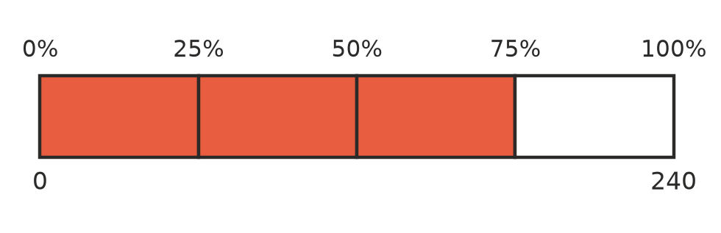
  - What is 25% of 240?
  - What is 75% of 240? (This is the shaded part.)
- Which of these is not the same as 20% of 45?
  - $\frac{1}{5}$ × 45
  - 0.2 × 45
  - 45 ÷ 5
  - 45 ÷ 20

 Fluency
- Calculate.
  - 10% of 340 =
  - 5% of 260 =
  - 20% of 85 =
  - 75% of 64 =
  - 1% of 2500 =
  - 35% of 80 =
  - 12% of 50 =
  - 150% of 40 =
- Calculate. Give your answer in the unit shown.
  - 30% of 2 hours = ______________ minutes
  - 45% of 1 kg = ______________ g
  - 15% of $60 = $
  - 2.5% of 400 m = ______________ m
- Work backwards to find the whole amount.
  - 10% of a number is 14. What is the number?
  - 25% of a number is 9. What is the number?
  - 30% of a number is 21. What is the number?

 Reasoning
- Work out 30% of 70 and 70% of 30. Explain why the answers are the same.
- Ollie says that to find 15% of 80 you work out 80 ÷ 15. Explain why this is wrong and find the correct answer.

 Problem solving
- A rain jacket costs $85. In a sale it is 20% off.
  - How much is the discount?
  - What is the sale price?
- A pair of thongs costs $45 before GST. GST adds 10% to the price. What is the price with GST?
- A school has 720 students and 35% of them are in Years 7 and 8. How many students are in Years 7 and 8? Show your working.
- A footy club has 160 members. 45% of the members are juniors, and 25% of the juniors are girls.
  - How many juniors are there?
  - How many junior girls are there?
- The same cricket bat is on sale at two shops. Shop A sells it for $90 with 30% off. Shop B sells it for $80 with 20% off. Which shop is cheaper, and by how much? Show your working.
- Kayla earned $240 from a holiday job. She saved 35%, gave 10% to her church and spent the rest.
  - How much did she save?
  - How much did she give to her church?
  - How much did she spend?

