6.02 Compare percentages
Year 7 Maths · Worksheet · Level 3 · Challenge
Name: ____________________ Date: ______________
This worksheet practises comparing and ordering numbers that are very close together, finding numbers between two values and thinking carefully about what a percentage is a percentage of. Tip: when two numbers are close, work out the percentages exactly before you decide.

 Understanding
- The number line from 0% to 100% is split into equal parts. Write the percentage at each point.
- 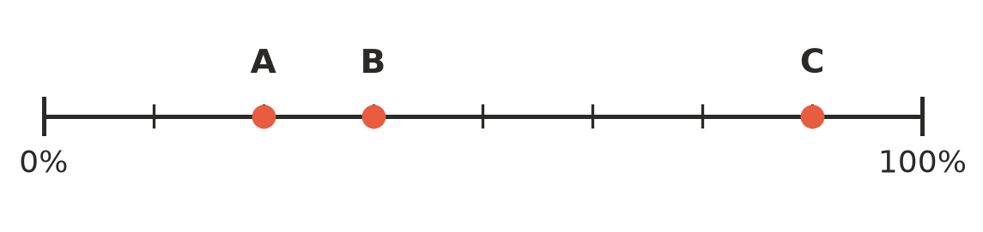
  - A = ______________
  - B = ______________
  - C = ______________
- Write <, > or = in each box.
  - 0.125 □ 12.5%
  - $\frac{5}{6}$ □ 83%
  - 2.05 □ 250%
  - $\frac{7}{40}$ □ 0.18
  - 0.7% □ 0.07

 Fluency
- Write each list in order from smallest to largest.
  - 0.45, $\frac{4}{9}$, 45.5%, 0.4, $\frac{11}{25}$ ______________
  - $1\frac{1}{4}$, 1.2, 112%, 1.02, $\frac{7}{6}$ ______________

- Write these numbers in order from largest to smallest: 0.3%, $\frac{1}{30}$, 0.031, 2.9%

- Answer each question.
  - Find the fraction with a denominator of 12 that is between 40% and 50%. ______________
  - Find the fraction with a denominator of 7 that is between 50% and 60%. ______________

 Reasoning
- Is 40% of an amount always more than 35% of an amount? Explain, using an example.

- Kai’s end-of-term results were: Maths 43 out of 50, Science 0.85, English $\frac{17}{20}$ and History 86%. Kai says Maths was his best subject. Is he right? Explain.

- Without a calculator, decide which is bigger: $\frac{7}{12}$ or 58%. Explain how you know.

 Problem solving
- Four netball teams finished the season with these results. Team A won 11 of its 16 games. Team B won 0.7 of its games. Team C won 68% of its games. Team D won 18 of its 25 games. Write the teams in order from best to worst. Show your working.

- Three bottles of fruit drink show how much real juice they contain. Bottle A is $\frac{3}{8}$ juice, Bottle B is 35% juice and Bottle C is 0.32 juice.
  - Write the bottles in order from most juice to least juice. ______________
  - A label can only say “At least one-third real juice” if that is true. Which bottles can use this label? ______________

- Use the digits 2, 4 and 5, each once, to make a decimal of the form 0.□□□ that is between 45% and 50%. Is there more than one answer? Explain.

