6.02 Compare percentages
Year 7 Maths · Worksheet · Level 1 · Warm-up
Name: ____________________ Date: ______________
This worksheet practises comparing and ordering percentages, fractions and decimals. Tip: to compare numbers written in different ways, change them all to percentages first.

 Understanding
- The number line goes from 0% to 100%. Write the percentage at each point.
- 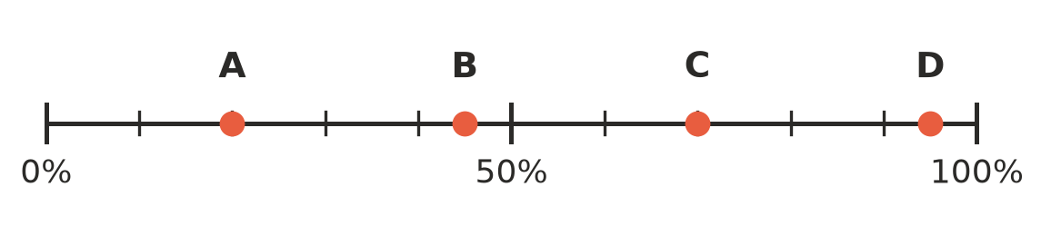
  - A = ______________
  - B = ______________
  - C = ______________
  - D = ______________
- Write < or > in each box.
  - 35% □ 53%
  - 8% □ 80%
  - 99% □ 100%
  - 120% □ 102%

 Fluency
- Write these percentages in order from smallest to largest.
  - 45%, 54%, 4%, 40% ______________
  - 12%, 120%, 21%, 2% ______________
- Change each fraction or decimal to a percentage, then write <, > or = in the box.
  - 0.6 □ 58%
  - $\frac{1}{4}$ □ 30%
  - $\frac{3}{5}$ □ 60%
  - 0.09 □ 10%
  - $\frac{1}{2}$ □ 45%
- Which number is the largest in each list?
  - 0.7, $\frac{3}{4}$, 72% ______________
  - $\frac{1}{5}$, 0.25, 22% ______________
  - 0.9, $\frac{17}{20}$, 88% ______________
- Write these numbers in order from smallest to largest: 0.3, $\frac{1}{4}$, 28%, 0.35

 Reasoning
- Sam scored 17 out of 20 on a spelling test. Lily scored 82% on the same test. Who did better? Explain.

- Zoe says that 0.5 is smaller than 45% because 5 is smaller than 45. Explain her mistake.

 Problem solving
- Three surf shops are having a sale. Shop A has 30% off. Shop B has $\frac{1}{4}$ off. Shop C has $\frac{2}{5}$ off. Which shop has the biggest discount? Show your working.

- Four friends are reading the same book. Noah has read 0.6 of it, Ella has read 55%, Jack has read $\frac{3}{5}$ and Mia has read $\frac{13}{20}$.
  - Who has read the most? ______________
  - Which two friends have read the same amount? ______________

- In a footy match, the Hawks kicked 7 goals from 10 shots. The Eagles kicked 15 goals from 20 shots. Which team had the better percentage of goals from their shots? Show your working.

