6.02 Compare percentages
Year 7 Maths · A5 question sheet · Level 2 · Core
This worksheet practises comparing and ordering percentages, fractions and decimals, including numbers bigger than one whole. Tip: write every number as a percentage first, then compare. Keep the original numbers in your final answer.

 Understanding
- Write each point on the number line as a percentage and as a decimal.
- 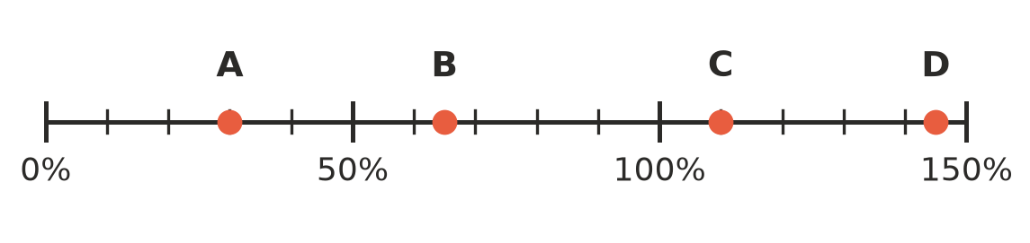
  - A = ______________ =
  - B = ______________ =
  - C = ______________ =
  - D = ______________ =
  - Mark $\frac{3}{4}$ on a copy of the number line in your book with an arrow and the letter E.
- Write <, > or = in your book.
  - 0.4 □ 4%
  - $\frac{3}{8}$ □ 37.5%
  - 1.3 □ 103%
  - $\frac{7}{25}$ □ 0.3
  - 0.065 □ 6.5%

 Fluency
- Write each list in order from smallest to largest.
  - 0.62, 26%, $\frac{6}{10}$, 0.6%
  - 1.5, 105%, $\frac{5}{4}$, 0.15
  - $\frac{3}{8}$, 0.4, 35%, $\frac{9}{25}$
- Write these numbers in order from largest to smallest: $\frac{2}{3}$, 0.65, 67%, $\frac{16}{25}$, 0.7
- Which number is larger in each pair? Show your working.
  - 0.85 or $\frac{7}{8}$
  - $\frac{19}{20}$ or 94%
  - 2.4 or 204%

 Reasoning
- Three students sat different science tests. Harry scored 42 out of 50, Ruby scored 33 out of 40 and Ivy scored 83%. Put the students in order from best to worst result. Explain how you decided.
- Emma says that $\frac{3}{8}$ is bigger than $\frac{2}{5}$ because 3 is bigger than 2. Use percentages to show whether she is right.
- Answer each question.
  - Write a percentage that is between $\frac{3}{5}$ and 0.65.
  - Write a fraction that is between 20% and 25%.

 Problem solving
- In Mrs Lee’s class, 18 of the 24 students bought lunch from the canteen. In Mr Ng’s class, 21 of the 30 students bought lunch from the canteen. Which class had the higher percentage buying lunch? Show your working.
- At basketball practice, Lachlan made 13 shots out of 20, Priya made 16 shots out of 25 and Sienna made 33 shots out of 50. Rank the three players from best to worst. Show your working.
- Three shops have sale signs: Shop A says “35% off”, Shop B says “$\frac{1}{3}$ off” and Shop C says “Save $\frac{3}{10}$”. Which shop gives the biggest discount? Explain.
- At church camp, the water tank was $\frac{3}{5}$ full on Monday, 0.55 full on Tuesday and 58% full on Wednesday.
  - On which day was the tank fullest?
  - Did the amount of water go up or down from Tuesday to Wednesday?

