Number plane: Practice test 3
Year 7 Maths · Test · Test 3
Name: ____________________ Date: ______________
Time: 45 minutes
Total: 40 marks
Show your working in the boxes. Then write each final answer on the answer sheet on the last page.

 Section A: No calculator
- Use the number plane below to answer each part.
- 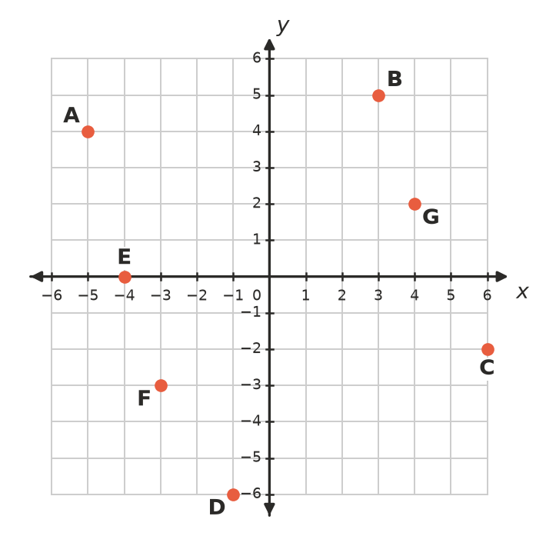
  - Write the coordinates of point A. (1 mark)

  - Write the coordinates of point D. (1 mark)

  - Which point has the coordinates (6, −2)? (1 mark)

  - Which point lies on the x-axis? (1 mark)

- Without plotting, say whether each point is in the 1st, 2nd, 3rd or 4th quadrant, or on an axis.
  - (9, −4) (1 mark)

  - (−6, 1) (1 mark)

  - (−5, 0) (1 mark)

- Which of these points is 5 units from the y-axis? (1 mark)
  - (2, 5)
  - (−5, 1)
  - (0, −5)
  - (3, −2)

- Plot the points J(−4, −1), K(0, 3), L(4, −1) and M(0, −5) on the number plane. Join them in order and join M back to J.
- 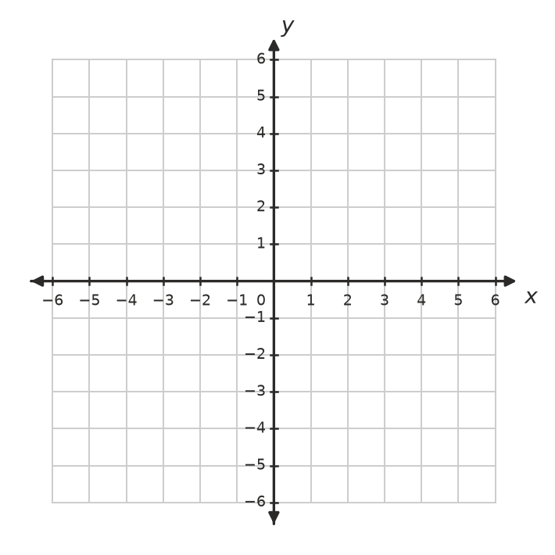
  - What type of shape is JKLM? (1 mark)

  - Write the coordinates of the point in the exact centre of the shape. (1 mark)

  - Find the length of JL. (1 mark)

  - Which corner of the shape is furthest from the x-axis? (1 mark)

- A robot vacuum cleaner moves on a floor marked out like a number plane.
  - The robot starts at (−2, 5). It moves 4 units right and then 9 units down. Write the coordinates of where it stops. (1 mark)

  - Describe the move from (−6, −2) to (1, 3) in words. (1 mark)

- The rule for a linear relationship is y = 3x − 4.
  - Complete the table of values. (2 marks)
x | −1 | 0 | 1 | 2 | 3
y

  - Plot the points from your table on the number plane below and rule a straight line through them. (1 mark)
- 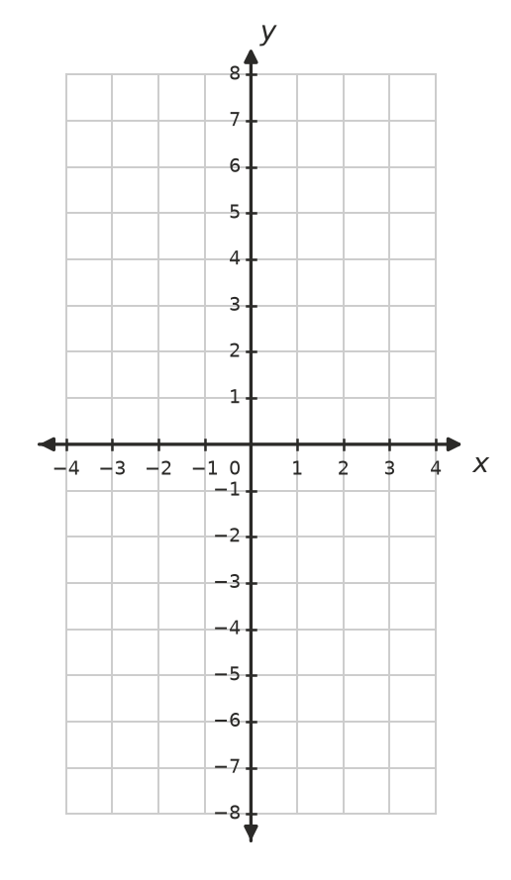
  - Does the point (10, 26) lie on this line? Show how you know. (1 mark)

- This pattern of triangles is made from matchsticks.
- 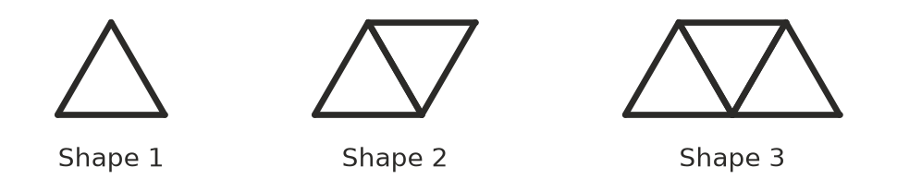
  - Complete the table. (1 mark)
Shape number (n) | 1 | 2 | 3 | 4 | 5
Matchsticks (m) | 3 | 5 | 7

  - Write a rule for the number of matchsticks, m, in Shape n. (1 mark)

  - How many matchsticks are in Shape 25? (1 mark)

  - Explain why no shape in this pattern uses exactly 40 matchsticks. (1 mark)

- Write a rule for y in terms of x for each table.
  - (1 mark)
x | 1 | 2 | 3 | 4
y | 2 | 5 | 8 | 11

  - (1 mark)
x | −1 | 0 | 1 | 2
y | 5 | 3 | 1 | −1

- Sam says, “The distance from (−3, 2) to (5, 2) is 2 units, because 5 − 3 = 2.” Explain Sam’s mistake and find the correct distance. (2 marks)

- The point (a, b) is in the 2nd quadrant.
  - In which quadrant is the point (b, a)? (1 mark)

  - In which quadrant is the point (−a, b)? (1 mark)

 Section B: Calculator allowed
- Ava used her phone on a long bus trip. The graph shows the phone’s battery charge during the trip.
- 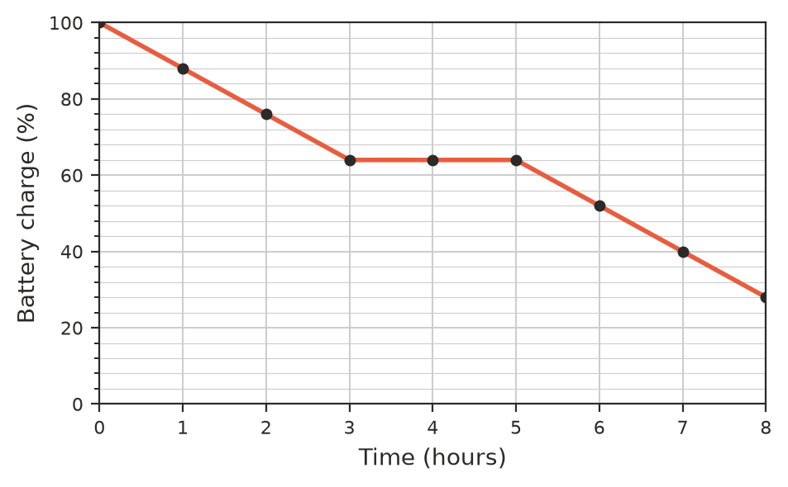
  - What was the battery charge after 2 hours? (1 mark)

  - Describe what happened to the battery charge between 3 hours and 5 hours, and give a reason why this might have happened. (1 mark)

  - While the phone was being used, how much charge did it lose each hour? (1 mark)

  - The battery keeps losing charge at the same rate after 8 hours. After how many hours from the start will the charge be 4%? (1 mark)

- A youth group sells cupcakes at a fundraiser. Their profit is found with the rule P = 2.75n − 60, where P is the profit in dollars and n is the number of cupcakes sold.
  - Complete the table. (1 mark)
Cupcakes sold (n) | 0 | 10 | 20 | 30
Profit (P dollars)

  - What does a negative value of P mean for the youth group? (1 mark)

  - How many cupcakes must they sell to make a profit of $105? (1 mark)

- The floor of a garden shed is drawn on a number plane where 1 unit is 1 metre. Its corners are at (−3.2, −1.5), (4.3, −1.5), (4.3, 2.5) and (−3.2, 2.5).
  - Find the perimeter of the floor. (1 mark)

  - Find the area of the floor. (1 mark)

- A straight line has the rule y = 1.5x − 2.4.
  - Find y when x = 4.2. (1 mark)

  - Find x when y = 9.6. (1 mark)

  - Does the point (−2, −5.4) lie on this line? Show how you know. (1 mark)

 Answer sheet
Name: ____________________
Write your final answer for each question in the table.
Question | Answer | Marks | Question | Answer | Marks
1a |  | /1 | 7c |  | /1
1b |  | /1 | 7d |  | /1
1c |  | /1 | 8a |  | /1
1d |  | /1 | 8b |  | /1
2a |  | /1 | 9 |  | /2
2b |  | /1 | 10a |  | /1
2c |  | /1 | 10b |  | /1
3 |  | /1 | 11a |  | /1
4a |  | /1 | 11b |  | /1
4b |  | /1 | 11c |  | /1
4c |  | /1 | 11d |  | /1
4d |  | /1 | 12a | (in the table in Question 12) | /1
5a |  | /1 | 12b |  | /1
5b |  | /1 | 12c |  | /1
6a | (in the table in Question 6) | /2 | 13a |  | /1
6b | (on the grid in Question 6) | /1 | 13b |  | /1
6c |  | /1 | 14a |  | /1
7a | (in the table in Question 7) | /1 | 14b |  | /1
7b |  | /1 | 14c |  | /1
 |  |  |  | Total | /40

