Number plane: Practice test 2
Year 7 Maths · Test · Test 2
Name: ____________________ Date: ______________
Time: 45 minutes
Total: 40 marks
Show your working in the boxes. Then write each final answer on the answer sheet on the last page.

 Section A: No calculator
- Use the number plane below to answer each part.
- 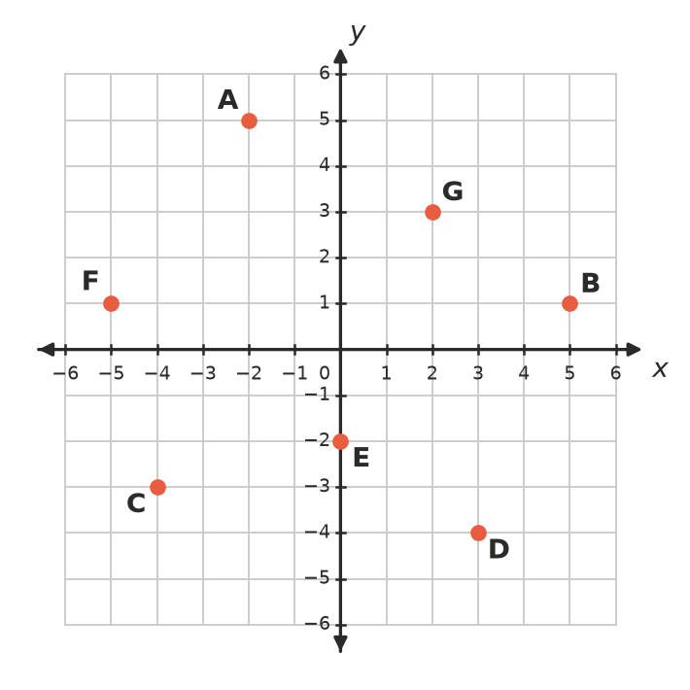
  - Write the coordinates of point B. (1 mark)

  - Write the coordinates of point C. (1 mark)

  - Which point has the coordinates (3, −4)? (1 mark)

  - Which point lies on the y-axis? (1 mark)

- Write the coordinates of the point that is:
  - 7 units to the left of the origin, on the x-axis (1 mark)

  - 2 units below the origin, on the y-axis (1 mark)

  - 3 units to the left of the origin and 1 unit down. (1 mark)

- Which of these points is in the 4th quadrant? (1 mark)
  - (−3, 2)
  - (4, −1)
  - (−5, −5)
  - (0, −6)

- K(−3, −2), L(5, −2) and M(5, 4) are three corners of a rectangle KLMN. Plot K, L and M on the number plane, then plot the fourth corner, N.
- 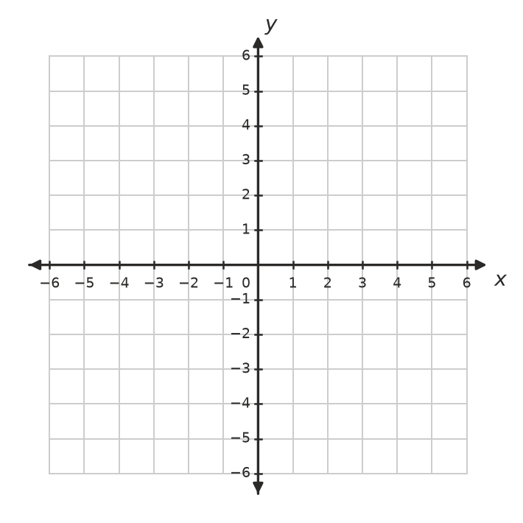
  - Write the coordinates of N. (1 mark)

  - Find the length of KL. (1 mark)

  - Find the length of LM. (1 mark)

  - Find the perimeter of the rectangle KLMN. (1 mark)

- A map of a national park is drawn on a number plane.
  - A bushwalker starts at (−4, −1). She walks 7 units right and then 3 units down. Write the coordinates of where she finishes. (1 mark)

  - Describe the move from the lookout at (5, 2) to the waterfall at (−2, 6) in words. (1 mark)

- The rule for a linear relationship is y = 4 − x.
  - Complete the table of values. (2 marks)
x | −2 | −1 | 0 | 1 | 2
y

  - Plot the points from your table on the number plane below and rule a straight line through them. (1 mark)
- 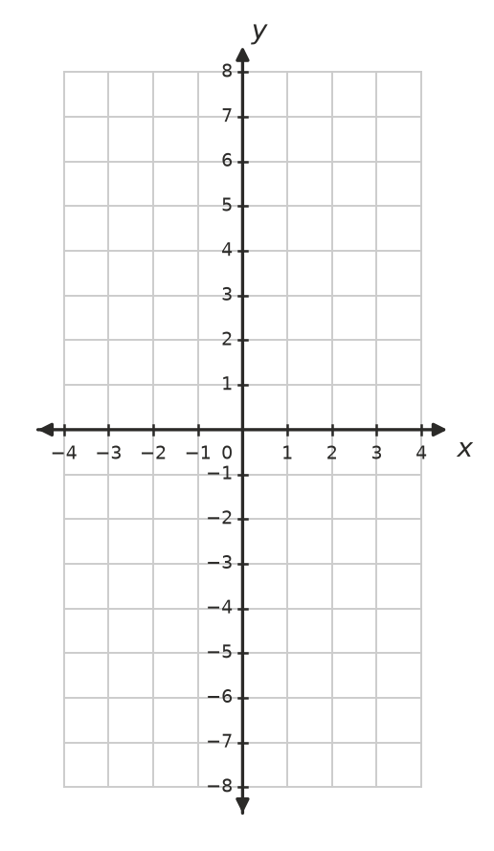
  - For this rule, what value of x gives y = −3? (1 mark)

- Square tables are pushed together in a row for a church camp dinner. Chairs are placed around them as shown.
- 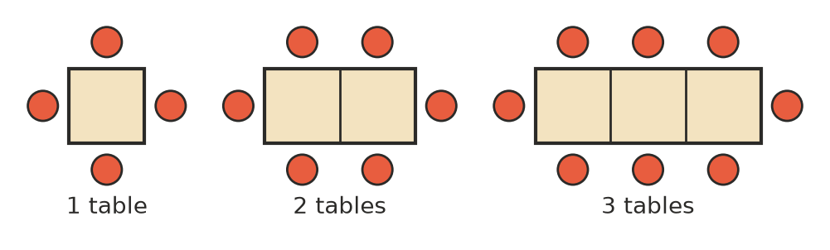
  - Complete the table. (1 mark)
Number of tables (t) | 1 | 2 | 3 | 4 | 5
Number of chairs (c) | 4 | 6 | 8

  - Write a rule for the number of chairs, c, when there are t tables. (1 mark)

  - How many chairs fit around 15 tables? (1 mark)

  - How many tables are needed for 40 chairs? (1 mark)

- Write a rule for y in terms of x for each table.
  - (1 mark)
x | 1 | 2 | 3 | 4
y | 3 | 7 | 11 | 15

  - (1 mark)
x | 0 | 1 | 2 | 3
y | 12 | 9 | 6 | 3

- Tom says, “The point (0, 5) is on the x-axis, because one of its coordinates is 0.” Is Tom correct? Explain your answer. (2 marks)

- Point P is in the 3rd quadrant. It is 4 units from the x-axis, and its x-coordinate is double its y-coordinate. Find the coordinates of P. Show your working. (2 marks)

 Section B: Calculator allowed
- Lily rode her bike to the beach and back. The graph shows her distance from home during the trip.
- 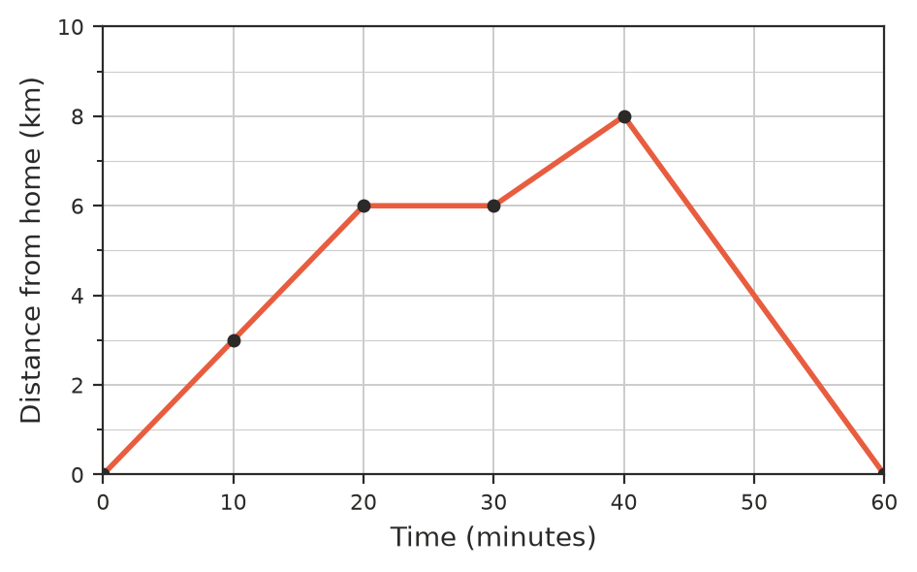
  - How far from home was Lily after 10 minutes? (1 mark)

  - What was Lily doing between 20 and 30 minutes? (1 mark)

  - How long did the ride home take? (1 mark)

  - Find Lily’s speed on the ride home, in km/h. (1 mark)

- The cost of hiring a kayak is found with the rule C = 12.50h + 8, where C is the cost in dollars and h is the number of hours.
  - Complete the table. (1 mark)
Hours (h) | 1 | 2 | 3
Cost (C dollars)

  - Find the cost of hiring a kayak for 7 hours. (1 mark)

  - Noah has $70.50. For how many hours can he hire a kayak? (1 mark)

- A sandpit is drawn on a number plane where 1 unit is 1 metre. Its corners are at (−2.5, 1.5), (6.5, 1.5), (6.5, −3) and (−2.5, −3).
  - Find the perimeter of the sandpit. (1 mark)

  - Find the area of the sandpit. (1 mark)

- The points in this table follow a linear pattern.
x | 1 | 2 | 3 | 4
y | 4.5 | 7.2 | 9.9 | 12.6

  - Write a rule for y in terms of x. (1 mark)

  - Find y when x = 10. (1 mark)

  - Find x when y = 55.8. (1 mark)

 Answer sheet
Name: ____________________
Write your final answer for each question in the table.
Question | Answer | Marks | Question | Answer | Marks
1a |  | /1 | 7c |  | /1
1b |  | /1 | 7d |  | /1
1c |  | /1 | 8a |  | /1
1d |  | /1 | 8b |  | /1
2a |  | /1 | 9 |  | /2
2b |  | /1 | 10 |  | /2
2c |  | /1 | 11a |  | /1
3 |  | /1 | 11b |  | /1
4a |  | /1 | 11c |  | /1
4b |  | /1 | 11d |  | /1
4c |  | /1 | 12a | (in the table in Question 12) | /1
4d |  | /1 | 12b |  | /1
5a |  | /1 | 12c |  | /1
5b |  | /1 | 13a |  | /1
6a | (in the table in Question 6) | /2 | 13b |  | /1
6b | (on the grid in Question 6) | /1 | 14a |  | /1
6c |  | /1 | 14b |  | /1
7a | (in the table in Question 7) | /1 | 14c |  | /1
7b |  | /1
 |  |  |  | Total | /40

