Number plane: Practice test 1
Year 7 Maths · Test · Test 1
Name: ____________________ Date: ______________
Time: 45 minutes
Total: 40 marks
Show your working in the boxes. Then write each final answer on the answer sheet on the last page.

 Section A: No calculator
- Use the number plane below to answer each part.
- 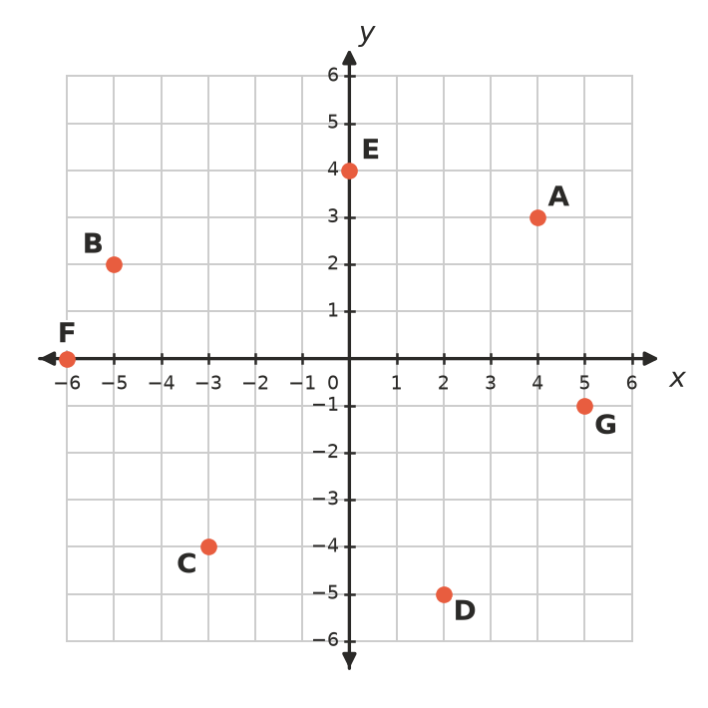
  - Write the coordinates of point A. (1 mark)

  - Write the coordinates of point C. (1 mark)

  - Which point has the coordinates (2, −5)? (1 mark)

  - Which point lies on the x-axis? (1 mark)

- Without plotting, say whether each point is in the 1st, 2nd, 3rd or 4th quadrant, or on an axis.
  - (−8, 5) (1 mark)

  - (0, −3) (1 mark)

- Which of these points is furthest from the x-axis? (1 mark)
  - (5, −2)
  - (−1, 4)
  - (3, 3)
  - (−2, −6)

- Plot the points P(−4, 3), Q(2, 3), R(2, −2) and S(−4, −2) on the number plane. Join them in order and join S back to P.
- 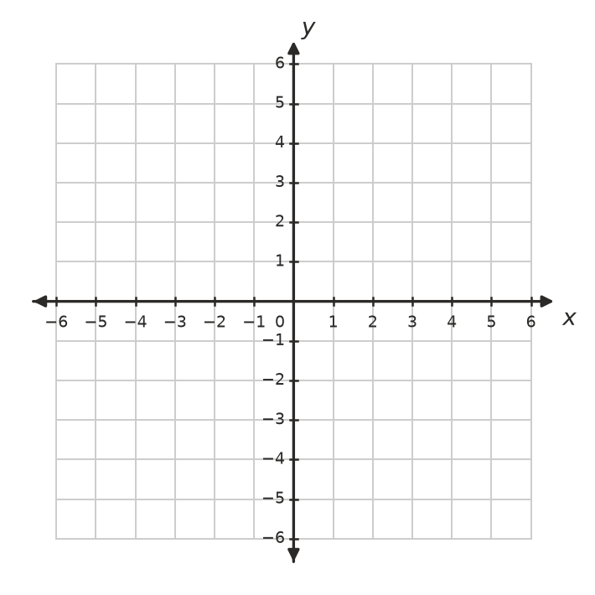
  - What type of shape is PQRS? (1 mark)

  - Find the length of PQ. (1 mark)

  - Find the length of QR. (1 mark)

  - Find the area of PQRS. (1 mark)

- A drone is flying over a paddock that is marked out like a number plane.
  - The drone starts at (3, −2). It flies 6 units left and then 5 units up. Write the coordinates of where it finishes. (1 mark)

  - Describe the move from (−1, 4) to (5, −3) in words. (1 mark)

- Three corners of a square are (−2, 1), (3, 1) and (3, −4). Write the coordinates of the fourth corner. (1 mark)

- The rule for a linear relationship is y = 2x + 3.
  - Complete the table of values. (2 marks)
x | −2 | −1 | 0 | 1 | 2
y

  - Plot the points from your table on the number plane below and rule a straight line through them. (1 mark)
- 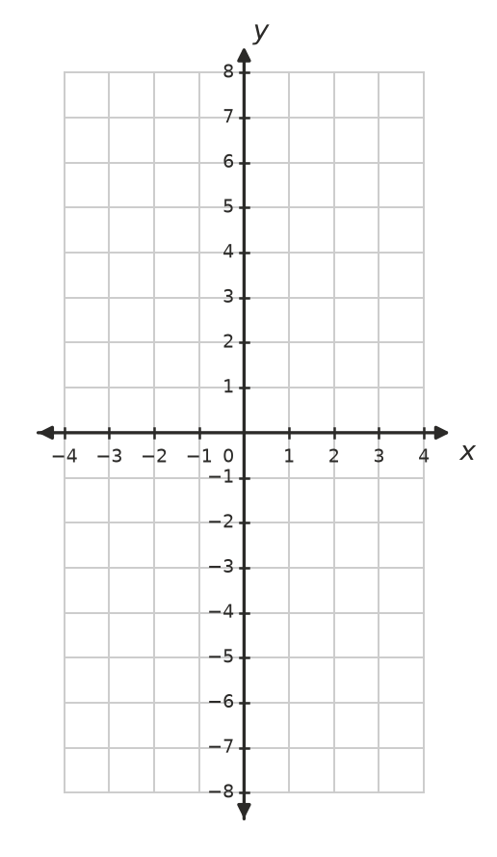
  - Does the point (6, 14) lie on this line? Show how you know. (1 mark)

- This pattern is made from matchsticks.
- 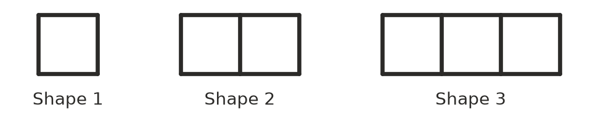
  - Complete the table. (1 mark)
Shape number (n) | 1 | 2 | 3 | 4 | 5
Matchsticks (m) | 4 | 7 | 10

  - Write a rule for the number of matchsticks, m, in Shape n. (1 mark)

  - How many matchsticks are in Shape 20? (1 mark)

  - The points (n, m) from the table are plotted on a number plane. Would they lie on a straight line? Give a reason. (1 mark)

- Write a rule for y in terms of x for each table.
  - (1 mark)
x | 1 | 2 | 3 | 4
y | 6 | 11 | 16 | 21

  - (1 mark)
x | 0 | 1 | 2 | 3
y | 9 | 7 | 5 | 3

- Mia plotted the point (−3, 5). She started at the origin, moved 3 units up and then 5 units left. Explain Mia’s mistake and describe how she should have plotted the point. (2 marks)

- A point lies on the line y = 2x − 1. Its x-coordinate and y-coordinate add to 14. Find the coordinates of the point. Show your working. (2 marks)

 Section B: Calculator allowed
- The graph shows the temperature at Thredbo on a winter’s day.
- 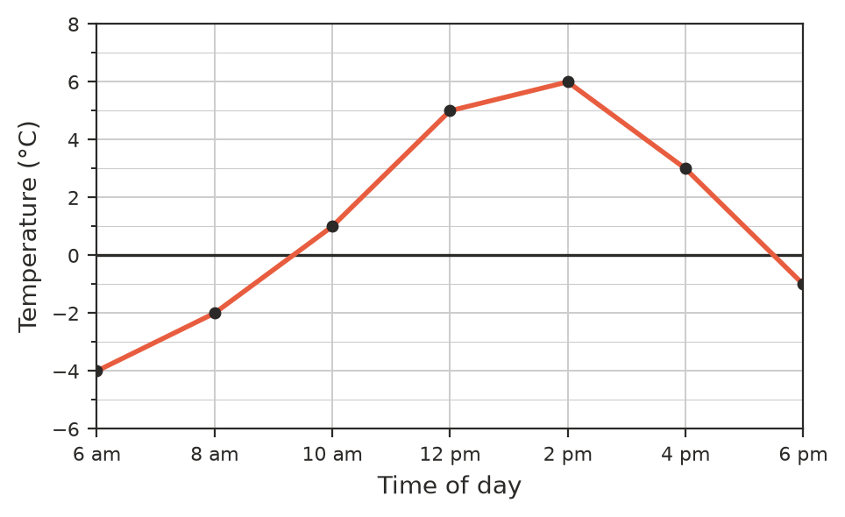
  - What was the temperature at 8 am? (1 mark)

  - What was the highest temperature during the day? (1 mark)

  - By how many degrees did the temperature rise from 6 am to 2 pm? (1 mark)

  - Between which two times on the graph did the temperature fall the most? (1 mark)

- A taxi fare is worked out with the rule C = 2.35d + 4.20, where C is the cost in dollars and d is the distance in kilometres.
  - Complete the table. (1 mark)
Distance (d km) | 0 | 10 | 20
Cost (C dollars)

  - Find the cost of an 18 km trip. (1 mark)

  - Josh’s taxi trip cost $74.70. How far did he travel? (1 mark)

- A rectangular garden bed is drawn on a number plane where 1 unit is 1 metre. Its corners are at (−3.5, −2), (4.5, −2), (4.5, 4.5) and (−3.5, 4.5).
  - Find the perimeter of the garden bed. (1 mark)

  - Find the area of the garden bed. (1 mark)

- A computer game character starts at the point (−15, 9). Each step, it moves 2.5 units right and 1.5 units down.
  - Write the coordinates of the character after 4 steps. (1 mark)

  - After how many steps is the character on the x-axis? (1 mark)

  - In which quadrant is the character after 10 steps? (1 mark)

 Answer sheet
Name: ____________________
Write your final answer for each question in the table.
Question | Answer | Marks | Question | Answer | Marks
1a |  | /1 | 8c |  | /1
1b |  | /1 | 8d |  | /1
1c |  | /1 | 9a |  | /1
1d |  | /1 | 9b |  | /1
2a |  | /1 | 10 |  | /2
2b |  | /1 | 11 |  | /2
3 |  | /1 | 12a |  | /1
4a |  | /1 | 12b |  | /1
4b |  | /1 | 12c |  | /1
4c |  | /1 | 12d |  | /1
4d |  | /1 | 13a | (in the table in Question 13) | /1
5a |  | /1 | 13b |  | /1
5b |  | /1 | 13c |  | /1
6 |  | /1 | 14a |  | /1
7a | (in the table in Question 7) | /2 | 14b |  | /1
7b | (on the grid in Question 7) | /1 | 15a |  | /1
7c |  | /1 | 15b |  | /1
8a | (in the table in Question 8) | /1 | 15c |  | /1
8b |  | /1
 |  |  |  | Total | /40

