10.03 Graphs of linear relationships
Year 7 Maths · Worksheet · Level 3 · Challenge
Name: ____________________ Date: ______________
This worksheet practises finding rules for patterns and tables, plotting lines in all four quadrants, deciding whether points are in a straight line, and interpreting graphs of real situations. Tip: in a linear relationship, y always changes by the same amount each time x goes up by 1.

 Understanding
- The rule is $y=5−2x$.
$x$ | 0 | 1 | 2 | 3 | 4 | 5
$y$

  - Complete the table of values.
  - What happens to y each time x goes up by 1? ______________
- Each figure in this pattern has white tiles in a row with a border of coloured tiles around them. Figure 1 has 1 white tile, Figure 2 has 2 white tiles, and so on.
- 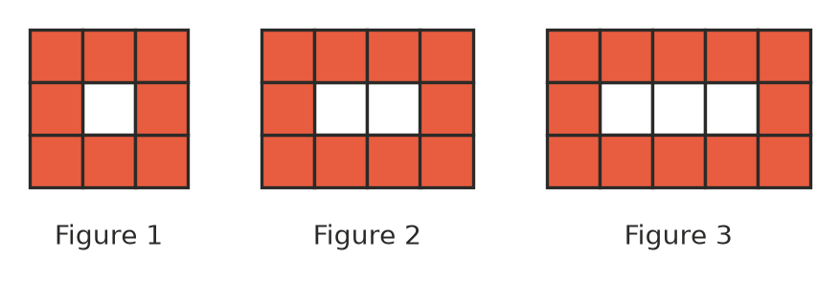
Figure number | 1 | 2 | 3 | 4
Number of coloured tiles

  - Complete the table.
  - Write a rule for the number of coloured tiles, $c$, in Figure $n$. ______________
  - How many coloured tiles are in Figure 25? ______________
  - Which figure has 80 coloured tiles? ______________
  - Can a figure in this pattern have exactly 45 coloured tiles? Explain. ______________

 Fluency
- The rule is $y=x−2$.
$x$ | −2 | −1 | 0 | 1 | 2 | 3 | 4
$y$

  - Complete the table of values.
  - Plot the points on the grid and join them with a ruler.
- 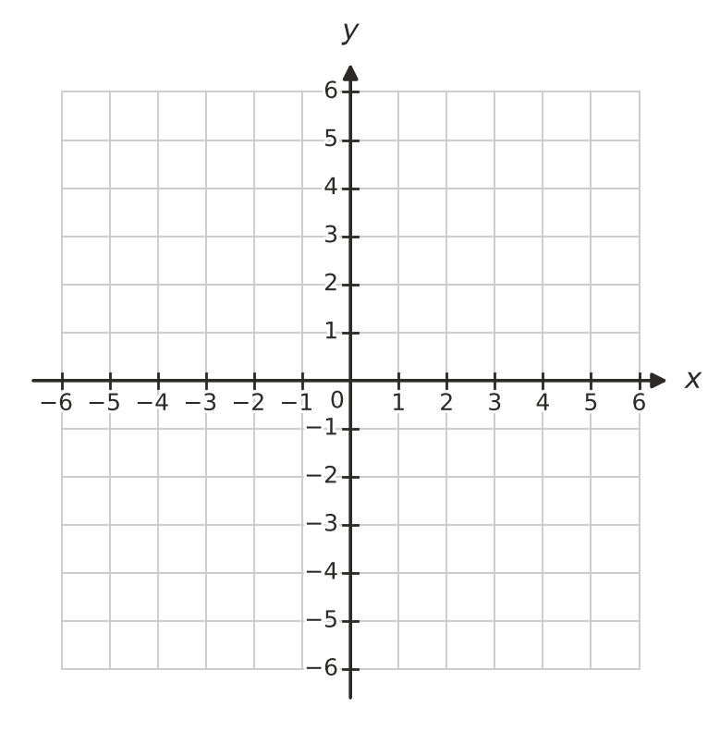
  - Where does the line cross the x-axis? ______________
  - Where does the line cross the y-axis? ______________
- Each set of points follows a linear rule. Write the rule.
  - (0, −3), (1, −1), (2, 1), (3, 3) ______________
  - (1, 2), (2, −1), (3, −4), (4, −7) ______________
  - (2, 5), (4, 9), (6, 13), (8, 17) ______________
  - (−2, 6), (−1, 5), (0, 4), (1, 3) ______________
- This table shows a linear relationship.
$x$ | 1 | 3 | 5 | 7 | 9
$y$ | 4 |  | 16 |  | 28

  - Fill in the two missing values.
  - Write the rule. ______________
- Answer each question about the line $y=2x−5$.
  - Which of these points are on the line: (4, 3), (3, 2), (0, −5), (6, 8)? ______________
  - The point (k, 11) is on the line. Find k. ______________

 Reasoning
- Look at the points P(−2, −5), Q(1, 1) and R(3, 6).
  - Without plotting them, decide whether P, Q and R lie on a straight line. Explain how you know.

  - Change the y-coordinate of R so that the three points do lie on a straight line. ______________
- The table shows the perimeter and the area of squares with different side lengths.
Side length (cm) | 1 | 2 | 3 | 4
Perimeter (cm) | 4 | 8 | 12 | 16
Area (cm²) | 1 | 4 | 9 | 16

  - Which relationship is linear: side length and perimeter, or side length and area? Explain.

  - Describe what the graph of the other relationship would look like. ______________
- Two lines are drawn on the grid.
- 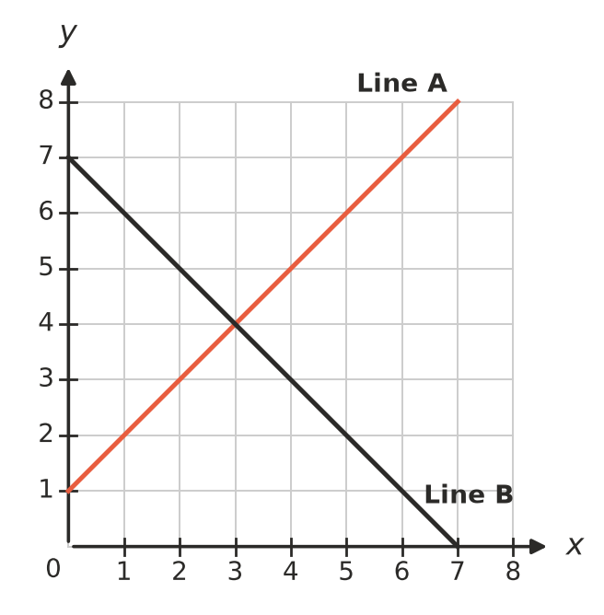
  - Write the coordinates of the point where the lines cross. ______________
  - Which line has the rule $y=x+1$? ______________
  - Write the rule for the other line. ______________
  - For which whole-number values of x from 0 to 7 is Line A higher than Line B? ______________

 Problem solving
- Ana and Ben are saving for a church camp. The graph shows how much each of them has saved.
- 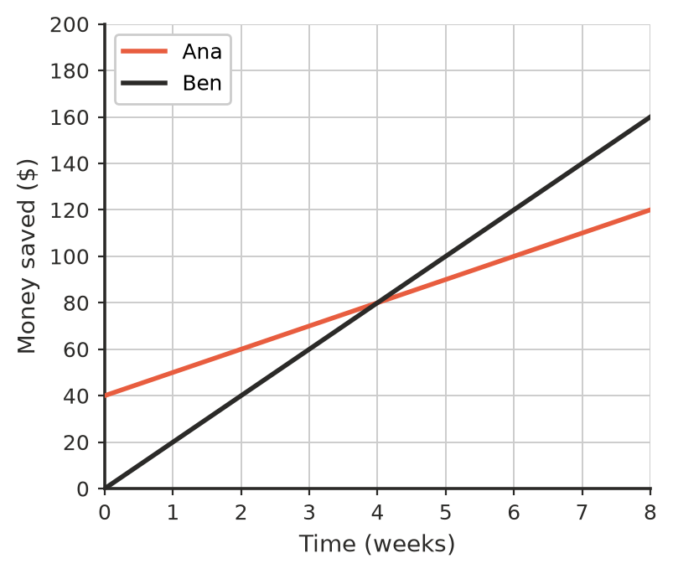
  - Who had some money saved at the start, and how much? ______________
  - How much does each person save per week? ______________
  - After how many weeks have they saved the same amount, and how much is it? ______________
  - Who has saved more after 8 weeks, and by how much? ______________
  - Write a rule for the amount Ana has saved, $s$ dollars, after $w$ weeks. ______________
- A farm water tank is being drained to be cleaned. The graph shows how much water is left.
- 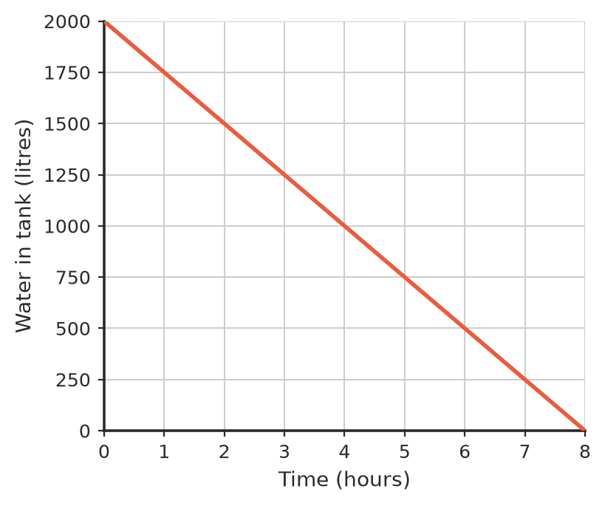
  - How much water is in the tank after 3 hours? ______________
  - When are there 500 litres left? ______________
  - How many litres drain out each hour? ______________
  - Write a rule for the water left, $W$ litres, after $t$ hours. ______________
- A taxi charges $5 to start the trip, plus $3 for every kilometre.
Distance (km) | 0 | 2 | 4 | 6 | 8 | 10
Fare ($)

  - Complete the table.
  - Plot the points on the graph and join them with a line.
- 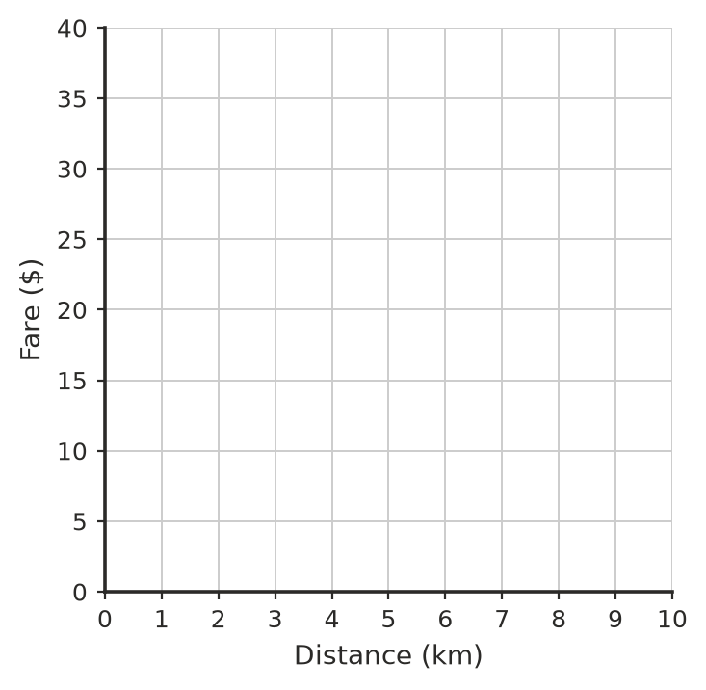
  - Write a rule for the fare, $F$ dollars, for a trip of $d$ km. ______________
  - What is the fare for a 12 km trip? ______________
  - How far can you travel for a fare of 50 dollars? ______________
  - Explain why the graph does not start at the origin.

