10.03 Graphs of linear relationships
Year 7 Maths · Worksheet · Level 1 · Warm-up
Name: ____________________ Date: ______________
This worksheet practises making tables of values from a rule or a pattern, plotting the points, and reading information from straight-line graphs. Tip: each column of a table of values gives you one point to plot, written as (x, y).

 Understanding
- The rule is $y=x+2$.
$x$ | 0 | 1 | 2 | 3 | 4
$y$

  - Complete the table of values.
  - Write the five points as coordinates. ______________
- Here is a pattern made with tiles.
- 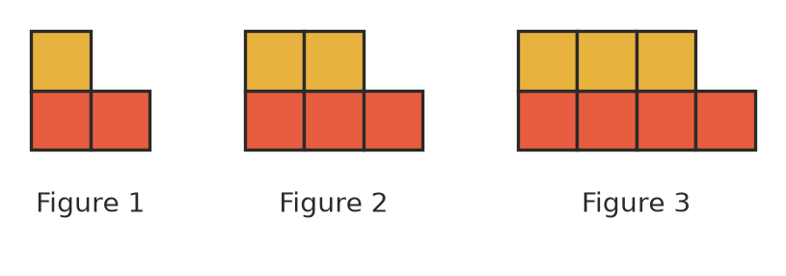
Figure number | 1 | 2 | 3 | 4
Number of tiles

  - Complete the table. Draw Figure 4 on scrap paper if it helps.
  - How many tiles are added each time? ______________
  - Write the four pairs of numbers as coordinates, such as (1, 3). ______________
  - How many tiles will Figure 10 have? ______________

 Fluency
- The rule is $y=2x$, which means $y=2×x$.
$x$ | 0 | 1 | 2 | 3 | 4
$y$

  - Complete the table of values.
  - Plot the points on the grid.
- 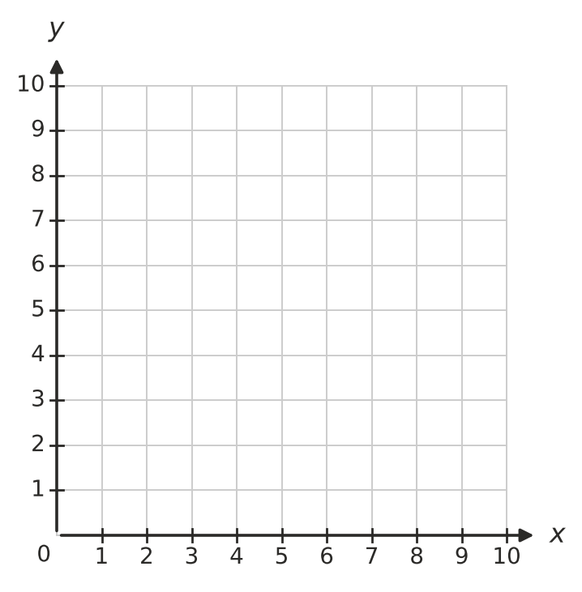
  - Do the points make a straight line? If so, join them with a ruler. ______________
- Use the graph to answer the questions.
- 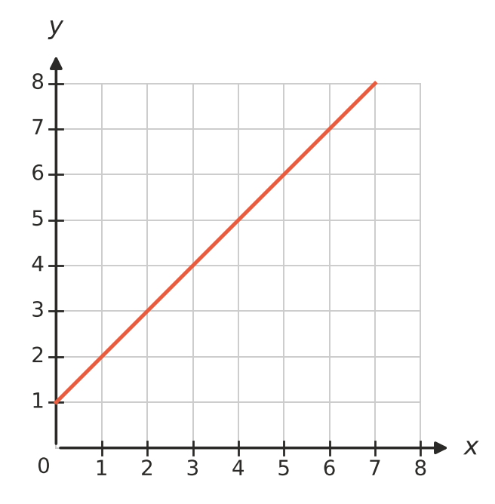
$x$ | 0 | 2 | 4 | 6
$y$

  - Complete the table of values.
  - What is the value of y when $x=3$? ______________
  - What is the value of x when $y=6$? ______________
  - Complete the sentence: each y-value is ______________ more than its x-value.
- Which rule matches this table? Answer: ______________
$x$ | 1 | 2 | 3 | 4
$y$ | 4 | 5 | 6 | 7

  - $y=x+3$
  - $y=4x$
  - $y=x+4$

 Reasoning
- These points should follow a pattern, but one of them is wrong: (1, 2), (2, 4), (3, 6), (4, 7).
  - Which point does not fit the pattern? ______________
  - What should that point be? Explain how you know.

- Noah says, “The graph of $y=x+3$ goes through the origin, (0, 0).” Is Noah right? Explain.

 Problem solving
- A farmer fills a water tank. The graph shows the amount of water in the tank.
- 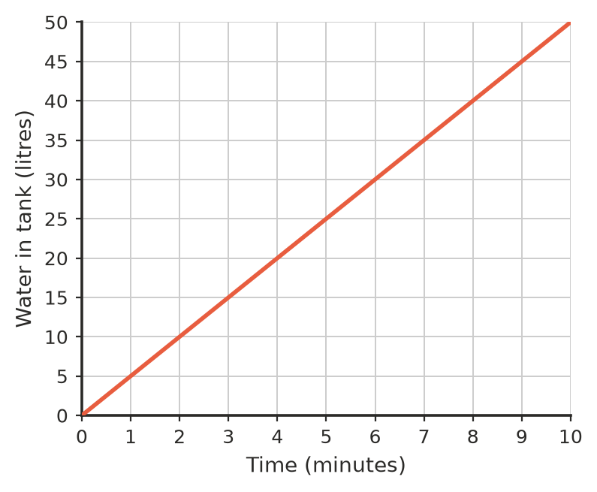
  - How much water is in the tank after 4 minutes? ______________
  - How long does it take to have 30 litres in the tank? ______________
  - How many litres go into the tank each minute? ______________
  - Describe what happens to the amount of water as time goes on. ______________
- A candle is lit and left to burn. The graph shows its height.
- 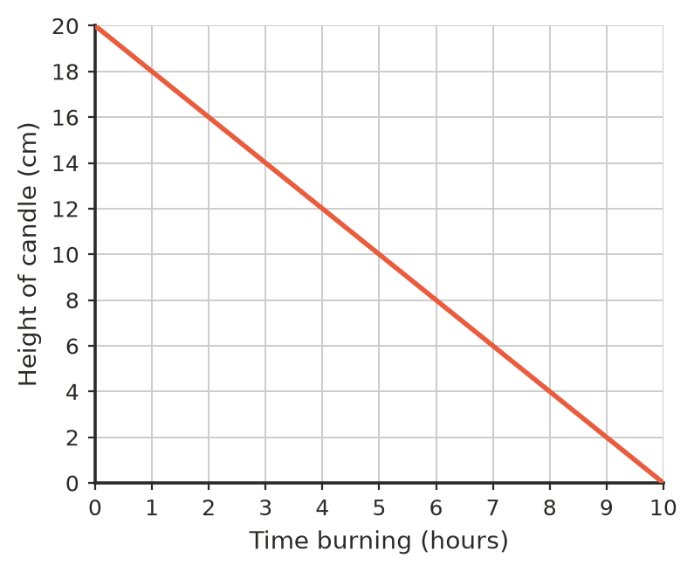
  - How tall was the candle before it was lit? ______________
  - How tall was it after 3 hours? ______________
  - After how many hours was it 8 cm tall? ______________
  - How many centimetres shorter does it get each hour? ______________
  - After how many hours has the candle burnt right down? ______________
- Pies at the school canteen cost $4 each.
Number of pies | 0 | 1 | 2 | 3 | 4 | 5
Cost ($)

  - Complete the table.
  - Plot the points on the graph.
- 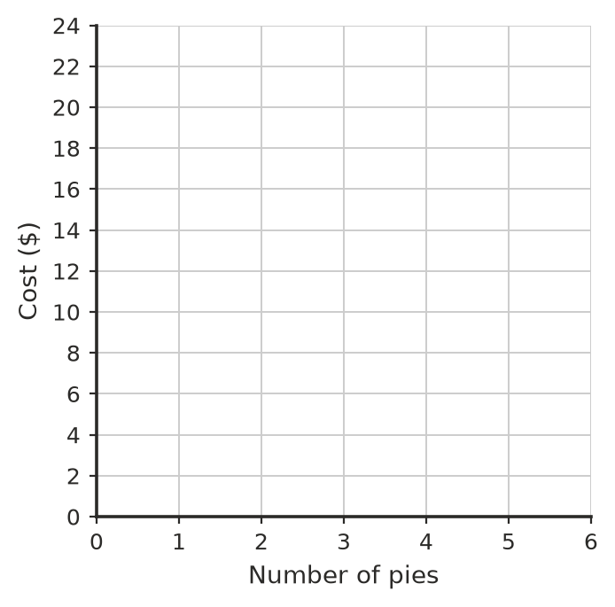
  - Do the points lie in a straight line? ______________
  - How much would 9 pies cost? ______________

