10.03 Graphs of linear relationships
Year 7 Maths · A5 question sheet · Level 2 · Core
This worksheet practises making tables of values from rules and patterns, plotting straight-line graphs, finding rules, and reading graphs of real situations. Tip: to find a rule from a table, look at how much y changes each time x goes up by 1. That number multiplies x in the rule.

 Understanding
- The rule is $y=3x−1$.
$x$ | 1 | 2 | 3 | 4 | 5
$y$

  - Copy and complete the table of values.
  - Write the five points as coordinates.
- Here is a pattern made with tiles.
- 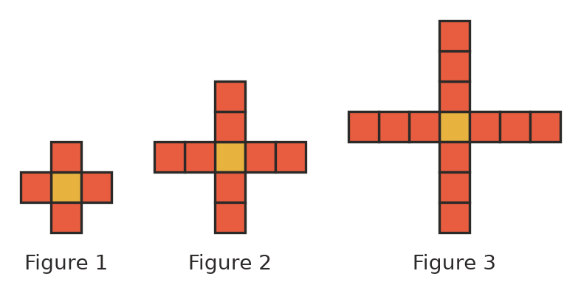
Figure number | 1 | 2 | 3 | 4
Number of tiles

  - Copy and complete the table.
  - How many tiles are added each time?
  - Write a rule for the number of tiles, $t$, in Figure $n$.
  - How many tiles will Figure 10 have?
  - Which figure has 61 tiles?

 Fluency
- The rule is $y=2x+1$.
$x$ | 0 | 1 | 2 | 3 | 4
$y$

  - Copy and complete the table of values.
  - Plot the points on a grid in your book and join them with a ruler.
  - Use your line to find y when $x=3$. Check your answer with the rule.
- Use the graph to answer the questions.
- 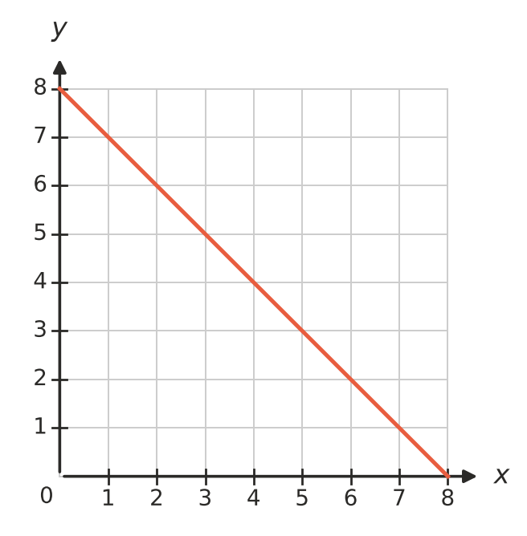
$x$ | 0 | 2 | 5 | 8
$y$

  - Copy and complete the table of values.
  - Which rule matches the graph: $y=x+8$, $y=8−x$ or $y=8x$?
  - Where does the line cross the x-axis?
- Each row of the table follows a different rule. Write the rule for each row in the last column.
$x$ | 1 | 2 | 3 | 4
a) $y$ | 5 | 6 | 7 | 8
b) $y$ | 3 | 6 | 9 | 12
c) $y$ | 1 | 3 | 5 | 7
d) $y$ | 10 | 9 | 8 | 7

- Does each point lie on the line $y=2x+1$? Write Yes or No in your book.
Point
(3, 7)
(5, 10)
(0, 1)
(4, 8)

 Reasoning
- Without plotting them, decide whether the points (1, 3), (2, 5), (3, 7) and (4, 8) lie on a straight line. Explain how you know.
- Look at this table.
$x$ | 1 | 2 | 3 | 4
$y$ | 10 | 8 | 6 | 4

  - Describe how y changes as x goes up by 1.
  - Write a rule for the table.

 Problem solving
- Maddie goes on a bushwalk. The graph shows how far she has walked.
- 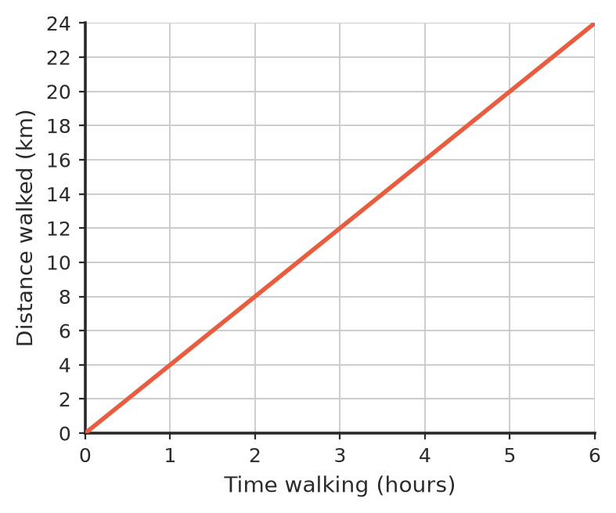
  - How far has Maddie walked after 3 hours?
  - How long does it take her to walk 20 km?
  - How many kilometres does she walk each hour?
  - Describe the relationship between the time and the distance walked.
- A family drives to the coast on a road trip. The graph shows the fuel left in the car’s tank.
- 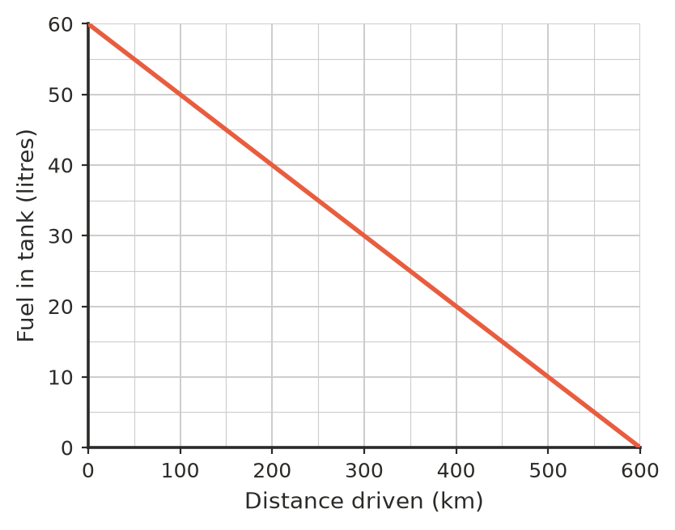
  - How much fuel was in the tank at the start?
  - How much fuel was left after 200 km?
  - How far had they driven when there were 15 litres left?
  - How many litres of fuel does the car use for every 100 km?
  - Describe what happens to the fuel in the tank as the distance driven goes up.
- A jumping castle costs $40 to deliver, plus $20 for each hour of hire.
Hire time (hours) | 1 | 2 | 3 | 4 | 5
Cost ($)

  - Copy and complete the table.
  - Plot the points on the graph.
  - Write a rule for the cost, $C$ dollars, for $h$ hours of hire.
  - Use your rule to find the cost of hiring the castle for 8 hours.
- Explain why it makes sense to draw the bushwalk graph in Question 9 as a solid line, but the points for the tile pattern in Question 2 should not be joined.

