10.02 Directed numbers on the number plane
Year 7 Maths · Worksheet · Level 3 · Challenge
Name: ____________________ Date: ______________
This worksheet practises working in all four quadrants: reading points on a scaled grid, undoing moves, finding missing corners of shapes and solving coordinate puzzles. Tip: when a point moves, work on the x-coordinate (left and right) and the y-coordinate (up and down) separately.

 Understanding
- The letters a and b stand for positive whole numbers. Which quadrant is each point in? If it is on an axis, write which axis.
  - (a, −b) ______________
  - (−a, −b) ______________
  - (−a, b) ______________
  - (b, a) ______________
  - (0, −a) ______________
- Only every second number is labelled on these axes, but every grid line is 1 unit. Write the coordinates of each point.
- 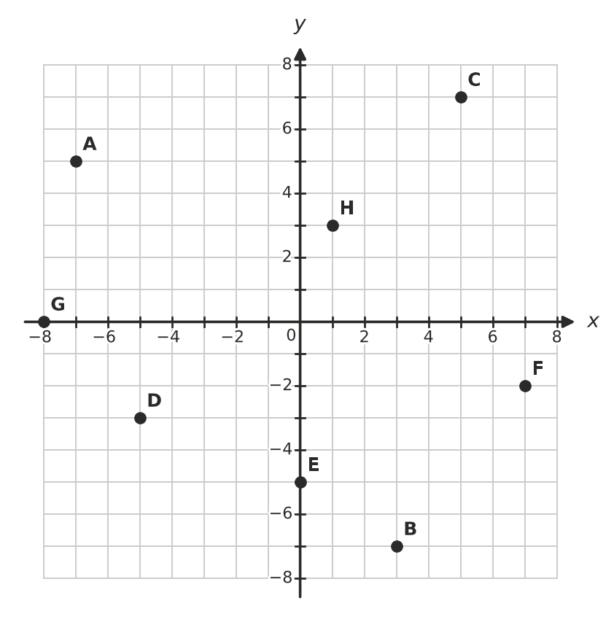
  - A = ______________
  - B = ______________
  - C = ______________
  - D = ______________
  - E = ______________
  - F = ______________
  - G = ______________
  - H = ______________

 Fluency
- Plot these points and join them in order with a ruler. Join G back to A.
- A(−6, 1) B(2, 1) C(2, 4) D(7, −1) E(2, −6) F(2, −3) G(−6, −3)
- 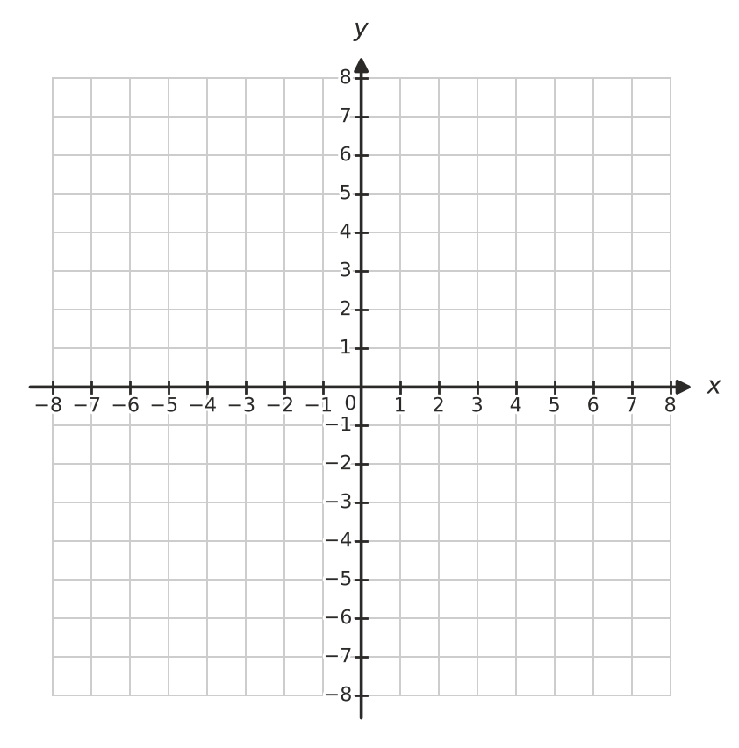
  - How many sides does the shape have? ______________
  - How long is the side AB, in units? ______________
  - The points C, B, F and E are all on one vertical line. How long is CE, in units? ______________
  - ABFG is a rectangle. What is its area, in square units? ______________
- Answer each question about moving on the number plane.
  - Start at (−3, 5). Move 7 right, 9 down and then 2 left. Where do you finish? ______________
  - Point P moves 6 left and 4 up, and finishes at (−2, 1). Where did P start? ______________
  - Describe the moves that take you from (−7, −2) to (3, −8). ______________
  - A point starts at (−8, 8). Each move takes it 5 right and 5 down. Write its position after 1, 2 and 3 moves. ______________
  - After how many moves in part d) is the point first in the 4th quadrant? ______________
- Answer each question.
  - How far apart are (−9, 4) and (7, 4), in units? ______________
  - Which point is exactly halfway between (−9, 4) and (7, 4)? ______________
  - Which point is exactly halfway between (3, −7) and (3, 5)? ______________
  - Two points are on the same horizontal line as (1, −2), and 6 units away from it. Write both points. ______________

 Reasoning
- A point is 4 units from the x-axis and 3 units from the y-axis.
  - List all the possible points. ______________
  - Explain why there is more than one answer.

- Start with the point (5, 2), which is in the 1st quadrant.
  - Change the sign of the x-coordinate. Write the new point and its quadrant. ______________
  - Change the sign of the y-coordinate of (5, 2) instead. Write the new point and its quadrant. ______________
  - Change the sign of both coordinates of (5, 2). Write the new point and its quadrant. ______________
  - Describe what happens to the position of a point when you change the sign of its x-coordinate.

- A(−4, −2), B(3, −2) and C(5, 3) are three corners of a parallelogram ABCD. Plot them on the grid.
  - Find the fourth corner D. ______________
  - There is one other point E on this grid so that A, B, C and E are the corners of a different parallelogram. Find E. ______________

 Problem solving
- Use the letters on this grid.
- 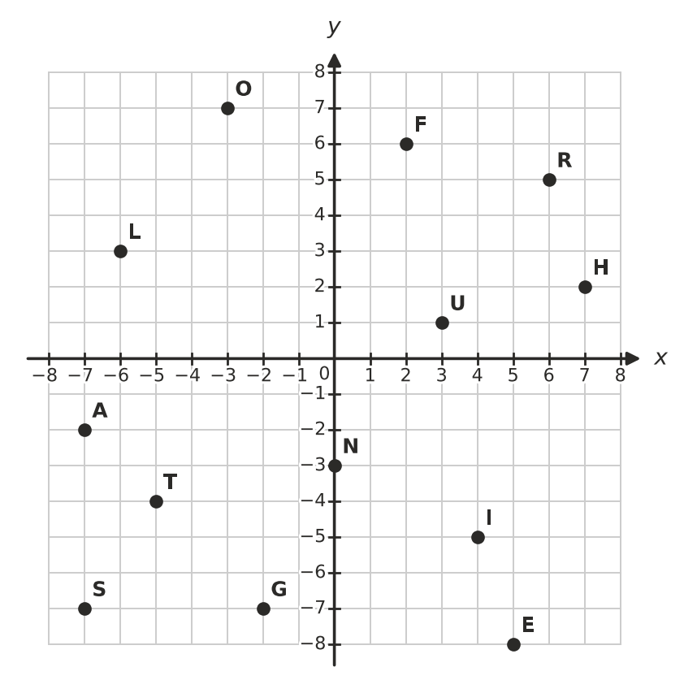
  - Find the letters at these points to spell a word that Jesus used to describe himself in John 8:12.
- (−6, 3) (4, −5) (−2, −7) (7, 2) (−5, −4)
- The word is ______________
  - Write the coordinates you would use to spell the word FAITH.

- A rectangle has corners at (−6, −3), (5, −3), (5, 4) and (−6, 4).
  - What is its perimeter, in units? ______________
  - What is its area, in square units? ______________
  - How many points with whole-number coordinates are inside the rectangle (not on its edges)? ______________
- A map of a country town has the school at the origin. Each unit is 1 km, right is east and up is north. The church is at (−3, 4), the beach is at (6, −2) and a farm is at (−5, −6). The roads follow the grid lines.
  - Which place is in the 3rd quadrant? ______________
  - What is the shortest road distance from the church to the beach, in km? ______________
  - What is the shortest road distance from the farm to the beach, in km? ______________
  - Sam drives from the farm 8 km east and then 10 km north. Where is he now, and how far is he from the church by road? ______________
- Find each mystery point.
  - I am in the 3rd quadrant. My x-coordinate is 2 less than my y-coordinate, and my two coordinates add to −10. ______________
  - My x-coordinate is 7 more than my y-coordinate. My two coordinates add to 1. ______________

