10.02 Directed numbers on the number plane
Year 7 Maths · Worksheet · Level 2 · Core
Name: ____________________ Date: ______________
This worksheet practises reading and plotting points in all four quadrants, moving around the number plane, and finding distances across the axes. Tip: the quadrants are numbered 1st to 4th going anticlockwise from the top right, and the signs of the coordinates tell you which quadrant a point is in.

 Understanding
- Write which quadrant each point is in. If it is on an axis, write which axis.
Point | Quadrant or axis
(−7, 2)
(5, −8)
(−1, −9)
(6, 6)
(0, −4)
(−3, 0)

- Write the coordinates of each point.
- 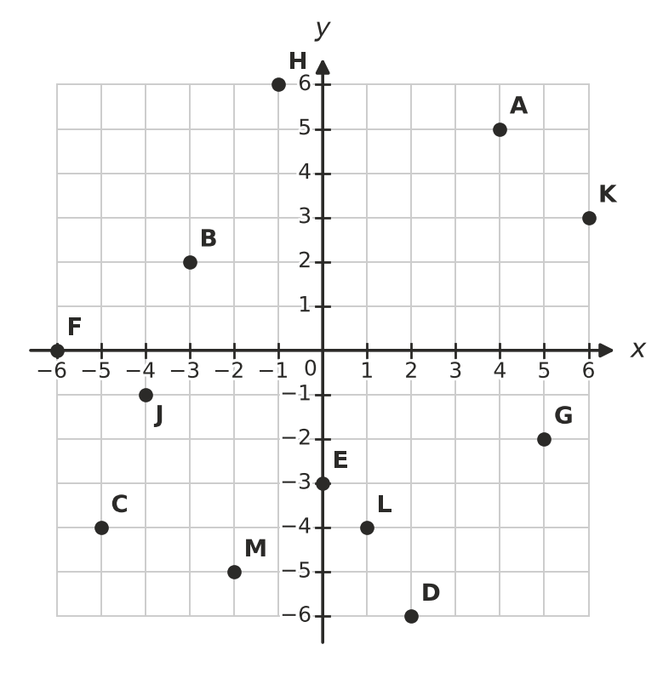
  - A = ______________
  - B = ______________
  - C = ______________
  - D = ______________
  - E = ______________
  - F = ______________
  - G = ______________
  - H = ______________
- Look at the same grid. Which letter is at each point?
  - (−4, −1) ______________
  - (6, 3) ______________
  - (1, −4) ______________
  - (−2, −5) ______________

 Fluency
- Plot each point on the grid. Draw a dot and write its letter next to it.
- A(−5, 3) B(4, −2) C(0, −6) D(−2, −4) E(6, 1) F(−3, 0)
- 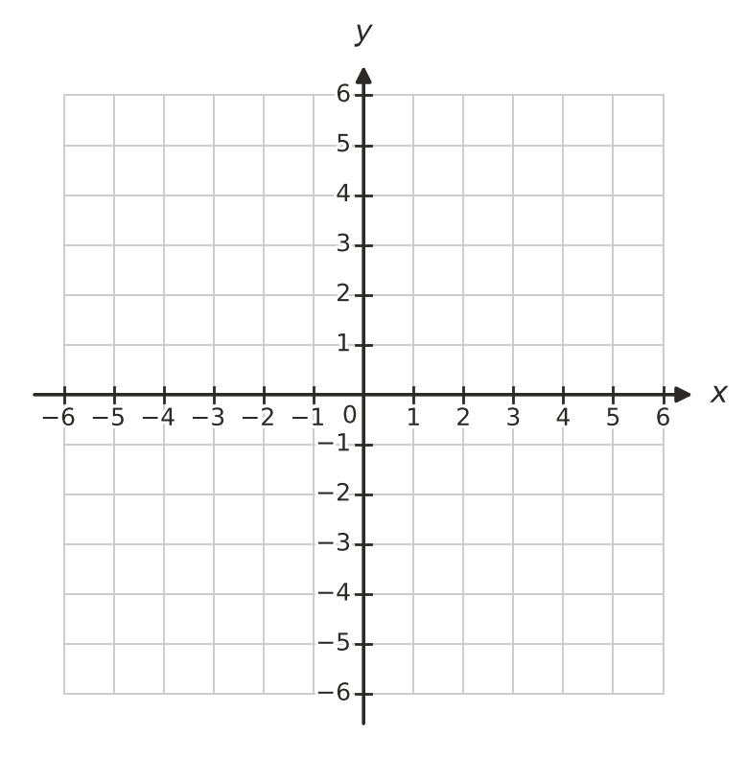
- Plot the points K(−5, −3), L(5, −3), M(2, 3) and N(−2, 3). Join them in order with a ruler, and join N back to K.
  - What shape have you drawn? ______________
  - How long is the side KL, in units? ______________
  - How long is the side NM, in units? ______________
- Answer each question about moving on the number plane.
  - Start at (−4, 5). Move 6 right and 8 down. Where do you finish? ______________
  - Start at (3, −2). Move 7 left and 4 up. Where do you finish? ______________
  - Describe the moves that take you from (−5, −1) to (2, 4). ______________
  - Describe the moves that take you from (4, 6) to (−3, −2). ______________
- Answer each question.
  - How far apart are (−6, 3) and (5, 3), in units? ______________
  - How far apart are (2, −5) and (2, 4), in units? ______________
  - How far apart are (−4, −6) and (−4, −1), in units? ______________
  - Which point is exactly halfway between (−5, 2) and (3, 2)? ______________

 Reasoning
- Without plotting it, explain how you know which quadrant the point (−8, −15) is in.

- Which point is the odd one out? Explain your choice.
- (−2, 5) (−7, 1) (3, −4) (−1, 9)

- Ella says, “The point (0, −5) is in the 3rd quadrant, because −5 is negative.” Explain what Ella has got wrong.

 Problem solving
- Find the letter at each point to spell a word.
- 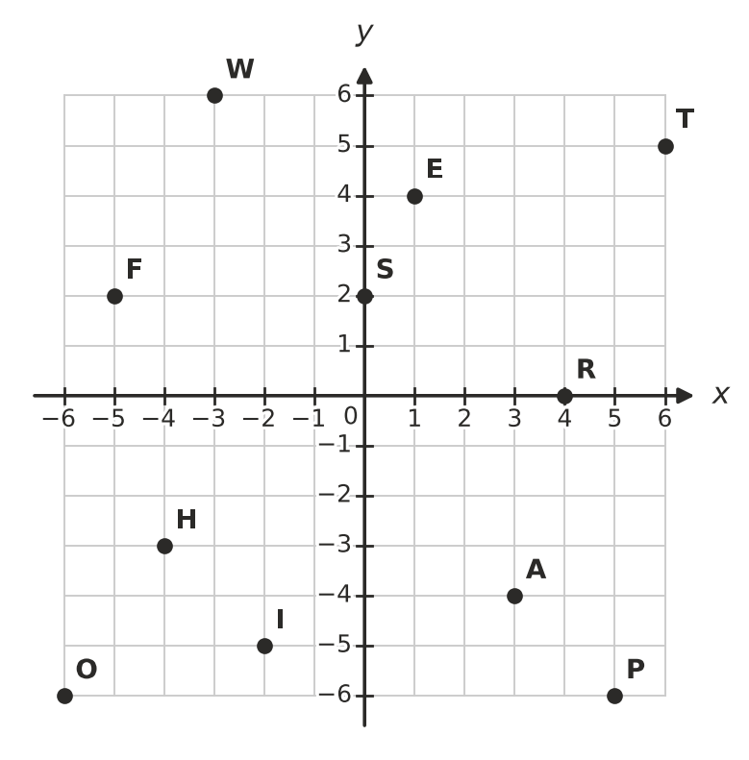
- (−5, 2) (3, −4) (−2, −5) (6, 5) (−4, −3)
- The word is ______________
- A rectangle has three corners at (−5, 4), (3, 4) and (3, −2). Plot them on the grid.
  - Find the fourth corner. ______________
  - What is the perimeter of the rectangle, in units? ______________
  - What is the area of the rectangle, in square units? ______________
- A drone starts at (−3, −4). It flies 5 units up, then 8 units right, then 6 units down.
  - Where does the drone finish? ______________
  - Which quadrant is it in now? ______________
  - Flying only along the grid lines, what is the shortest distance back to its starting point, in units? ______________

