10.02 Directed numbers on the number plane
Year 7 Maths · Worksheet · Level 1 · Warm-up
Name: ____________________ Date: ______________
This worksheet practises reading and plotting points with negative coordinates. The axes split the number plane into four quadrants, numbered 1st, 2nd, 3rd and 4th, going anticlockwise from the top right. Tip: a negative x-coordinate means go left from the origin, and a negative y-coordinate means go down.

 Understanding
- Complete the table. Write + (positive) or − (negative) in each empty box.
Quadrant | Sign of the x-coordinate | Sign of the y-coordinate
1st (top right)
2nd (top left)
3rd (bottom left)
4th (bottom right)

- Write the coordinates of each point.
- 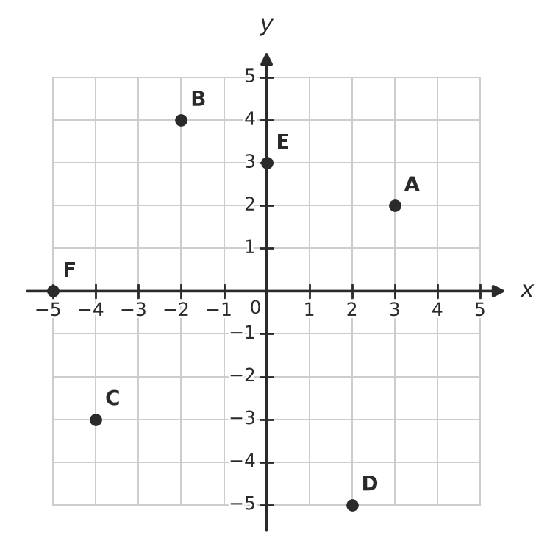
  - A = ______________
  - B = ______________
  - C = ______________
  - D = ______________
  - E = ______________
  - F = ______________
- Which quadrant is each point in? If the point is on an axis, write which axis.
  - (3, −2) ______________
  - (−4, 1) ______________
  - (−2, −5) ______________
  - (1, 4) ______________
  - (0, −3) ______________

 Fluency
- Plot each point on the grid. Draw a dot and write its letter next to it.
- P(2, −3) Q(−4, 2) R(−3, −1) S(0, 4) T(−5, 0) U(4, 4)
- 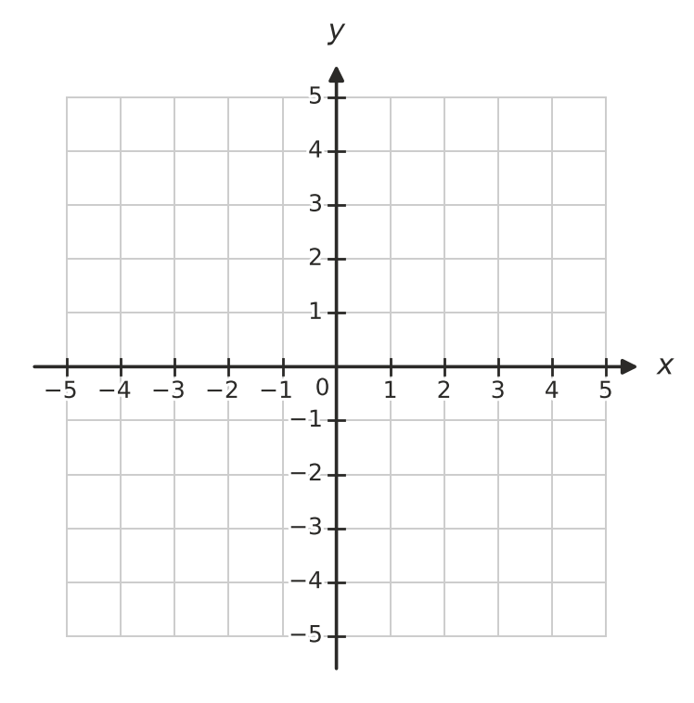
- Start at the given point and make the moves. Write the coordinates of the point where you finish.
  - Start at (2, 1). Move 5 left. ______________
  - Start at (−1, 3). Move 4 down. ______________
  - Start at (−2, −2). Move 3 right and 6 up. ______________
  - Start at (4, −1). Move 6 left and 2 down. ______________
- How far apart are these points, in units? Count the squares on a grid if it helps.
  - (−3, 2) and (4, 2) ______________
  - (1, −4) and (1, 3) ______________
  - (−5, −1) and (−1, −1) ______________

 Reasoning
- Ava says, “(−3, 4) and (3, −4) are in the same quadrant, because they use the same numbers.” Explain why Ava is wrong.

- Is each statement true or false? Write True or False in each empty box.
Statement | True or false
The origin is not in any quadrant.
The point (−1, −1) is in the 3rd quadrant.
Every point with a negative x-coordinate is in the 2nd quadrant.
The point (0, −6) is on the x-axis.

 Problem solving
- Plot the points A(−3, −2), B(2, −2), C(2, 3) and D(−3, 3). Join them in order with a ruler, and join D back to A.
  - What shape have you drawn? ______________
  - How long is the side AB, in units? ______________
  - What is the perimeter of the shape, in units? ______________
- Find the letter at each point to spell a word.
- 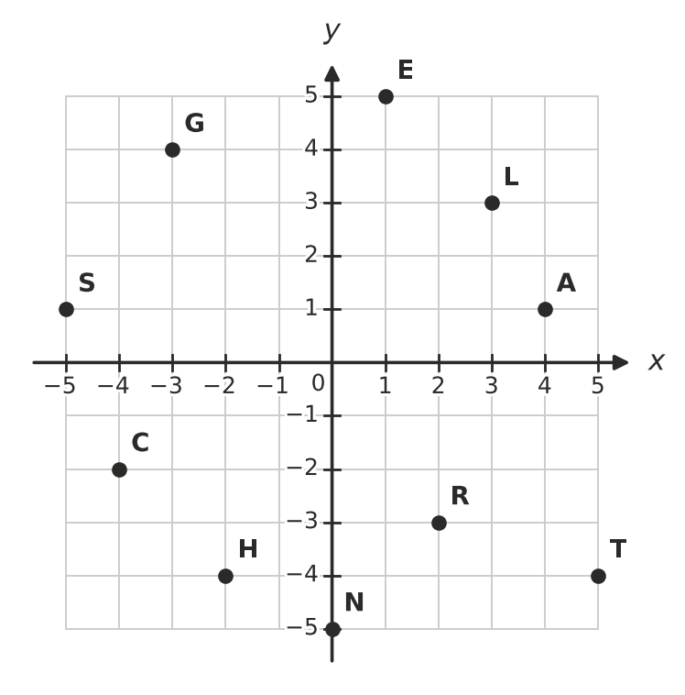
- (−3, 4) (2, −3) (4, 1) (−4, −2) (1, 5)
- The word is ______________
- A rectangle has three corners at (−4, 1), (3, 1) and (3, −2). Plot them on the grid and find the fourth corner.
- The fourth corner is at ______________

