10.02 Directed numbers on the number plane
Year 7 Maths · A5 question sheet · Level 2 · Core
This worksheet practises reading and plotting points in all four quadrants, moving around the number plane, and finding distances across the axes. Tip: the quadrants are numbered 1st to 4th going anticlockwise from the top right, and the signs of the coordinates tell you which quadrant a point is in.

 Understanding
- Write which quadrant each point is in. If it is on an axis, write which axis.
Point
(−7, 2)
(5, −8)
(−1, −9)
(6, 6)
(0, −4)
(−3, 0)

- Write the coordinates of each point.
- 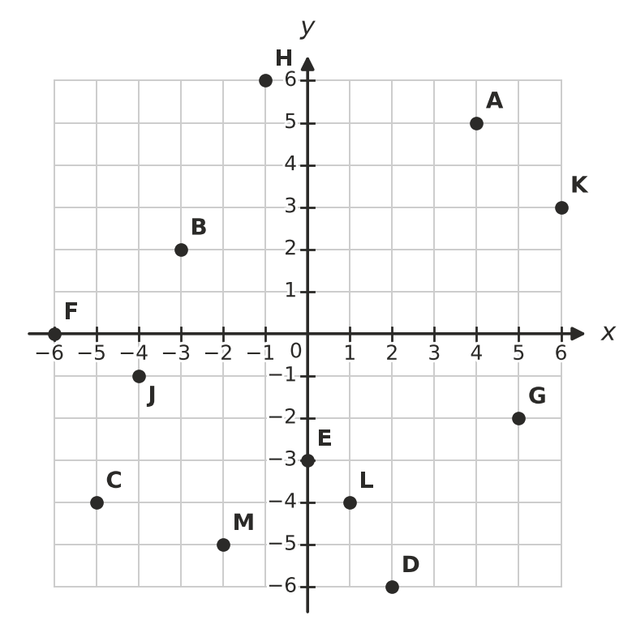
  - A =
  - B =
  - C =
  - D =
  - E =
  - F =
  - G =
  - H =
- Look at the same grid. Which letter is at each point?
  - (−4, −1)
  - (6, 3)
  - (1, −4)
  - (−2, −5)

 Fluency
- Plot each point on a grid in your book. Draw a dot and write its letter next to it.
- A(−5, 3) B(4, −2) C(0, −6) D(−2, −4) E(6, 1) F(−3, 0)
- Plot the points K(−5, −3), L(5, −3), M(2, 3) and N(−2, 3). Join them in order with a ruler, and join N back to K.
  - What shape have you drawn?
  - How long is the side KL, in units?
  - How long is the side NM, in units?
- Answer each question about moving on the number plane.
  - Start at (−4, 5). Move 6 right and 8 down. Where do you finish?
  - Start at (3, −2). Move 7 left and 4 up. Where do you finish?
  - Describe the moves that take you from (−5, −1) to (2, 4).
  - Describe the moves that take you from (4, 6) to (−3, −2).
- Answer each question.
  - How far apart are (−6, 3) and (5, 3), in units?
  - How far apart are (2, −5) and (2, 4), in units?
  - How far apart are (−4, −6) and (−4, −1), in units?
  - Which point is exactly halfway between (−5, 2) and (3, 2)?

 Reasoning
- Without plotting it, explain how you know which quadrant the point (−8, −15) is in.
- Which point is the odd one out? Explain your choice.
- (−2, 5) (−7, 1) (3, −4) (−1, 9)
- Ella says, “The point (0, −5) is in the 3rd quadrant, because −5 is negative.” Explain what Ella has got wrong.

 Problem solving
- Find the letter at each point to spell a word.
- 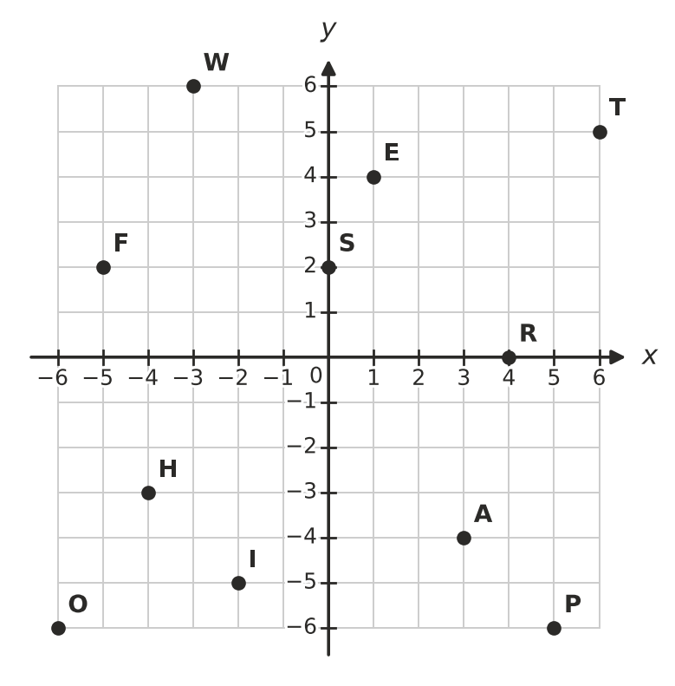
- (−5, 2) (3, −4) (−2, −5) (6, 5) (−4, −3)
- The word is
- A rectangle has three corners at (−5, 4), (3, 4) and (3, −2). Plot them on a grid in your book.
  - Find the fourth corner.
  - What is the perimeter of the rectangle, in units?
  - What is the area of the rectangle, in square units?
- A drone starts at (−3, −4). It flies 5 units up, then 8 units right, then 6 units down.
  - Where does the drone finish?
  - Which quadrant is it in now?
  - Flying only along the grid lines, what is the shortest distance back to its starting point, in units?

