10.01 The number plane
Year 7 Maths · Worksheet · Level 3 · Challenge
Name: ____________________ Date: ______________
This worksheet practises reading points on grids with different scales, working with shapes on the number plane, and solving coordinate puzzles. Tip: before reading a point, check the scale. If the axes go up in 2s, each grid square is worth 2.

 Understanding
- The axes on this grid go up in 2s. Write the coordinates of each point.
- 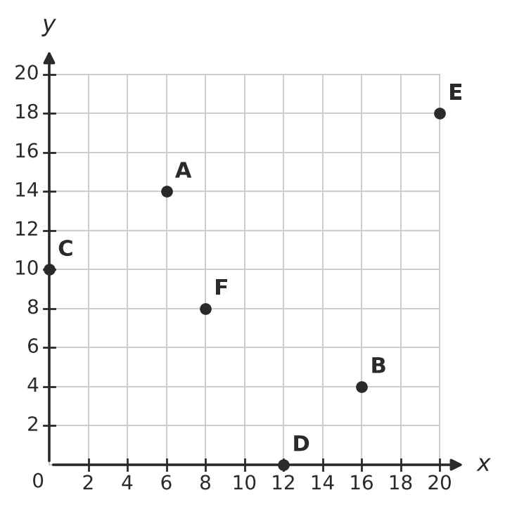
  - A = ______________
  - B = ______________
  - C = ______________
  - D = ______________
  - E = ______________
  - F = ______________
- Fill in the gaps.
  - Every point with an x-coordinate of 0 lies on the ______________ axis.
  - The only point that is on both axes is ______________
  - A point is 3 units above the x-axis and 5 units to the right of the y-axis. Its coordinates are ______________
  - The points (4, 1), (4, 5) and (4, 9) all lie on a line that is ______________ (horizontal or vertical).

 Fluency
- Plot these points and join them in order with a ruler. Join F back to A.
- A(1, 1) B(8, 1) C(8, 4) D(4, 4) E(4, 9) F(1, 9)
- 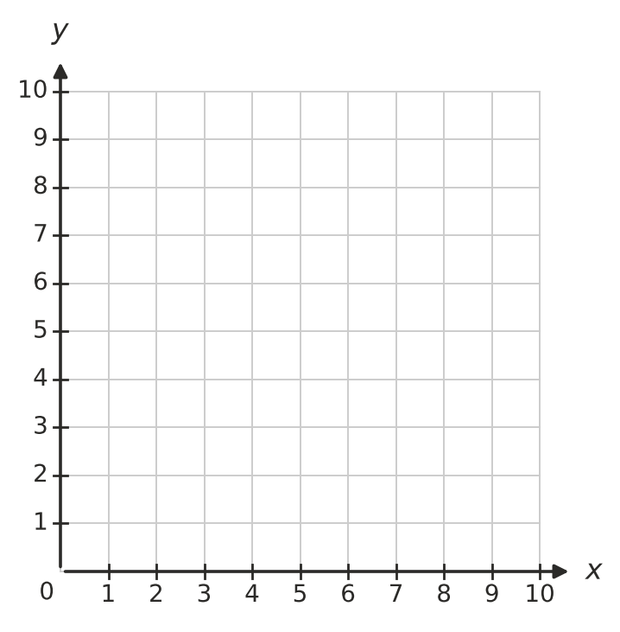
  - What is the perimeter of the shape, in units? ______________
  - What is the area of the shape, in square units? ______________
- Answer each question about moving on the grid.
  - Start at (6, 2). Move 3 right, 5 up and then 7 left. Where do you finish? ______________
  - Describe the moves that take you from (9, 1) to (2, 8). ______________
  - Point P moves 4 left and 3 down, and finishes at (5, 6). Where did P start? ______________
  - Point Q moves 2 right and 6 down, and finishes on the x-axis at (3, 0). Where did Q start? ______________
- Answer each question.
  - How far apart are (3, 7) and (15, 7), in units? ______________
  - Which point is exactly halfway between (3, 7) and (15, 7)? ______________
  - Which point is exactly halfway between (6, 2) and (6, 14)? ______________
  - Two points are on the same horizontal line as (8, 6), and 5 units away from it. Write both points. ______________

 Reasoning
- You walk only along the grid lines from (1, 2) to (6, 5).
  - What is the shortest distance you can walk, in units? ______________
  - Is there only one route that is this short? Explain.

- Jack says, “The points (a, b) and (b, a) can never be the same point.” Is Jack right? Explain, using an example.

- A(1, 1), B(5, 1) and C(7, 4) are three corners of a parallelogram ABCD. Plot them on the grid.
- 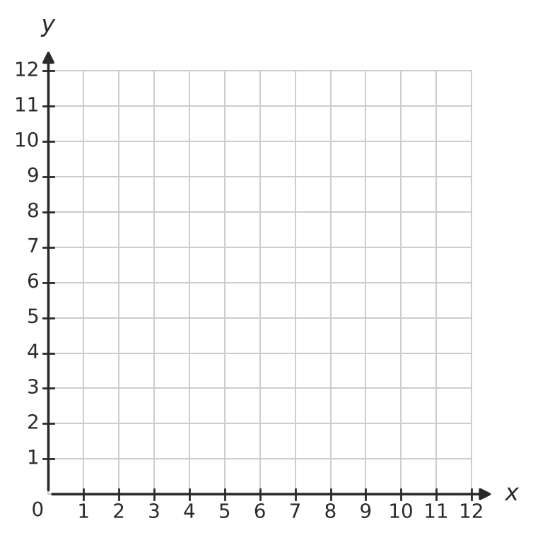
  - Find the coordinates of the fourth corner D. ______________
  - There is a point E on this grid, different from D, so that A, B, C and E are the corners of a different parallelogram. Find E. ______________

 Problem solving
- The grid is a map of a farm. Each grid square is 100 m wide.
- 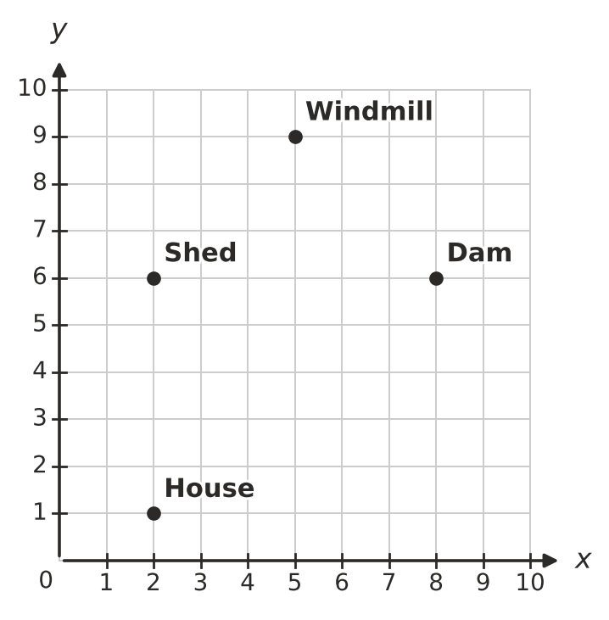
  - Write the coordinates of the Dam. ______________
  - How far is it from the House straight to the Shed, in metres? ______________
  - Walking only along the grid lines, what is the shortest distance from the House to the Dam, in metres? ______________
  - A water trough is placed exactly halfway between the Shed and the Dam. Write its coordinates. ______________
- Triangle PQR is drawn on the grid.
- 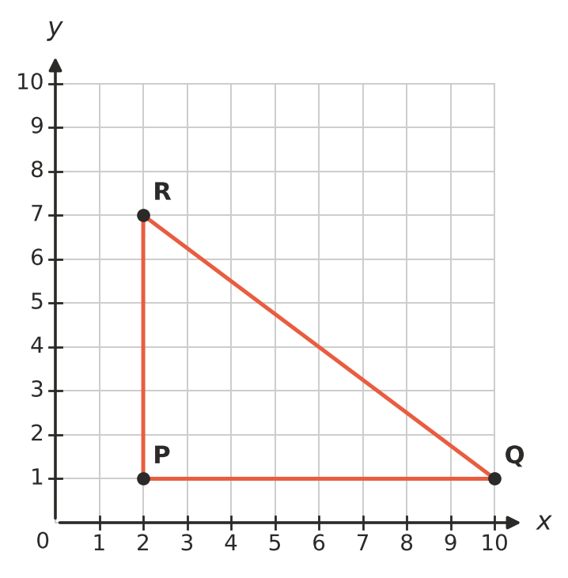
  - How long are the sides PQ and PR, in units? ______________
  - Explain how you could use a rectangle to find the area of the triangle. Then find its area in square units.

- Find each mystery point.
  - My x-coordinate is 3 more than my y-coordinate. My two coordinates add to 11. ______________
  - My y-coordinate is double my x-coordinate. My two coordinates add to 12. ______________
  - I am on the y-axis, and I am the same distance from the origin as the point (7, 0). ______________
- A(5, 1), B(9, 5) and C(5, 9) are three corners of a square ABCD. Plot them on the grid.
  - Find the fourth corner D. ______________
  - Draw a larger square around ABCD with sides along the grid lines. Use it to find the area of ABCD, in square units.

