10.01 The number plane
Year 7 Maths · Worksheet · Level 1 · Warm-up
Name: ____________________ Date: ______________
This worksheet practises reading and plotting points on the number plane. Tip: a point like (4, 7) means go 4 across first, then 7 up. Across comes before up, just as x comes before y in the alphabet.

 Understanding
- Fill in the gaps.
  - The horizontal axis (going across) is called the ______________ axis.
  - The vertical axis (going up) is called the ______________ axis.
  - The point where the two axes cross is called the ______________ and its coordinates are ______________
  - In the point (4, 7), the x-coordinate is ______________ and the y-coordinate is ______________
- Write the coordinates of each point on the grid.
- 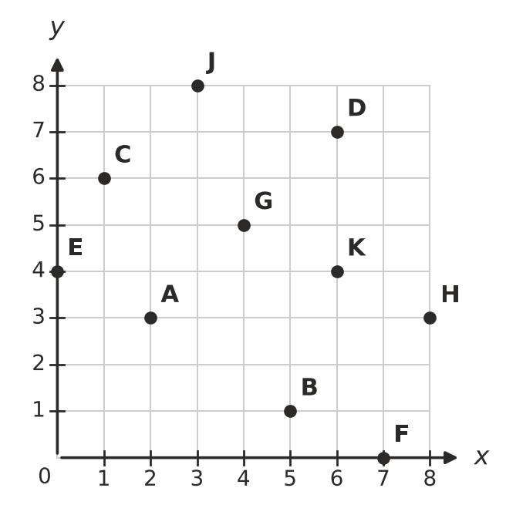
  - A = ______________
  - B = ______________
  - C = ______________
  - D = ______________
  - E = ______________
  - F = ______________
- Look at the same grid. Which letter is at each point?
  - (6, 4) ______________
  - (4, 5) ______________
  - (3, 8) ______________
  - (8, 3) ______________

 Fluency
- Plot each point on the grid. Draw a dot and write its letter next to it.
- P(1, 2) Q(4, 5) R(6, 2) S(3, 0) T(0, 7)
- 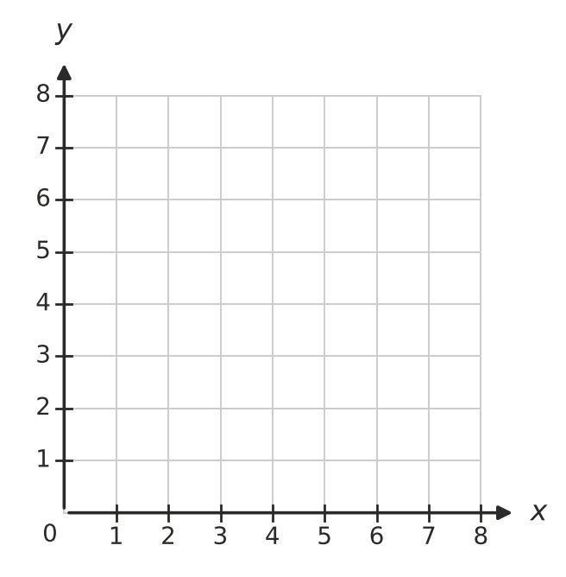
- Plot the points A(2, 1), B(6, 1), C(6, 5) and D(2, 5) on the grid. Join them in order with a ruler, and join D back to A.
  - What shape have you drawn? ______________
  - How long is the side AB, in units? ______________
  - What is the perimeter of the shape, in units? ______________
- Start at the given point and make the moves. Write the coordinates of the point where you finish.
  - Start at (2, 3). Move 4 right and 2 up. ______________
  - Start at (5, 6). Move 3 left and 1 down. ______________
  - Start at (0, 0). Move 7 right and 3 up. ______________
  - Start at (8, 4). Move 8 left. ______________
- How far apart are these points, in units? A quick sketch may help.
  - (1, 4) and (7, 4) ______________
  - (3, 2) and (3, 9) ______________
  - (0, 5) and (8, 5) ______________

 Reasoning
- Mia was asked to plot the point (3, 5). She started at the origin, went up 3 and then across 5. Explain what Mia did wrong, and where her dot should be.

- Is each statement true or false? Write True or False in each empty box.
Statement | True or false
The point (0, 6) is on the y-axis.
(6, 0) and (0, 6) are the same point.
The origin is the point (0, 0).
Every point on the x-axis has a y-coordinate of 0.

 Problem solving
- The grid is a map of a church camp. Each unit is one step on the map.
- 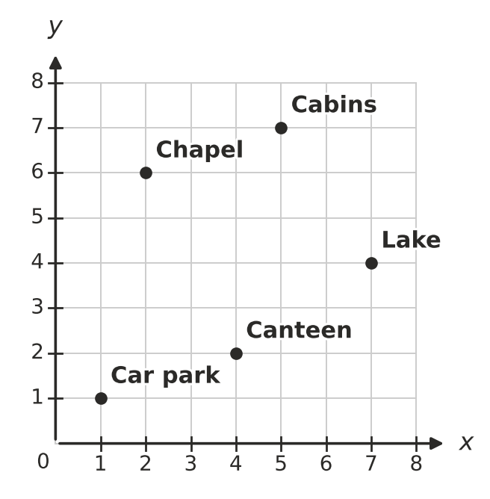
  - Write the coordinates of the Chapel. ______________
  - What is at the point (7, 4)? ______________
  - Ben starts at the Car park and walks 3 right and 1 up. Where is he now? ______________
  - Walking only along the grid lines, what is the shortest distance from the Canteen to the Cabins, in units? ______________
- A rectangle has three corners at (1, 2), (6, 2) and (6, 5). Plot them on the grid, then find the fourth corner.
- The fourth corner is at ______________

