10.01 The number plane
Year 7 Maths · A5 question sheet · Level 2 · Core
This worksheet practises reading and plotting points, describing moves on a grid, and finding distances along the grid lines. Tip: in an ordered pair (x, y), the x-coordinate tells you how far across and the y-coordinate tells you how far up.

 Understanding
- Copy and fill in the gaps.
  - The horizontal axis is called the ______________ and the vertical axis is called the
  - The origin has the coordinates
  - In the point (9, 2), the number that tells you how far up is
  - Every point on the x-axis has a y-coordinate of
  - Every point on the y-axis has an x-coordinate of
- Write the coordinates of each point on the grid.
- 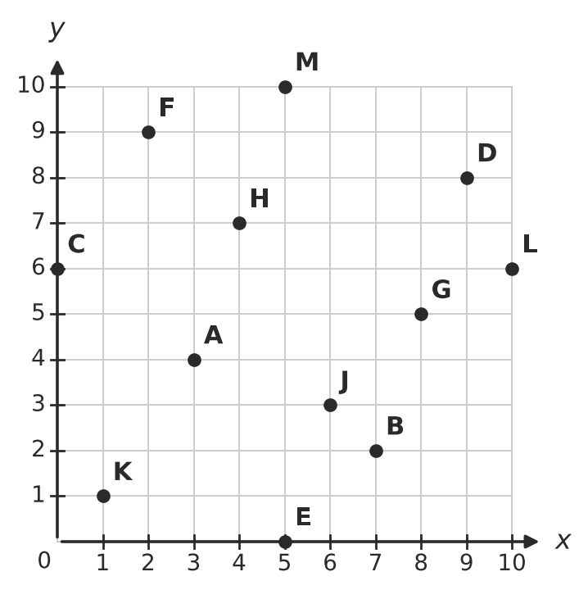
  - A =
  - B =
  - C =
  - D =
  - E =
  - F =
  - G =
  - H =
- Look at the same grid. Which letter is at each point?
  - (1, 1)
  - (10, 6)
  - (6, 3)
  - (5, 10)

 Fluency
- Plot each point on a grid in your book. Draw a dot and write its letter next to it.
- A(3, 7) B(8, 2) C(0, 5) D(6, 0) E(9, 9) F(5, 4)
- Plot the points K(1, 1), L(7, 1), M(9, 5) and N(3, 5). Join them in order with a ruler, and join N back to K.
  - What shape have you drawn?
  - How long is the side KL, in units?
  - How long is the side NM, in units?
  - What do you notice about the sides KL and NM?
- Answer each question about moving on the grid.
  - Start at (3, 8). Move 5 right and 2 down. Where do you finish?
  - Start at (10, 4). Move 6 left and 3 up. Where do you finish?
  - Describe the moves that take you from (2, 2) to (9, 6).
  - Describe the moves that take you from (7, 9) to (1, 3).
- Answer each question.
  - How far apart are (2, 6) and (9, 6), in units?
  - How far apart are (4, 1) and (4, 10), in units?
  - How far apart are (0, 3) and (0, 8), in units?
  - Which point is exactly halfway between (2, 5) and (8, 5)?

 Reasoning
- Explain why (2, 7) and (7, 2) are different points. Say where each one is.
- Which point is the odd one out? Explain your choice.
- (0, 4) (0, 7) (4, 0) (0, 1)
- Is each statement true or false? Write True or False in your book.
Statement
The point (5, 5) is the same distance from both axes.
The point (0, 0) is on both axes.
The points (3, 1), (3, 6) and (3, 9) are all on a horizontal line.
To get from (1, 4) to (6, 4), you move 5 units right.

 Problem solving
- The grid is a map of a footy ground. Each unit on the grid is 10 metres.
- 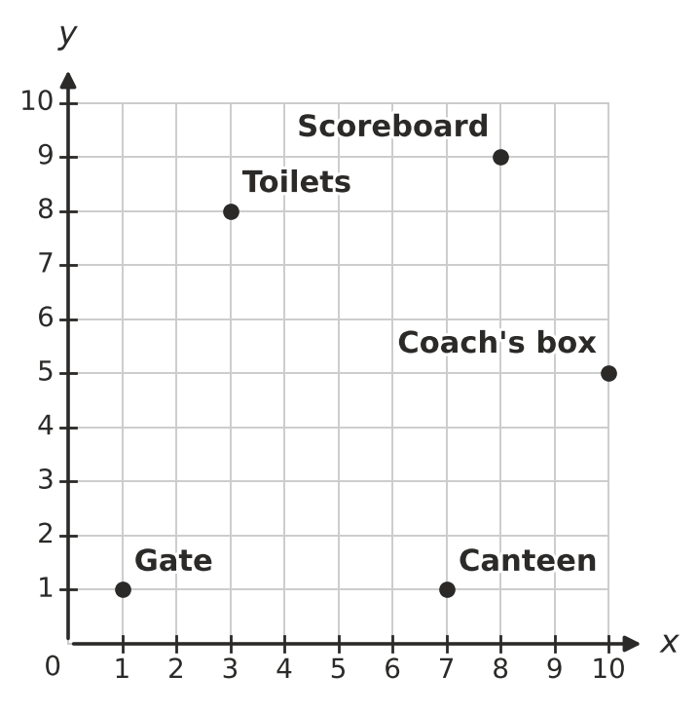
  - Write the coordinates of the Scoreboard.
  - What is at the point (3, 8)?
  - Walking only along the grid lines, what is the shortest distance from the Gate to the Scoreboard, in units?
  - How many metres is that?
  - A bin is placed exactly halfway between the Gate and the Canteen. Write its coordinates.
- A square has three corners at (2, 3), (6, 3) and (6, 7). Plot them on a grid in your book.
  - Find the fourth corner.
  - What is the perimeter of the square, in units?
  - What is the area of the square, in square units?
- Look at this pattern of points: (1, 2), (3, 4), (5, 6), …
  - Write the next two points in the pattern.
  - Describe the pattern in words.
  - Is the point (20, 21) in the pattern? Explain.

