Length and area: Practice test 3
Year 7 Maths · Test · Test 3
Name: ____________________ Date: ______________
Time: 45 minutes
Total: 40 marks
Show your working in the boxes. Then write each final answer on the answer sheet on the last page.

 Section A: No calculator
- Convert each length to the unit shown.
  - 0.6 km to metres (1 mark)

  - 95 mm to centimetres (1 mark)

  - 3.08 m to centimetres (1 mark)

  - 47 cm to metres (1 mark)

- A school relay team runs four legs at the athletics carnival: 400 m, 0.8 km, 1200 m and 0.6 km. How far does the team run altogether, in kilometres? (2 marks)

- Find the perimeter of each shape.
  - A rectangle 13 m long and 8 m wide. (1 mark)

  - A regular octagon with sides 4.5 cm long. (1 mark)

- An isosceles triangle has a perimeter of 50 cm. Its base is 14 cm. How long is each of the two equal sides? (2 marks)

- All the corners of this shape are right angles. The stem of the T is in the middle of the top bar. Find the perimeter of the shape. (2 marks)
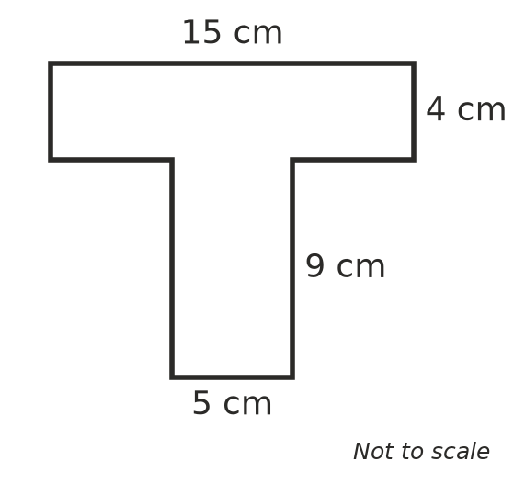

- Find the area of each shape.
  - A square with sides 7 cm long. (1 mark)

  - A rectangle 3 m long and 50 cm wide. Give your answer in square metres. (1 mark)

- Find the area of each triangle. The dashed lines are perpendicular heights.
- 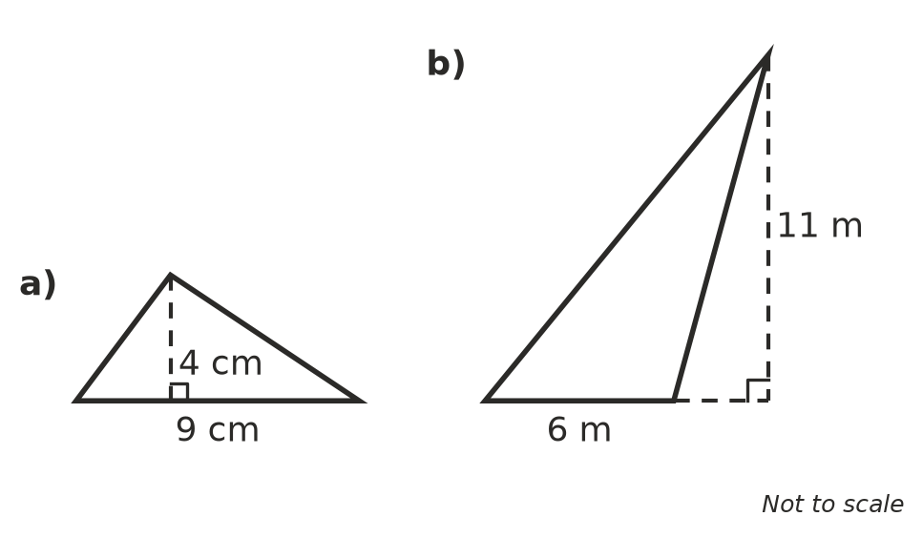
  - Triangle a) (1 mark)

  - Triangle b) (1 mark)

- Answer these questions about parallelograms.
- 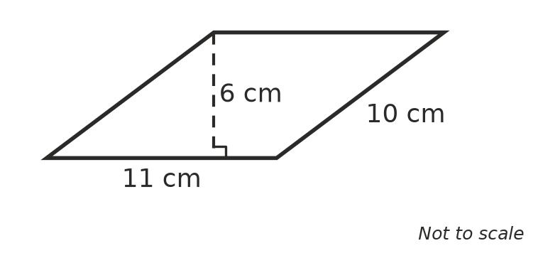
  - Find the area of the parallelogram above. (1 mark)

  - Another parallelogram has an area of 72 cm² and a base of 9 cm. What is its perpendicular height? (1 mark)

- A square tile has an area of 81 cm². Find the perimeter of the tile. (2 marks)

- A triangle is cut out of the top of a rectangular piece of timber, as shown. Find the area of the shaded timber that is left. (3 marks)
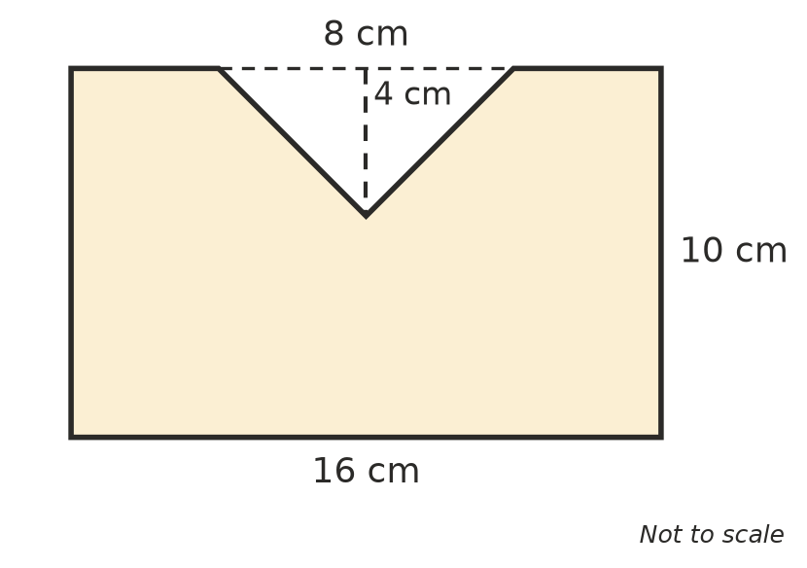

- Zoe says the area of a triangle with a base of 8 cm and a perpendicular height of 6 cm is 48 cm². Explain the mistake Zoe made, then find the correct area. (2 marks)

- Answer these questions about circles.
  - For every circle, the circumference divided by the diameter gives the same number. What is this number called, and what is its value to 2 decimal places? (1 mark)

  - Write the exact circumference of a circle with a radius of 11 m in terms of $π$. (1 mark)

- A rectangle and a square both have a perimeter of 36 cm. The rectangle is twice as long as it is wide. Which shape has the larger area, and by how much? (2 marks)

 Section B: Calculator allowed
- Find the circumference of each circle. Use the $π$ key on your calculator and round your answers to 1 decimal place.
- 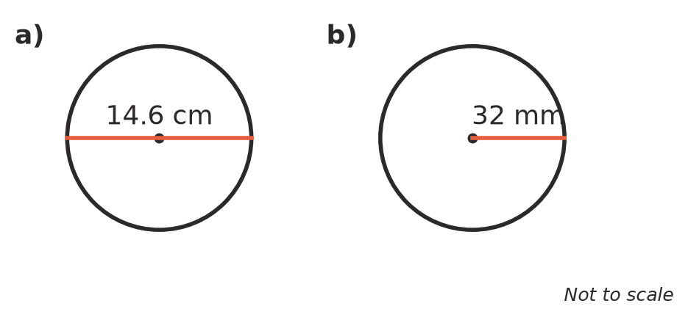
  - Circle a) (1 mark)

  - Circle b) (1 mark)

- A trundle wheel is used to measure distances. Each time the wheel turns once, it rolls exactly 1 m.
  - Find the diameter of the wheel in millimetres. Round your answer to the nearest millimetre. (2 marks)

  - Jack pushes the trundle wheel along a path and it turns 240 times. How long is the path in kilometres? (1 mark)

- A window is a rectangle with a semicircle on top. Find the perimeter of the window frame. Round your answer to 2 decimal places. (3 marks)
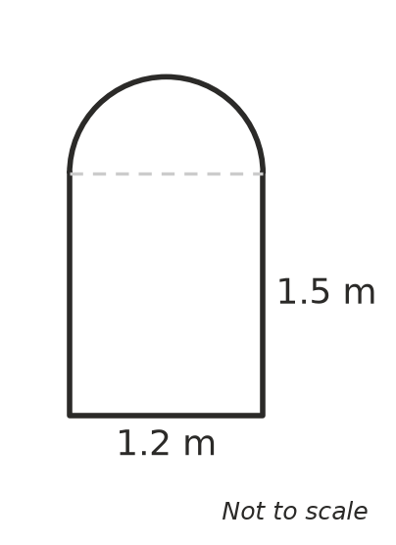

- The school canteen floor is a rectangle 8.4 m long and 5.5 m wide.
  - Find the area of the floor. (1 mark)

  - Floor tiles cost $34.90 per square metre. How much will it cost to tile the floor? (2 marks)

 Answer sheet
Name: ____________________
Write your final answer for each question in the table.
Question | Answer | Marks | Question | Answer | Marks
1a |  | /1 | 8b |  | /1
1b |  | /1 | 9 |  | /2
1c |  | /1 | 10 |  | /3
1d |  | /1 | 11 |  | /2
2 |  | /2 | 12a |  | /1
3a |  | /1 | 12b |  | /1
3b |  | /1 | 13 |  | /2
4 |  | /2 | 14a |  | /1
5 |  | /2 | 14b |  | /1
6a |  | /1 | 15a |  | /2
6b |  | /1 | 15b |  | /1
7a |  | /1 | 16 |  | /3
7b |  | /1 | 17a |  | /1
8a |  | /1 | 17b |  | /2
 |  |  |  | Total | /40

