Length and area: Practice test 2
Year 7 Maths · Test · Test 2
Name: ____________________ Date: ______________
Time: 45 minutes
Total: 40 marks
Show your working in the boxes. Then write each final answer on the answer sheet on the last page.

 Section A: No calculator
- Convert each length to the unit shown.
  - 7.2 cm to millimetres (1 mark)

  - 3 km to metres (1 mark)

  - 480 cm to metres (1 mark)

  - 25 000 mm to metres (1 mark)

- Four students measured the length of the school canteen bench. Write their measurements in order from shortest to longest. (2 marks)
- 2.3 m 2030 mm 235 cm 0.0021 km

- Find the perimeter of each shape.
- 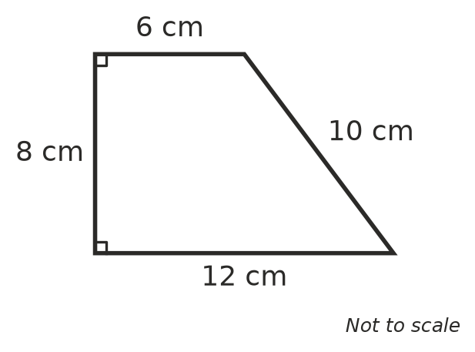
  - The shape above. (1 mark)

  - An equilateral triangle with sides 2.5 m long. (1 mark)

- A square photo frame has a perimeter of 64 cm.
  - How long is each side? (1 mark)

  - What is the area of the frame? (1 mark)

- All the corners of this shape are right angles. Find its perimeter. (2 marks)
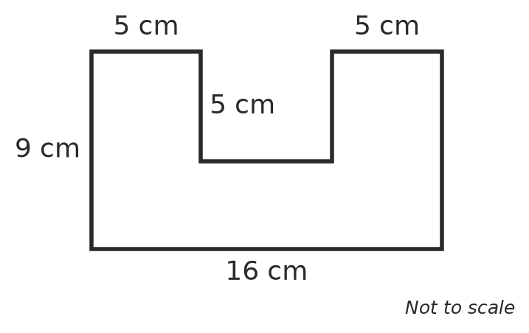

- A bookshelf is 2 m long and 40 cm wide. Find the area of the top of the shelf in square centimetres. (2 marks)

- Find the area of each triangle. The dashed line is a perpendicular height.
- 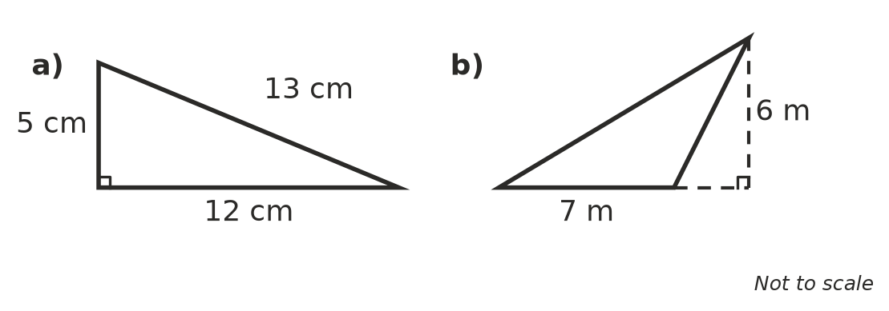
  - Triangle a) (1 mark)

  - Triangle b) (1 mark)

- Answer these questions about parallelograms.
- 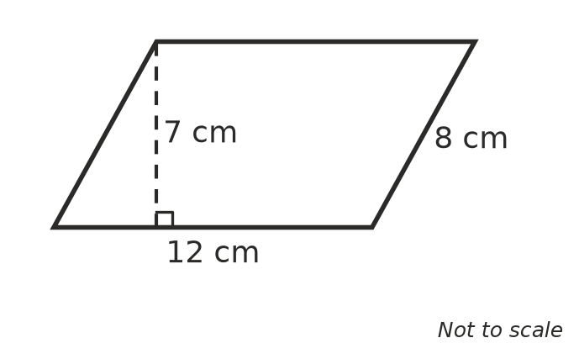
  - Find the area of the parallelogram above. (1 mark)

  - Another parallelogram has an area of 54 m² and a perpendicular height of 6 m. How long is its base? (1 mark)

- A 4 cm by 4 cm square hole is cut out of a rectangular card. Find the area of the shaded card that is left. (2 marks)
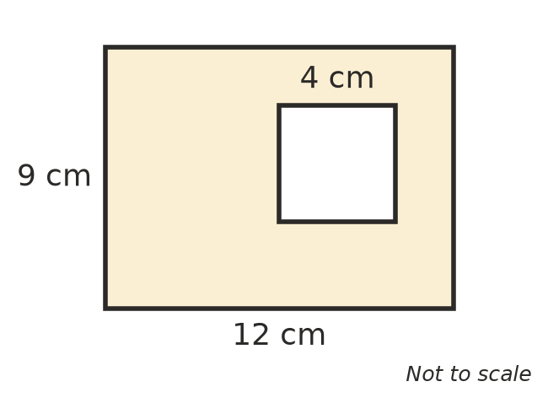

- The diagram shows the shape of a dam wall. Split it into a rectangle and two triangles to find its area. (3 marks)
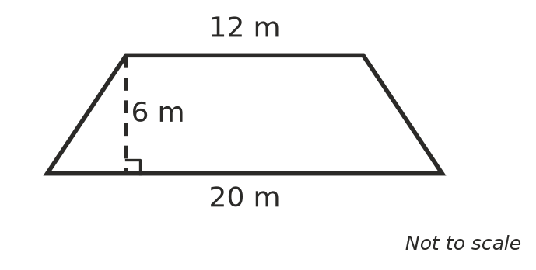

- Liam works out the area of this parallelogram as 10 × 6 = 60 cm². Explain the mistake Liam made, then find the correct area. (2 marks)
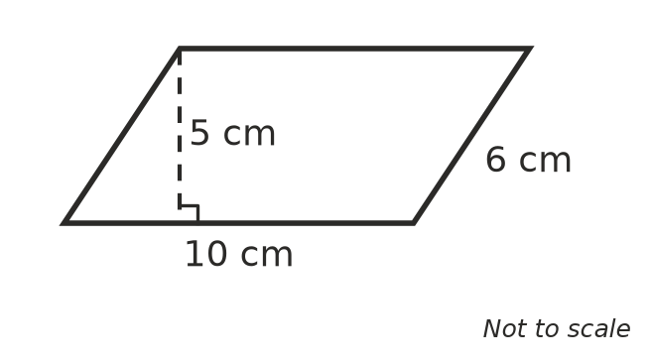

- Answer these questions about circles.
  - Write the circumference of a circle with a diameter of 18 cm in terms of $π$. (1 mark)

  - A circle has a circumference of 30$π$ m. What is its radius? (1 mark)

- A farmer has 20 m of fencing to make a rectangular pen for lambs. The side lengths must be whole numbers of metres. What length and width give the largest area? Show how you know. (2 marks)

 Section B: Calculator allowed
- Find the circumference of each circle. Use the $π$ key on your calculator and round your answers to 2 decimal places.
- 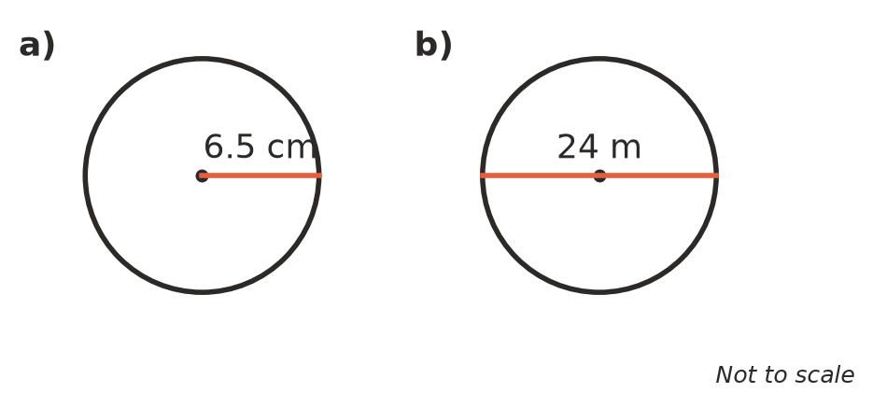
  - Circle a) (1 mark)

  - Circle b) (1 mark)

- A circular garden bed has a circumference of 40 m.
  - Find its diameter. Round your answer to 1 decimal place. (2 marks)

  - Find its radius. Round your answer to 1 decimal place. (1 mark)

- A running track has two straight sides of 80 m and a semicircle at each end. Each semicircle has a diameter of 50 m. Find the distance around the track. Round your answer to 1 decimal place. (3 marks)
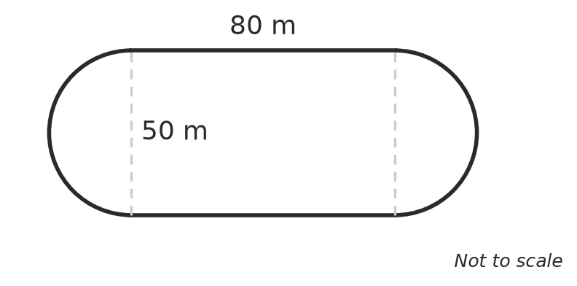

- A wall of a church hall is 6.4 m long and 2.7 m high. It has a door 0.9 m wide and 2.1 m high. The wall is being painted, but not the door.
  - Find the area to be painted. (2 marks)

  - One tin of paint covers 5 m². How many tins must be bought? (1 mark)

 Answer sheet
Name: ____________________
Write your final answer for each question in the table.
Question | Answer | Marks | Question | Answer | Marks
1a |  | /1 | 8b |  | /1
1b |  | /1 | 9 |  | /2
1c |  | /1 | 10 |  | /3
1d |  | /1 | 11 |  | /2
2 |  | /2 | 12a |  | /1
3a |  | /1 | 12b |  | /1
3b |  | /1 | 13 |  | /2
4a |  | /1 | 14a |  | /1
4b |  | /1 | 14b |  | /1
5 |  | /2 | 15a |  | /2
6 |  | /2 | 15b |  | /1
7a |  | /1 | 16 |  | /3
7b |  | /1 | 17a |  | /2
8a |  | /1 | 17b |  | /1
 |  |  |  | Total | /40

