Length and area: Practice test 1
Year 7 Maths · Test · Test 1
Name: ____________________ Date: ______________
Time: 45 minutes
Total: 40 marks
Show your working in the boxes. Then write each final answer on the answer sheet on the last page.

 Section A: No calculator
- Convert each length to the unit shown.
  - 8 cm to millimetres (1 mark)

  - 4.5 m to centimetres (1 mark)

  - 3200 m to kilometres (1 mark)

  - 650 mm to metres (1 mark)

- A farmer puts up three new fences: one is 1.2 km long, one is 450 m long and one is 350 m long. What is the total length of the new fences in metres? (2 marks)

- Find the perimeter of each shape.
- 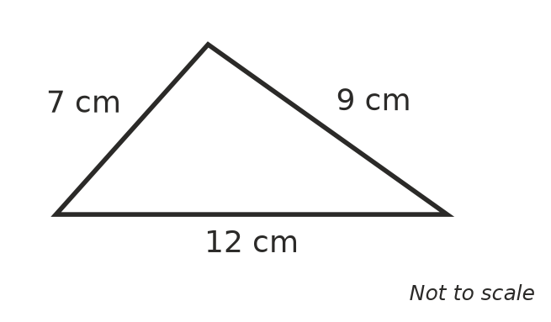
  - The triangle above. (1 mark)

  - A regular hexagon with sides 6 cm long. (1 mark)

- A rectangular vegetable patch has a perimeter of 38 m. It is 12 m long. How wide is it? (2 marks)

- All the corners of this shape are right angles. Find its perimeter. (2 marks)
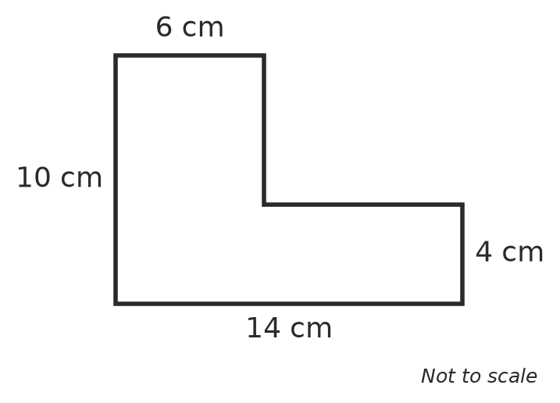

- Find the area of each shape.
  - A rectangle 9 cm long and 7 cm wide. (1 mark)

  - A square with sides 11 m long. (1 mark)

- Find the area of each triangle. The dashed lines are perpendicular heights.
- 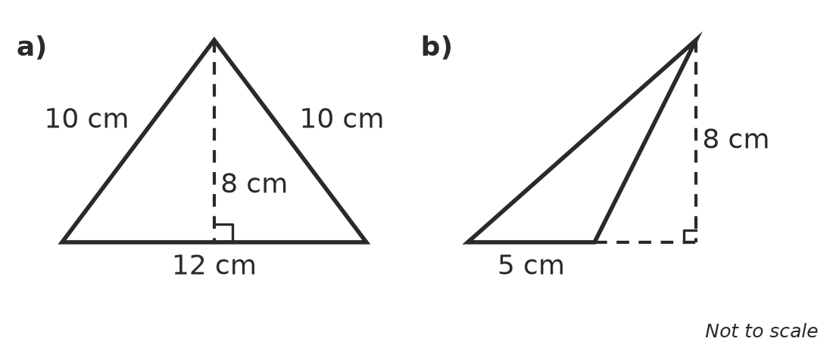
  - Triangle a) (1 mark)

  - Triangle b) (1 mark)

- Look at this parallelogram.
- 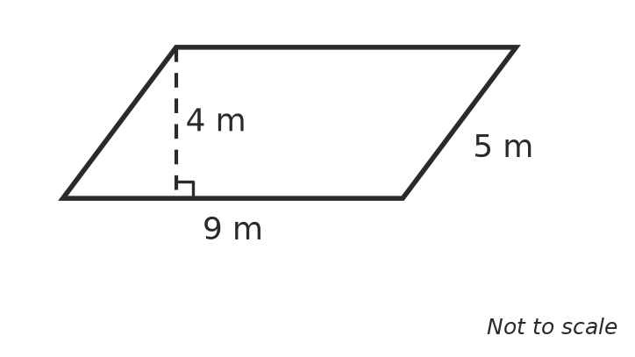
  - Find its area. (1 mark)

  - Find its perimeter. (1 mark)

- A triangle has an area of 42 cm² and a base of 12 cm. What is its perpendicular height? (2 marks)

- The diagram shows the end wall of a shed. It is a rectangle with a triangle on top. Find the area of the wall. (3 marks)
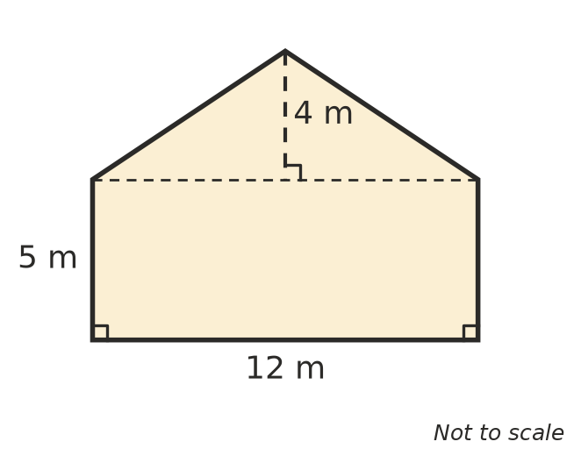

- Mia says, “If you double the side length of a square, its area doubles too.” Is Mia right? Use an example to explain. (2 marks)

- Look at this circle.
- 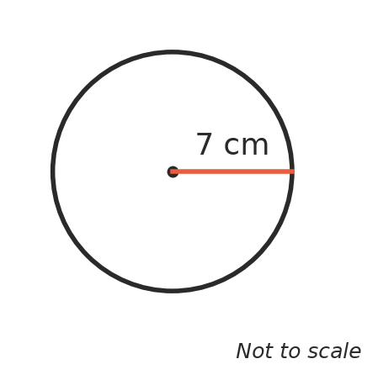
  - What is the diameter of the circle? (1 mark)

  - Write the exact circumference of the circle in terms of $π$. (1 mark)

- A rectangle has an area of 24 cm². Its length and width are whole numbers of centimetres. List all the possible rectangles, then find the one with the smallest perimeter. (2 marks)

 Section B: Calculator allowed
- Find the circumference of each circle. Use the $π$ key on your calculator and round your answers to 1 decimal place.
- 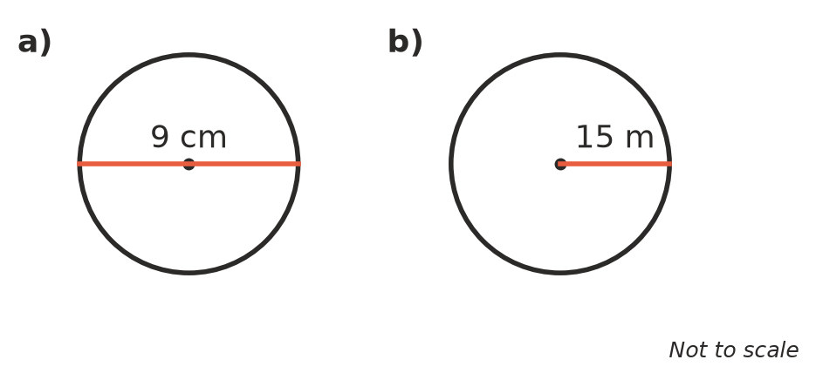
  - Circle a) (1 mark)

  - Circle b) (1 mark)

- A bike wheel has a diameter of 66 cm.
  - Find the circumference of the wheel, rounded to the nearest centimetre. (1 mark)

  - Use your answer to part a) to find how far the bike travels, in metres, when the wheel turns 500 times. (2 marks)

- A garden bed is a rectangle with a semicircle on one end. Find the perimeter of the garden bed. Round your answer to 1 decimal place. (3 marks)
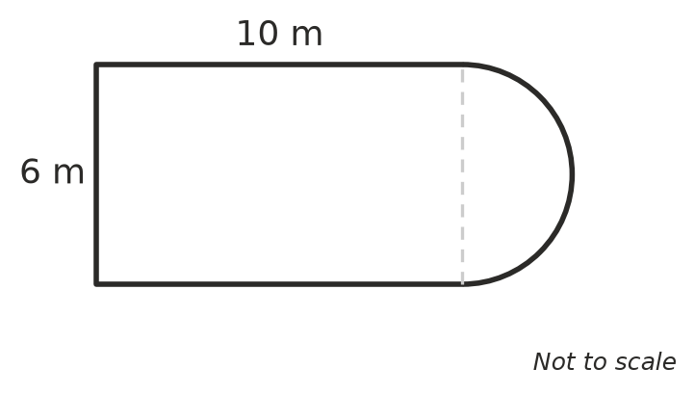

- A rectangular lawn is 15 m long and 9 m wide. In the lawn there is a square flower bed with sides of 3 m. New turf is laid on the whole lawn except the flower bed. Turf costs $12.50 per square metre. How much does the turf cost? (3 marks)

 Answer sheet
Name: ____________________
Write your final answer for each question in the table.
Question | Answer | Marks | Question | Answer | Marks
1a |  | /1 | 8b |  | /1
1b |  | /1 | 9 |  | /2
1c |  | /1 | 10 |  | /3
1d |  | /1 | 11 |  | /2
2 |  | /2 | 12a |  | /1
3a |  | /1 | 12b |  | /1
3b |  | /1 | 13 |  | /2
4 |  | /2 | 14a |  | /1
5 |  | /2 | 14b |  | /1
6a |  | /1 | 15a |  | /1
6b |  | /1 | 15b |  | /2
7a |  | /1 | 16 |  | /3
7b |  | /1 | 17 |  | /3
8a |  | /1
 |  |  |  | Total | /40

