12.08 Circumference of a circle
Year 7 Maths · A5 question sheet · Level 3 · Challenge
This worksheet stretches your skills with exact answers in terms of $π$, the perimeters of semicircles and quarter circles, working backwards and multi-step problems. Calculators are allowed. Unless a question says otherwise, use the $π$ key and round to 1 decimal place. Tip: an exact answer keeps $π$ as a symbol. For example, a circle with a diameter of 4 cm has a circumference of exactly 4$π$ cm.

 Understanding
- Find the exact circumference of each circle, in terms of $π$.
  - 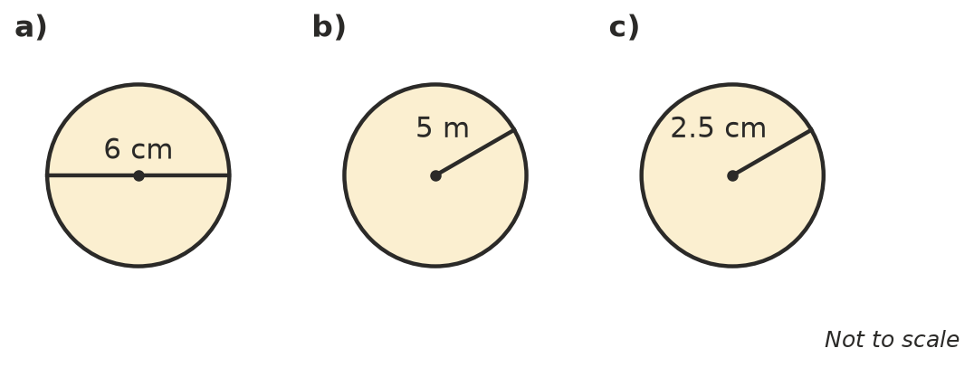

- Find the diameter and the radius of each circle.
  - circumference 18$π$ cm: diameter = ______________ radius =
  - circumference 7$π$ m: diameter = ______________ radius =

 Fluency
- Find the perimeter of each shape. Remember to add the straight sides. Give the exact answer in terms of $π$ first, then round to 1 decimal place.
- 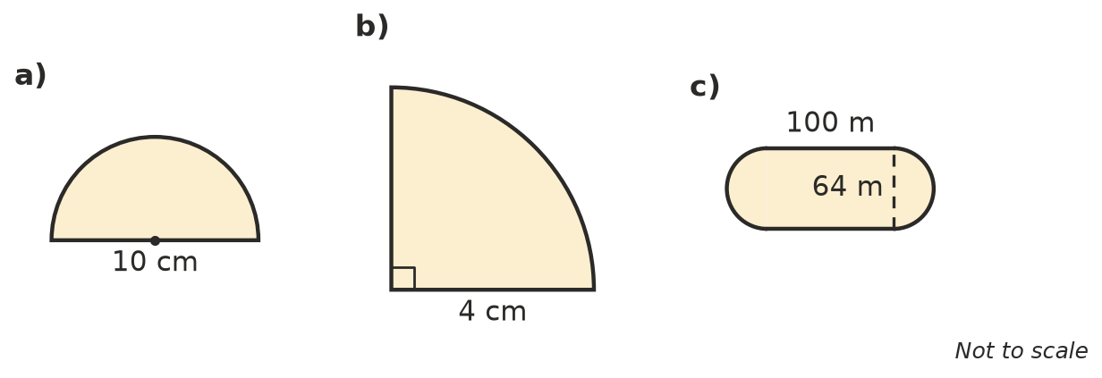
  - a semicircle with a diameter of 10 cm
  - a quarter circle with a radius of 4 cm
  - a running track with two straights of 100 m and a semicircle at each end, 64 m across
- Find each circumference. Use the $π$ key and round to 2 decimal places.
  - diameter 4.6 cm
  - radius 0.35 m
  - radius 12.5 mm
- Work backwards to find the missing length.
  - circumference 31.4 cm, using $π$ ≈ 3.14: radius =
  - circumference 1 km: diameter in metres, to 1 decimal place =
  - circumference 88 cm: radius, to 1 decimal place =

 Reasoning
- Lucy found the perimeter of the semicircle in Question 3 a) like this: $\frac{1}{2}$ × $π$ × 10 ≈ 15.7 cm. Explain what she forgot and give the correct perimeter.
- Circle A has a radius of 3 cm. Circle B has a radius of 6 cm.
  - Write the exact circumference of each circle.
  - How many times longer is the circumference of circle B? Explain why.
- Explain why C ÷ d gives the same number for a coin and for a Ferris wheel.

 Problem solving
- A bike wheel has a diameter of 66 cm. How many complete turns does the wheel make on a 5 km ride? Show your working.
- The Earth is close to a sphere with a radius of about 6371 km. About how far is it around the equator? Round to the nearest kilometre.
- Imagine a rope tied tightly around the Earth’s equator. The rope is then made longer so that it sits 1 m above the ground all the way around.
  - By how much does the radius of the circle increase?
  - How much longer does the rope need to be? Give the exact answer, then round to 1 decimal place.
  - Would the answer be different for a rope around a soccer ball? Explain.
- The minute hand of a clock is 12 cm long. How far does its tip travel in 15 minutes? Show your working.
- On the running track in Question 3 c), a runner in an outside lane runs 1 m further out from the inside edge, so her semicircles are 66 m across. How much further does she run in one lap than a runner on the inside edge? Give the exact answer and the answer to 1 decimal place.

