12.08 Circumference of a circle
Year 7 Maths · A5 question sheet · Level 2 · Core
This worksheet practises finding the circumference of a circle with C = $π$ × d or C = 2 × $π$ × r, and working backwards from the circumference to the diameter. Calculators are allowed. Unless a question says to use 3.14, use the $π$ key on your calculator and round your answer to 1 decimal place. Tip: always check whether you have been given the radius or the diameter.

 Understanding
- Name each labelled part of the circle.
- 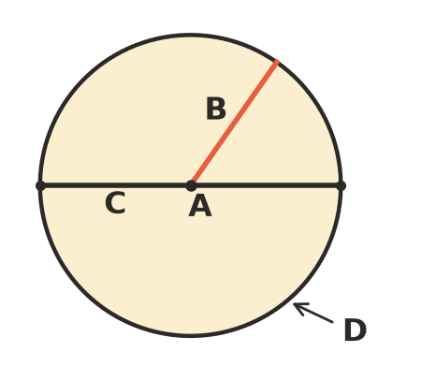
- Complete each sentence.
  - For every circle, circumference ÷ diameter =
  - So circumference = ______________ × diameter.
  - Because the diameter is 2 × the radius, circumference = ______________ × radius.
- Find the missing length.
  - radius 3.6 cm, diameter =
  - diameter 0.9 m, radius =
  - radius 125 mm, diameter in cm =

 Fluency
- Find the circumference of each circle. Use the $π$ key and round to 1 decimal place.
  - 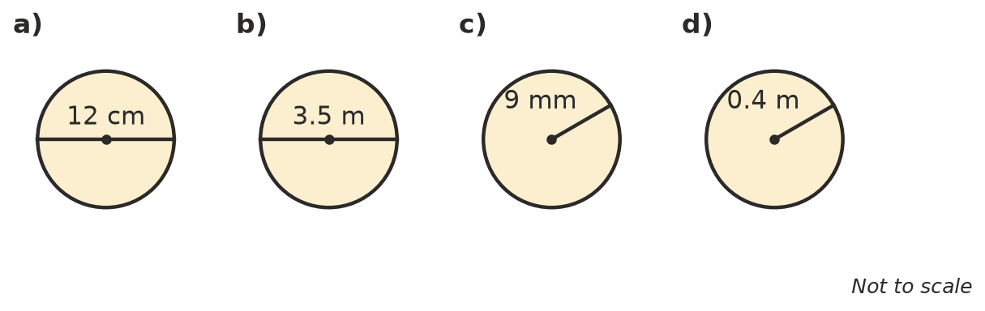

- Find the circumference of each circle. Use $π$ ≈ 3.14.
  - diameter 25 cm
  - radius 6 m
  - radius 1.5 km
- Work backwards to find the missing length. Use the $π$ key and round to 1 decimal place.
  - circumference 50 cm, diameter =
  - circumference 100 m, diameter =
  - circumference 20 cm, radius =

 Reasoning
- Jai found the circumference of a circle with a radius of 7 cm like this: $π$ × 7 ≈ 22.0 cm. Explain his mistake and find the correct circumference.
- If you double the diameter of a circle, what happens to its circumference? Explain, using an example.
- Without a calculator, choose the best estimate for the circumference of a circle with a diameter of 8 cm: 16 cm, 25 cm or 50 cm. Explain your choice.

 Problem solving
- A wheelbarrow wheel has a diameter of 70 cm. How far does the wheelbarrow travel, in metres, when the wheel turns 100 times? Show your working.
- The trunk of a gum tree has a circumference of 2.2 m. What is its diameter, to the nearest centimetre? Show your working.
- A piece of cane 2 m long is bent into a circle to make a hoop, with the ends just touching. What is the diameter of the hoop in centimetres? Show your working.
- A circular pond has a radius of 3.5 m. A fence with 3 rails is built around its edge. Each rail goes all the way around. What is the total length of the rails? Show your working.

