12.08 Circumference of a circle
Year 7 Maths · A5 question sheet · Level 1 · Warm-up
The circumference of a circle is the distance around it. For every circle, the circumference is $π$ (pi) times the diameter, where $π$ is about 3.14. So C = $π$ × d, or C = 2 × $π$ × r when you know the radius. Calculators are allowed. Each question tells you whether to use 3.14 or the $π$ key on your calculator. Tip: the diameter is always twice the radius.

 Understanding
- Name each labelled part of the circle. Choose from: centre, radius, diameter, circumference.
- 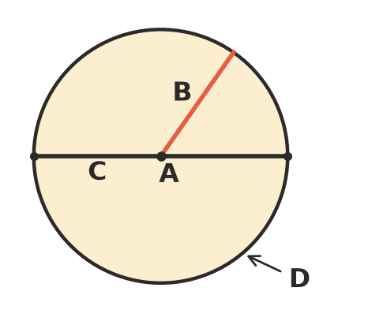
- Find the missing length.
  - radius 4 cm, diameter =
  - diameter 18 m, radius =
  - radius 2.5 cm, diameter =
  - diameter 7 mm, radius =
- Complete the rule and the fact.
  - circumference = $π$ ×
  - $π$ is about ______________ (to 2 decimal places)

 Fluency
- Find the circumference of each circle. Use $π$ ≈ 3.14.
  - 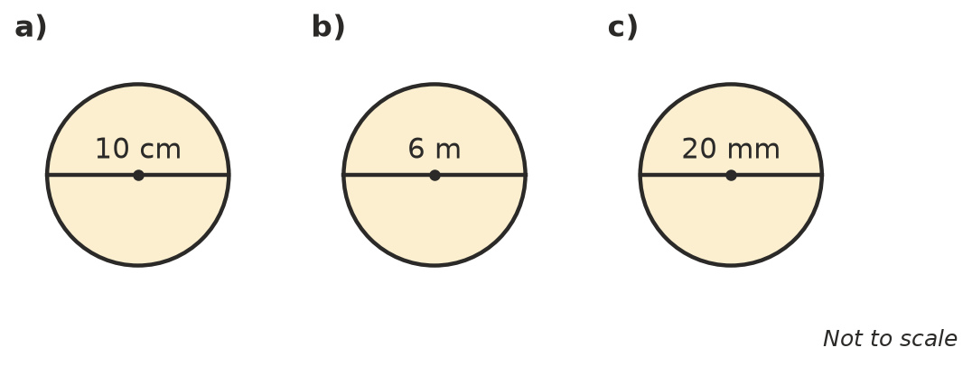

- Each circle shows its radius. Double the radius to find the diameter, then find the circumference. Use $π$ ≈ 3.14.
  - 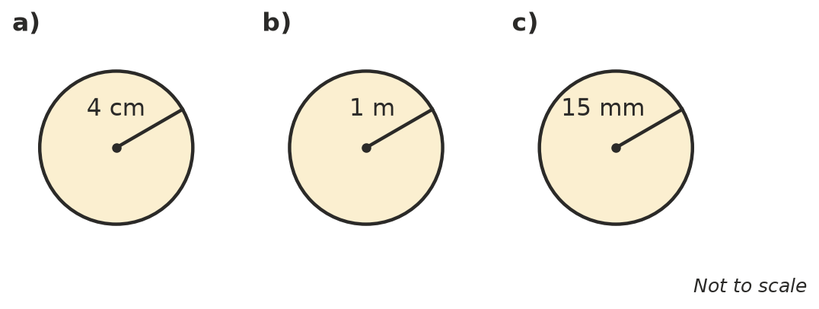

- Use the $π$ key on your calculator to find each circumference. Round to 1 decimal place.
  - diameter 9 cm
  - diameter 14 m
  - radius 8 cm

 Reasoning
- Kim found the circumference of a circle with a radius of 5 cm like this: 3.14 × 5 = 15.7 cm. Explain her mistake and find the correct circumference.
- The circumference of a circle is a bit more than 3 times its diameter. A circle has a diameter of 12 cm. Without a calculator, which is the best estimate of its circumference: 15 cm, 36 cm or 72 cm? Explain.

 Problem solving
- A bike wheel has a diameter of 60 cm. How far does the bike travel when the wheel turns around once? Use $π$ ≈ 3.14.
- A round table has a radius of 0.8 m. Lace is sewn around the edge of the tablecloth. How much lace is needed? Use the $π$ key and round to 1 decimal place.
- A circular garden bed has a diameter of 4 m. Edging is sold in whole metres.
  - Find the circumference of the bed. Use $π$ ≈ 3.14.
  - How many metres of edging must be bought?

