12.07 Area of composite shapes
Year 7 Maths · Worksheet · Level 2 · Core
Name: ____________________ Date: ______________
This worksheet practises finding the area of composite shapes by adding the areas of their parts, or by subtracting a part that has been cut out. The parts can be rectangles, triangles and parallelograms. Tip: before you calculate, find any missing side lengths and check that each part’s measurements belong to that part.

 Understanding
- This shape can be split into two rectangles, or seen as a big rectangle with a corner cut out.
- 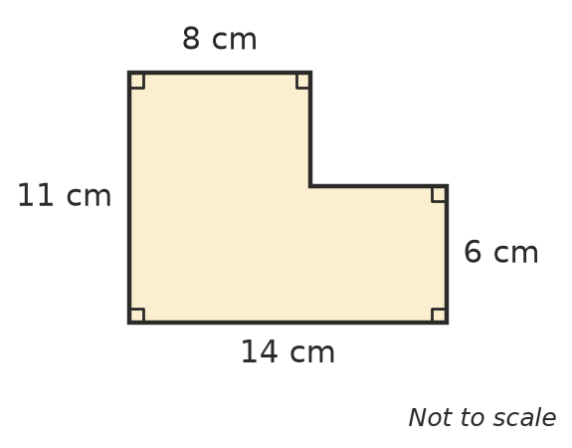
  - Find the two missing side lengths. ______________
  - Find the area by splitting the shape into two rectangles. ______________
  - Find the area by subtracting the missing corner from a 14 cm by 11 cm rectangle. ______________
- Describe one shape where it is easier to find the area by subtracting rather than adding. Explain why.

 Fluency
- Find the area of each shape. Find any missing sides first.
- 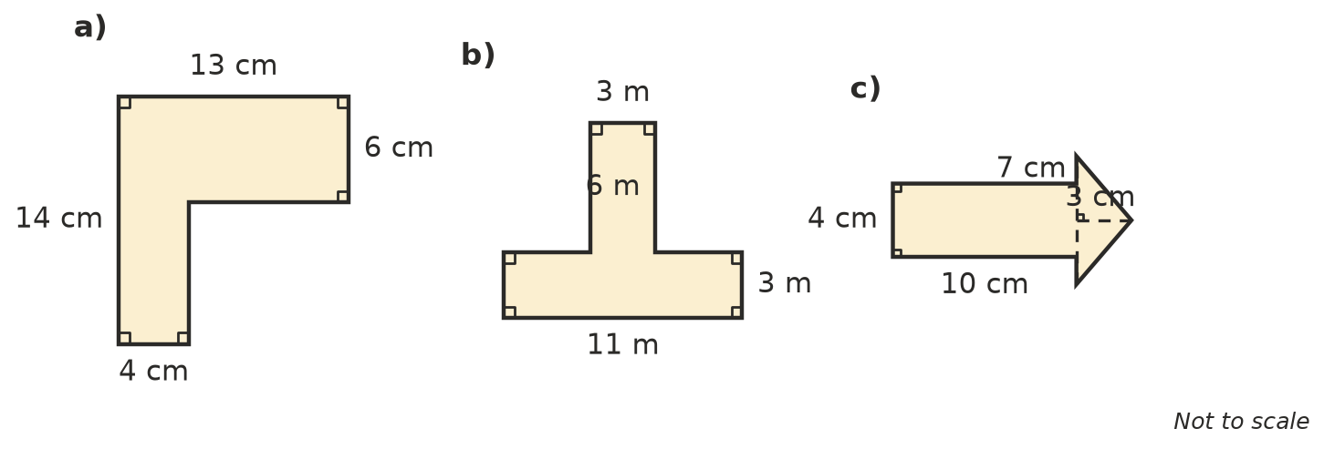
  - ______________
  - ______________
  - ______________
- Find the area of the shaded part of each shape.
- 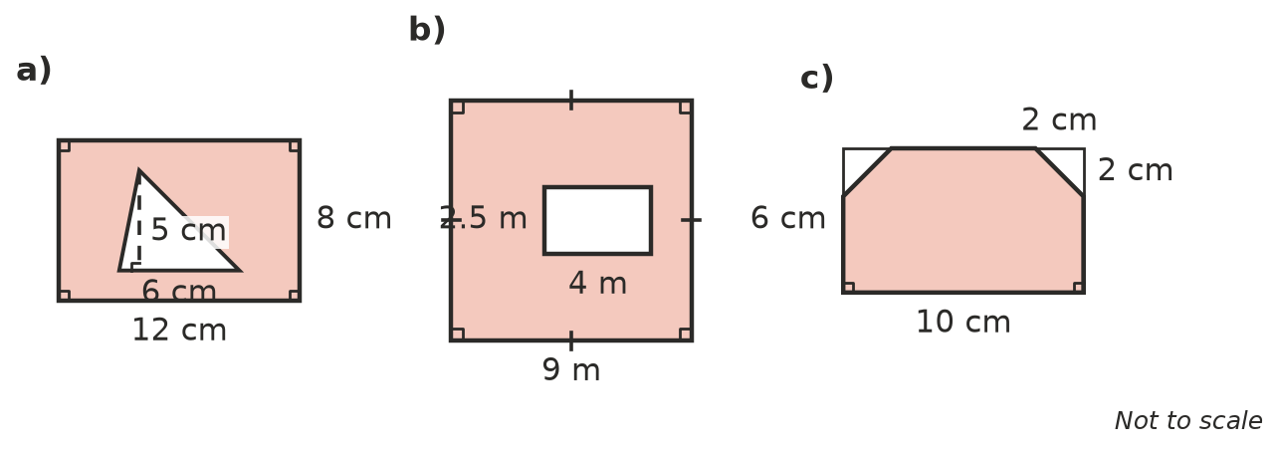
  - ______________
  - ______________
  - ______________
- The dashed line splits this shape into a rectangle and a triangle. Find its area.
- 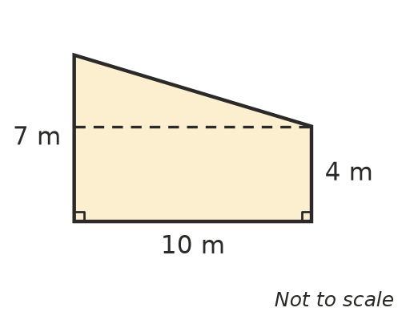
  - Area of the rectangle: ______________
  - Area of the triangle: ______________
  - Total area: ______________

 Reasoning
- Max found the area of the shape in Question 1 like this: “A 14 × 6 rectangle and an 8 × 11 rectangle: 84 + 88 = 172 cm².” Explain his mistake and how to fix it.

- Can two shapes have the same area but different perimeters? Give an example using shapes with an area of 12 cm².

 Problem solving
- This is the floor plan of a room. Carpet costs $45 per square metre.
- 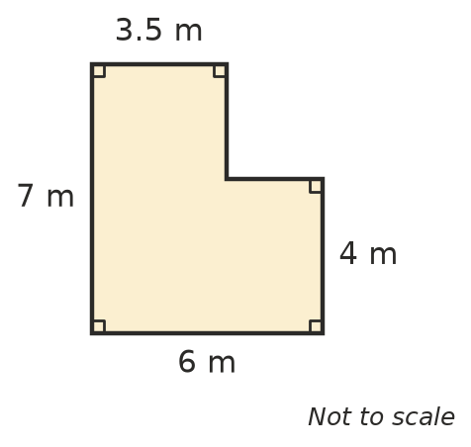
  - Find the area of the floor. ______________
  - How much will it cost to carpet the room? ______________
- A rectangular pool is 8 m long and 4 m wide. A path 1 m wide goes all the way around the pool. Find the area of the path. Show your working.

- The end wall of a house is a rectangle with a triangle on top. It has a window 1.5 m wide and 1.2 m high.
- 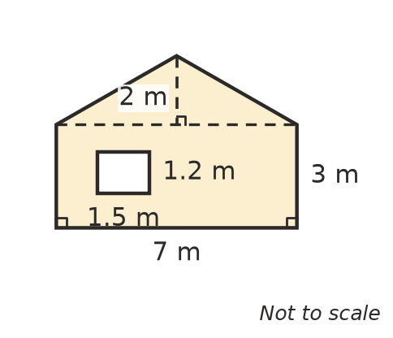
- Find the area of the wall that needs painting (leave out the window).

- A sign is shaped like the letter H. All its corners are right angles.
- 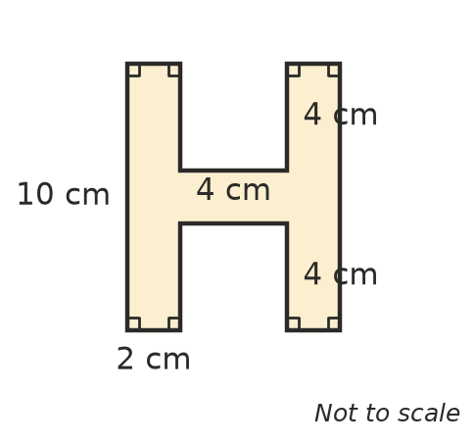
- Find its area. ______________
- A rectangular lawn is 12 m long and 8 m wide. In one corner there is a triangular flower bed with a base of 4 m and a height of 3 m. What area of lawn is left? Show your working.

- A right-angled triangle with shorter sides of 4 cm and 6 cm is cut off one corner of a square with sides of 10 cm. Find the area of the shape that is left.

