12.07 Area of composite shapes
Year 7 Maths · Worksheet · Level 1 · Warm-up
Name: ____________________ Date: ______________
A composite shape is made of simpler shapes such as rectangles and triangles. To find its area, split it into simple shapes, find the area of each one, then add them. If a piece has been cut out, find the area of the whole shape and subtract the piece. Tip: draw the dashed lines where you split the shape, and label the length of every side of each part.

 Understanding
- The dashed line splits this shape into two rectangles.
- 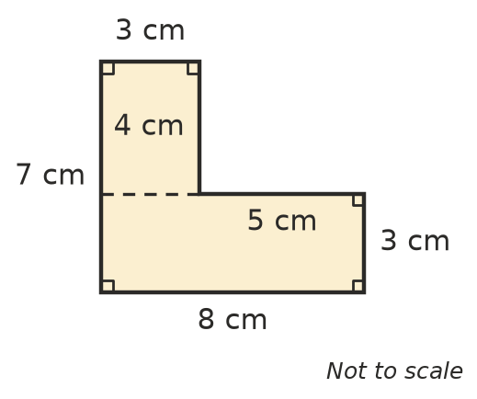
  - Find the area of the bottom rectangle. ______________
  - Find the area of the top rectangle. ______________
  - Find the total area. ______________
- Draw a line to split this shape into two rectangles.
- 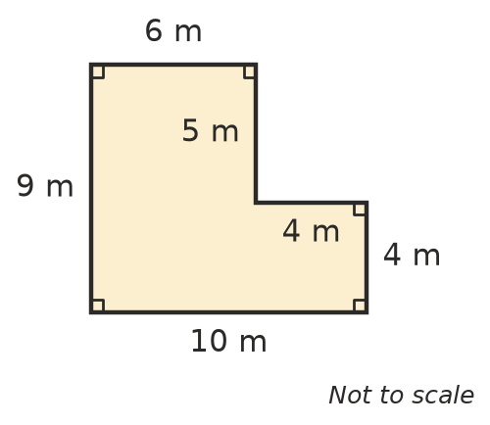
  - Find the area of the larger rectangle. ______________
  - Find the area of the smaller rectangle. ______________
  - Find the total area. ______________
- This shape is a rectangle with a triangle on top. Find its area.
- 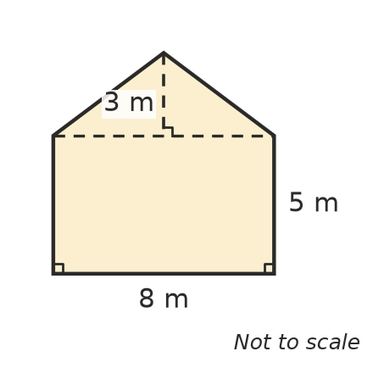
  - Area of the rectangle: ______________
  - Area of the triangle: ______________
  - Total area: ______________

 Fluency
- Find the area of each shape.
- 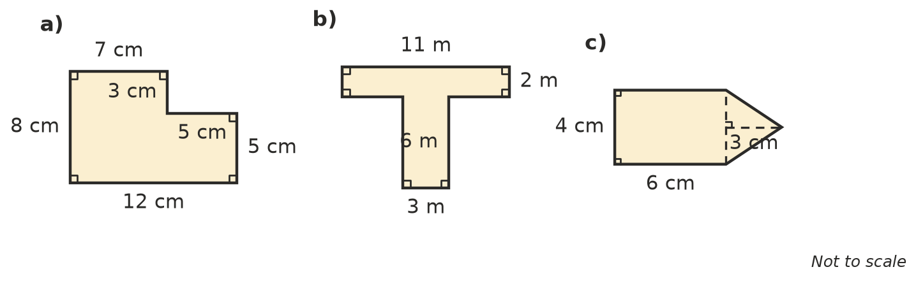
  - ______________
  - ______________
  - ______________
- A square hole has been cut out of a rectangle. Find the area of the shaded part.
- 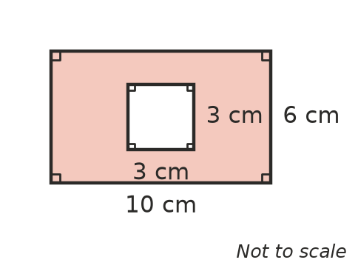
- Shaded area = ______________

 Reasoning
- The same shape has been split in two different ways.
- 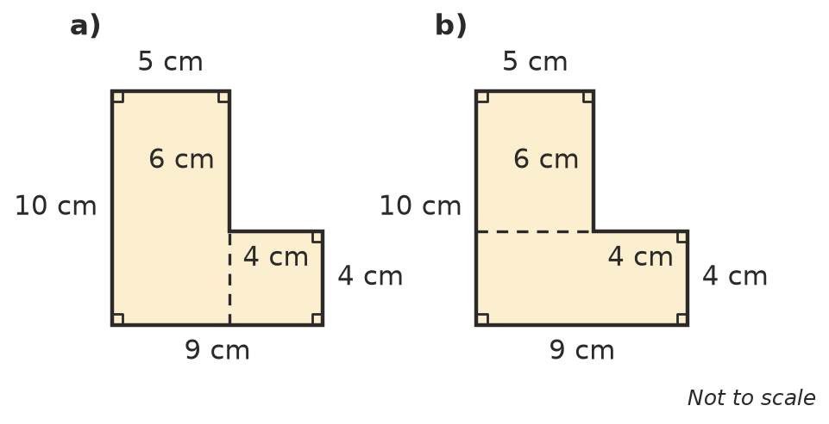
  - Find the area using the split in a). ______________
  - Find the area using the split in b). ______________
  - What do you notice? ______________
- Zoe says, “To find the area of a shape, add up the lengths of all its sides.” Explain why she is wrong.

 Problem solving
- Here is a plan of a lawn. New turf costs $9 per square metre.
- 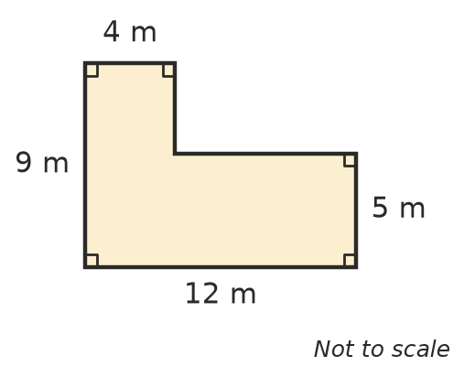
  - Find the area of the lawn. ______________
  - How much will the turf cost? ______________
- A photo 20 cm long and 15 cm wide is glued onto a card 25 cm long and 20 cm wide. What area of card is not covered by the photo? Show your working.

- A wall is 6 m long and 3 m high. It has a door 2 m high and 1 m wide. What area of the wall needs painting? Show your working.

- A rectangular garden is 10 m long and 6 m wide. It has a square pond with sides of 2 m. The rest of the garden is grass. What is the area of the grass?

