12.07 Area of composite shapes
Year 7 Maths · A5 question sheet · Level 3 · Challenge
This worksheet stretches your skills with harder composite shapes, shaded regions, decimals and multi-step problems. Tip: there is usually more than one way to split a shape. Choose the way with the fewest parts, and check your answer with a second method if you can.

 Understanding
- All the corners of this shape are right angles.
- 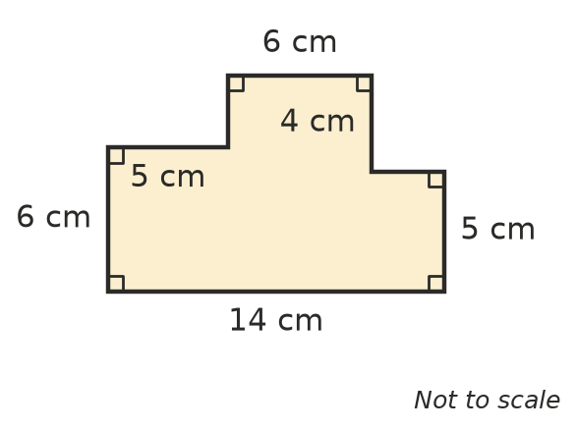
  - Find the two missing side lengths.
  - Find the area of the shape.
  - Check your answer by finding the area of the 14 cm by 9 cm rectangle around the shape and subtracting the two empty corners.

 Fluency
- Find the area of the shaded part of each shape. In a), the white strip is a road shaped like a parallelogram. In b), the corners of the shaded square are at the midpoints of the sides of the big square.
  - 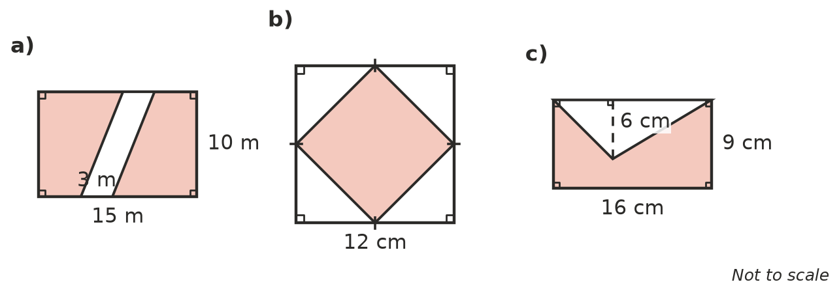

- Find the area of each shape.
  - 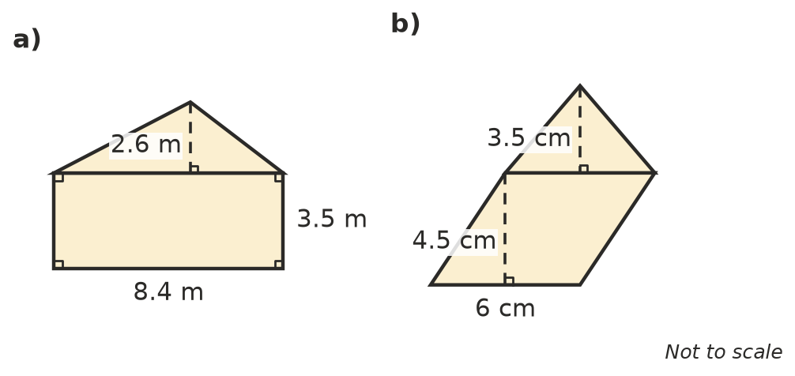

- A block of land is shaped like a trapezium. Its parallel sides are 20 m and 12 m long and it is 8 m deep (the perpendicular distance between the parallel sides). It is symmetrical, so it can be split into a rectangle and two identical right-angled triangles. Sketch it and find its area.

 Reasoning
- Explain why the shaded square in Question 2 b) is exactly half of the big square.
- A trapezium has parallel sides of 6 cm and 10 cm and a height of 4 cm. A diagonal cuts it into two triangles, one with base 6 cm and one with base 10 cm. Both triangles have a height of 4 cm.
  - Find the area of each triangle and the total area.
  - Show that the total is the same as $\frac{1}{2}$ × (6 + 10) × 4.

 Problem solving
- A rectangular paddock is 120 m long and 80 m wide. A straight road crosses it from one long side to the other. The road is shaped like a parallelogram that is 10 m wide when measured along the long sides.
  - Find the area of the road.
  - Find the area of the paddock that is left, in m² and in hectares.
- An L-shaped room is a 6 m by 5 m rectangle with a 2 m by 2 m square missing from one corner. It will be tiled with square tiles that have sides of 50 cm.
  - Find the area of the floor.
  - How many tiles cover the floor exactly?
  - The tiler orders 10% extra to allow for breakages. How many tiles should be ordered?
- A painting 40 cm long and 30 cm wide has a frame 5 cm wide all the way around it. Find the area of the frame. Show your working.
- A shape is made from a rectangle 10 cm long and 4 cm wide, with a square sitting on top at one end. The total area is 76 cm². How long are the sides of the square? Show your working.
- A garden shed has four walls. The two side walls are rectangles 3 m long and 2.4 m high. The two end walls are each a rectangle 2.5 m wide and 2.4 m high with a triangle on top that is 1 m high. One end wall has a door 2 m high and 0.8 m wide. Find the total area of wall that needs cladding (leave out the door).
- A letter T is made of two rectangles. The top bar is 12 cm long and 3 cm high. The stem below it is 4 cm wide. The whole letter has an area of 84 cm². How long is the stem? Show your working.

