12.06 Area of parallelograms
Year 7 Maths · Worksheet · Level 3 · Challenge
Name: ____________________ Date: ______________
This worksheet stretches your skills with parallelograms that have two different base and height pairs, mixed units, the number plane and multi-step problems. Tip: either pair of parallel sides can be the base. Use the height that is perpendicular to the base you chose.

 Understanding
- This parallelogram has sides of 12 cm and 8 cm. The black height (5 cm) is perpendicular to the 12 cm sides. The red height h is perpendicular to the 8 cm sides.
- 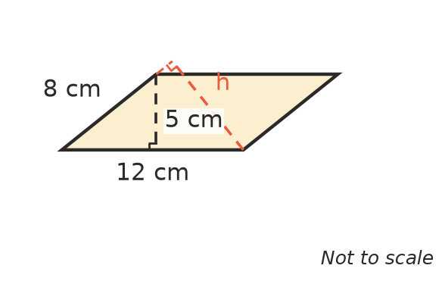
  - Find the area of the parallelogram. ______________
  - Use the area to find the red height h. ______________
- Some parallelograms lean so far that the height falls outside the shape. Explain why A = b × h still works for them. You may draw a diagram.

 Fluency
- Find the area of each parallelogram. Give the answer to b) in m² and the answer to c) in mm². Shape d) is a rhombus.
- 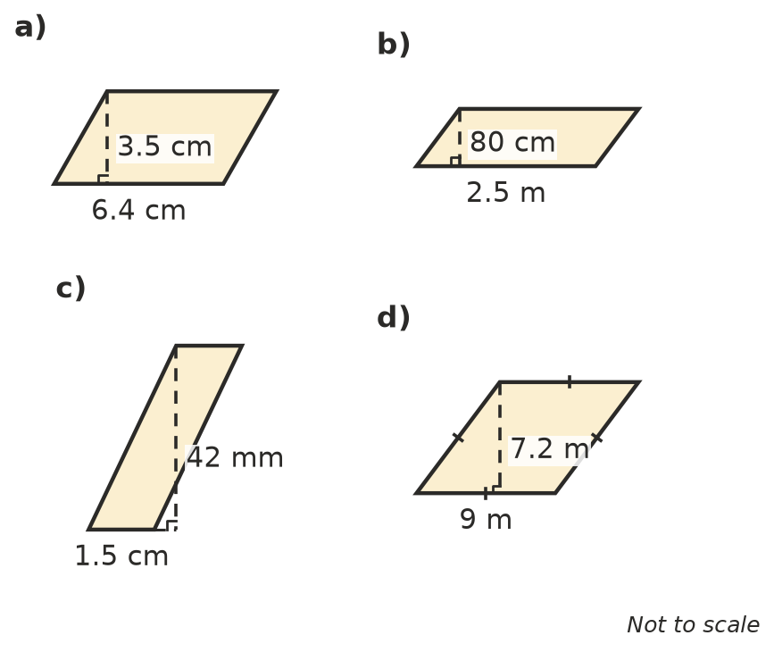
  - ______________
  - ______________
  - ______________
  - ______________
- Find the missing measurement.
  - area 4.2 m², height 1.5 m, base = ______________
  - area 1.5 m², base 60 cm, height in m = ______________
  - A parallelogram has sides of 12 cm and 16 cm and an area of 96 cm². Find the height to the 12 cm sides and the height to the 16 cm sides. ______________
- On a number plane, three corners of parallelogram ABCD are A(−2, −1), B(4, −1) and C(6, 3). Sketch it.
  - What are the coordinates of corner D? ______________
  - Find the area of the parallelogram (each unit is 1 cm). ______________

 Reasoning
- A shaded triangle is drawn inside a parallelogram. It has the same base as the parallelogram, and its top corner is on the top side.
- 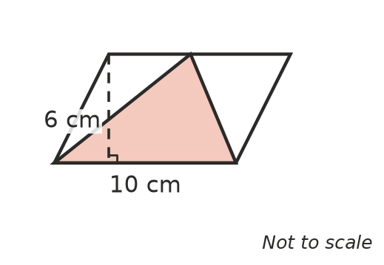
  - Find the area of the parallelogram and of the triangle. ______________
  - Explain why the triangle is always half of the parallelogram, wherever its top corner is on the top side.

- Ari says, “Every rhombus with sides of 10 cm has the same area.” Is he right? What is the largest possible area of a rhombus with sides of 10 cm? Explain.

- A rectangle 12 cm long and 8 cm wide is made from four sticks joined at the corners. It is pushed over into a parallelogram, keeping the same sticks. The height to the 12 cm side becomes 6 cm.
  - What is the area of the parallelogram? ______________
  - By how much has the area decreased? ______________
  - Has the perimeter changed? Explain. ______________

 Problem solving
- A courtyard shaped like a parallelogram has a base of 7.5 m and a height of 4.8 m. It will be covered with square pavers that have sides of 50 cm. About how many pavers are needed? Show your working.

- The base and height of a parallelogram are in the ratio 5 : 2. Its area is 160 cm². Find the base and the height.

- A paddock is shaped like a parallelogram with a base of 240 m and a height of 150 m.
  - Find its area in hectares (1 ha = 10 000 m²). ______________
  - Land sells for $8500 per hectare. What is the paddock worth? ______________
- A parallelogram and a triangle have the same area and the same height. The triangle’s base is 18 cm. What is the parallelogram’s base? Explain.

