12.06 Area of parallelograms
Year 7 Maths · Worksheet · Level 1 · Warm-up
Name: ____________________ Date: ______________
A parallelogram has two pairs of parallel sides. If you cut a triangle off one end and move it to the other end, it becomes a rectangle with the same base and height. So the area of a parallelogram is A = b × h. Tip: the height is the dashed line at right angles to the base, not the slanted side.

 Understanding
- A triangle is cut off the parallelogram and moved to the other end to make a rectangle. Each small square is 1 cm².
- 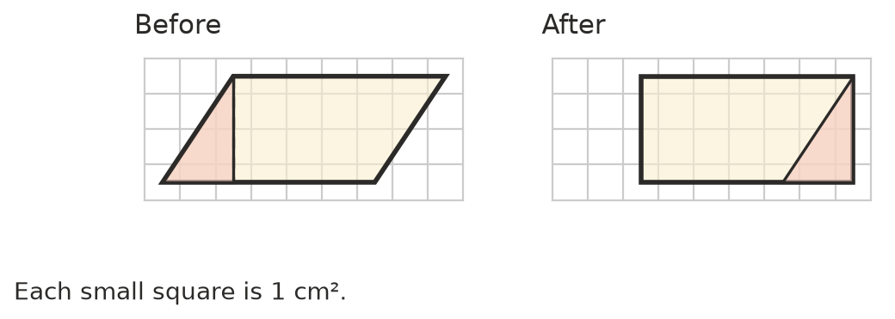
  - What are the length and width of the rectangle? ______________
  - What is the area of the rectangle? ______________
  - What is the area of the parallelogram? ______________
- Write the base and the perpendicular height of each parallelogram.
- 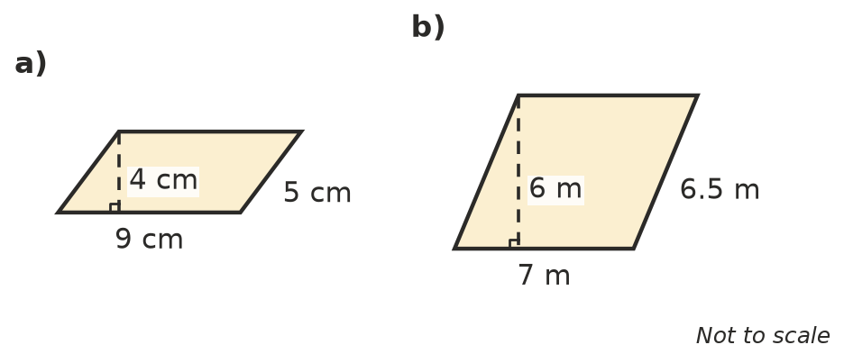
  - base = ______________ height = ______________
  - base = ______________ height = ______________
- Find the area of each parallelogram.
- 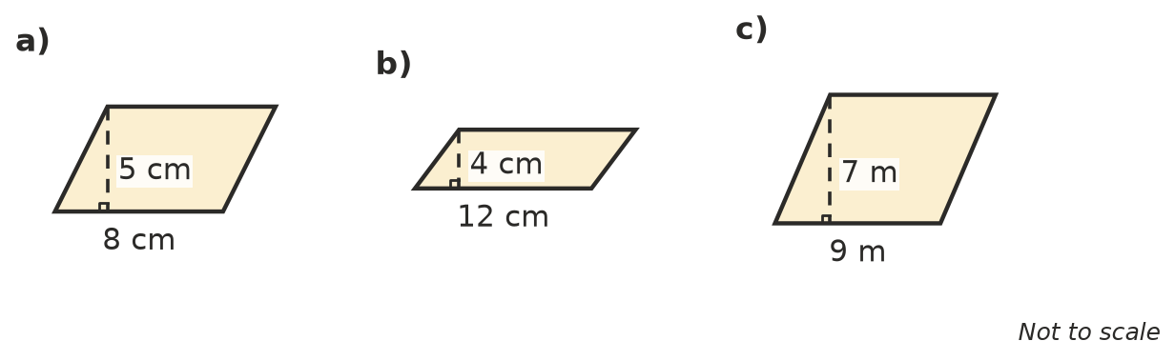
  - ______________
  - ______________
  - ______________

 Fluency
- Find the area of each parallelogram.
  - base 10 cm, height 6 cm ______________
  - base 15 cm, height 4 cm ______________
  - base 7 cm, height 11 cm ______________
  - base 25 m, height 12 m ______________
- The height of this parallelogram is outside the shape. Find its area.
- 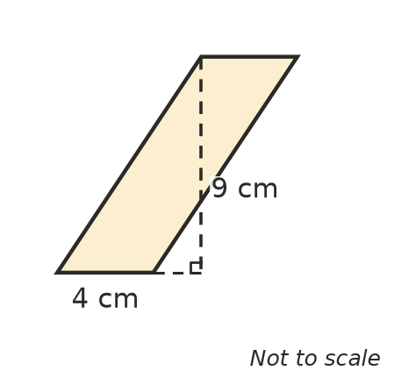
- Area = ______________

 Reasoning
- Explain why the area of a parallelogram is not the base × the slanted side.

- A rectangle is 6 cm long and 4 cm wide. A parallelogram has a base of 6 cm and a height of 4 cm. Compare their areas.

 Problem solving
- A garden bed is shaped like a parallelogram with a base of 5 m and a height of 3 m. Turf costs $10 per square metre. How much will it cost to turf the bed? Show your working.

- A parallelogram has an area of 48 cm² and a base of 8 cm. What is its height?

- A pattern is made from 20 tiles. Each tile is a parallelogram with a base of 10 cm and a height of 6 cm. What is the total area of the tiles? Show your working.

- A parallelogram and a triangle both have a base of 10 cm and a height of 6 cm. Find the area of each shape. What do you notice?

