12.06 Area of parallelograms
Year 7 Maths · A5 question sheet · Level 2 · Core
This worksheet practises finding the area of parallelograms with A = b × h, including parallelograms with the height outside the shape, mixed units and missing measurements. Tip: the base and the height are always at right angles to each other. A slanted side is never the height.

 Understanding
- Each small square is 1 cm².
- 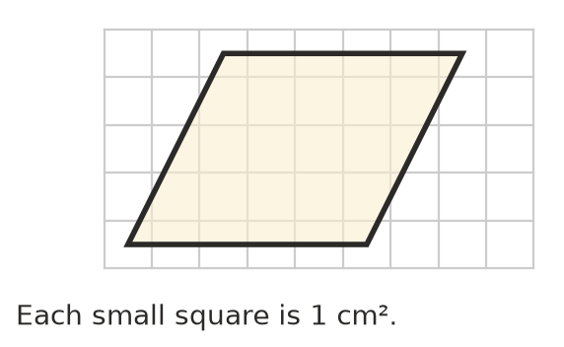
  - What is the base of the parallelogram?
  - What is its perpendicular height?
  - What is its area?
  - Describe how you could cut the parallelogram and rearrange it into a rectangle to check your answer.
- For each parallelogram, write the base and the height, then find the area.
- 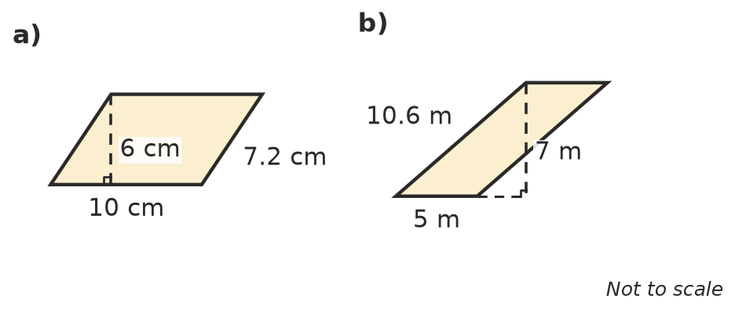
  - base = ______________ height = ______________ area =
  - base = ______________ height = ______________ area =

 Fluency
- Find the area of each parallelogram. Give the answer to c) in mm².
  - 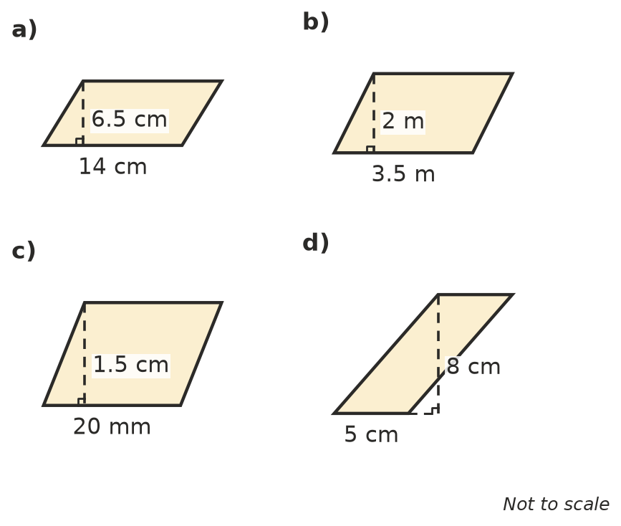

- Find the area of each parallelogram.
  - base 24 cm, height 15 cm
  - base 7.5 m, height 4 m
  - base 1.6 m, height 90 cm (answer in m²)
- Find the missing measurement.
  - area 56 cm², base 8 cm, height =
  - area 45 m², height 6 m, base =
  - area 3.6 m², base 1.2 m, height =

 Reasoning
- Shapes A, B and C all have a base of 5 cm and lie between the same two parallel lines, which are 3 cm apart.
- 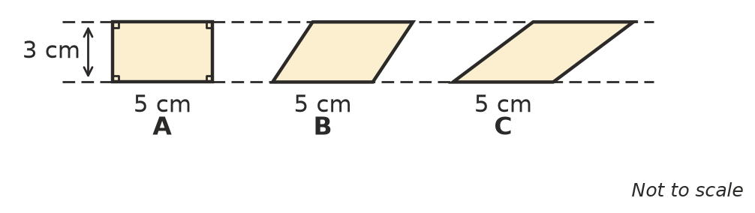
  - Find the area of each shape.
  - Explain why the answers are the same.
- Mila found the area of this parallelogram by working out 10 × 7 = 70 cm².
- 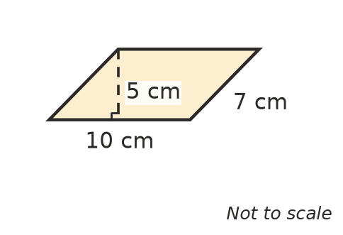
  - What mistake did she make?
  - What is the correct area?
- A square and a rhombus both have sides of 6 cm.
- 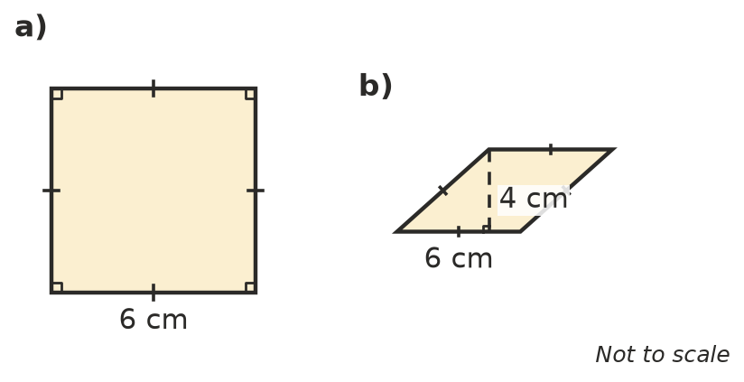
  - Find the area of each shape.
  - Explain why the rhombus has a smaller area, even though its sides are the same length.

 Problem solving
- A patio is shaped like a parallelogram with a base of 6 m and a height of 4 m. Paving costs $45 per square metre. What is the cost of paving the patio? Show your working.
- The base of a parallelogram is 3 times its height. Its area is 75 cm². Find the base and the height.
- A quilt has 12 patches shaped like parallelograms. Each patch has a base of 8 cm and a height of 5 cm. What is the total area of the patches?
- A parallelogram has its corners at (1, 1), (6, 1), (8, 4) and (3, 4) on a number plane, where each unit is 1 cm. Sketch it and find its area.
- Parallelogram A has a base of 9 cm and a height of 4 cm. Parallelogram B has a base of 6 cm and a height of 6 cm. Which one has the larger area? Show your working.

