12.05 Area of triangles
Year 7 Maths · Worksheet · Level 3 · Challenge
Name: ____________________ Date: ______________
This worksheet stretches your skills with triangles in any position, mixed units, missing measurements and triangles on a grid. Tip: any side of a triangle can be the base, as long as you use the height that is perpendicular to that side. When a triangle sits awkwardly on a grid, draw a rectangle around it and subtract the parts you don’t need.

 Understanding
- This triangle has two heights drawn: a black one (6 cm) to the 10 cm side and a red one (8 cm) to the 7.5 cm side.
- 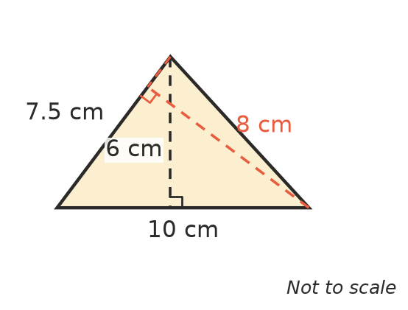
  - Find the area using the 10 cm side as the base. ______________
  - Find the area using the 7.5 cm side as the base. ______________
  - Explain why both answers are the same.

- Find the area of the shaded triangle. Hint: draw a rectangle around it and subtract the three right-angled triangles in the corners.
- 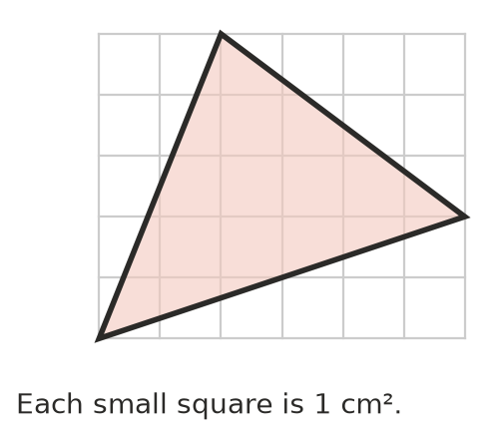

 Fluency
- Find the area of each triangle. Give the answer to c) in m² and the answer to d) in cm².
- 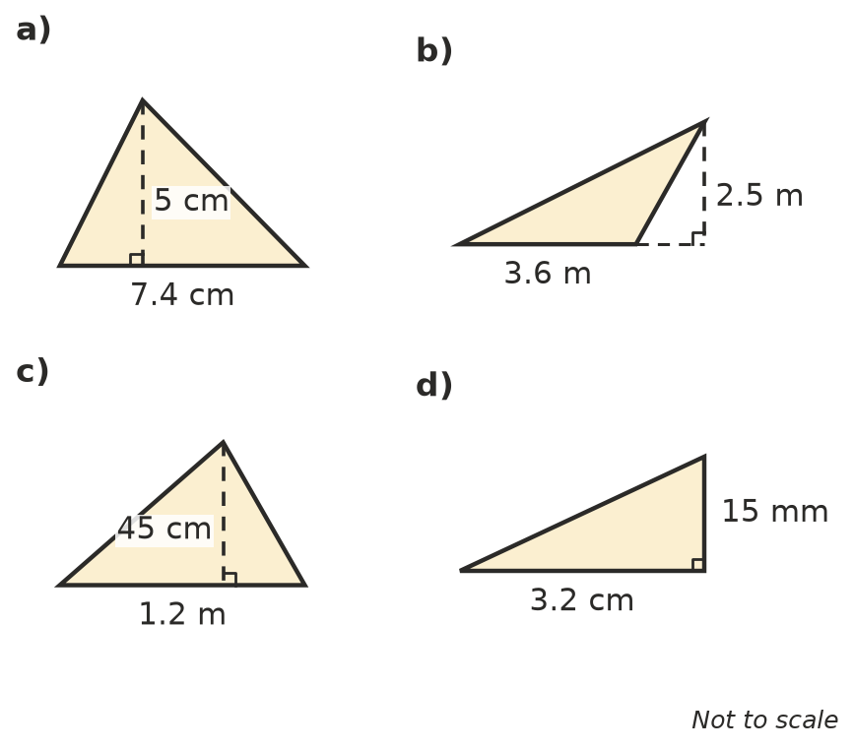
  - ______________
  - ______________
  - ______________
  - ______________
- Find the missing measurement.
  - area 4.5 m², base 3 m, height = ______________
  - area 60 cm², height 7.5 cm, base = ______________
  - area 1 m², base 80 cm, height in m = ______________
  - A right-angled triangle has two equal shorter sides and an area of 32 cm². How long are the equal sides? ______________
- This right-angled triangle has sides of 9 cm, 12 cm and 15 cm.
- 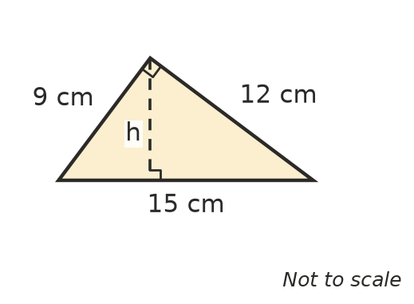
  - Find its area using the two shorter sides. ______________
  - Use your answer to find the height h to the 15 cm side. ______________

 Reasoning
- The base of a triangle is doubled and its height is halved. What happens to its area? Explain, using an example.

- A triangle has sides of 5 cm, 5 cm and 6 cm. Ella says its area is $\frac{1}{2}$ × 6 × 5 = 15 cm².
  - Explain why Ella is wrong. ______________
  - The perpendicular height to the 6 cm side is 4 cm. Find the correct area. ______________
- A kite is made of two triangles. Its diagonals are 60 cm and 40 cm long and cross at right angles.
- 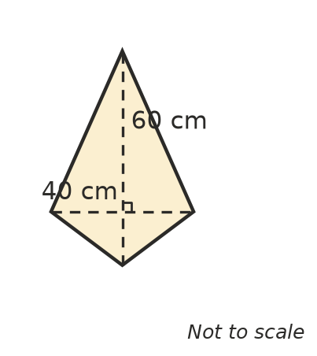
- Find the area of the kite. Hint: split it along the 60 cm diagonal into two triangles.

 Problem solving
- A triangular paddock has a base of 240 m and a perpendicular height of 150 m.
  - Find its area in m². ______________
  - A hectare is 10 000 m². How many hectares is the paddock? ______________
  - The paddock sells for $9000 per hectare. What is it worth? ______________
- The base and height of a triangle are in the ratio 3 : 4. Its area is 54 cm². Find the base and the height. Show your working.

- A triangle has its corners at the points (1, 1), (7, 1) and (4, 6) on a number plane, where each unit is 1 cm. Sketch it and find its area.

- A square has sides of 10 cm. A triangle is drawn by joining one corner of the square to the midpoints of the two sides that do not touch that corner. Find the area of the triangle. Show your working.

