12.05 Area of triangles
Year 7 Maths · Worksheet · Level 2 · Core
Name: ____________________ Date: ______________
This worksheet practises finding the area of any triangle with $A=\frac{1}{2}×b×h$, including triangles where the height is outside the shape, and working backwards to find a missing base or height. Tip: the base and the height must be at right angles to each other. Ignore any slanted side that isn’t the base.

 Understanding
- For each triangle, write the base and the perpendicular height, then find the area.
- 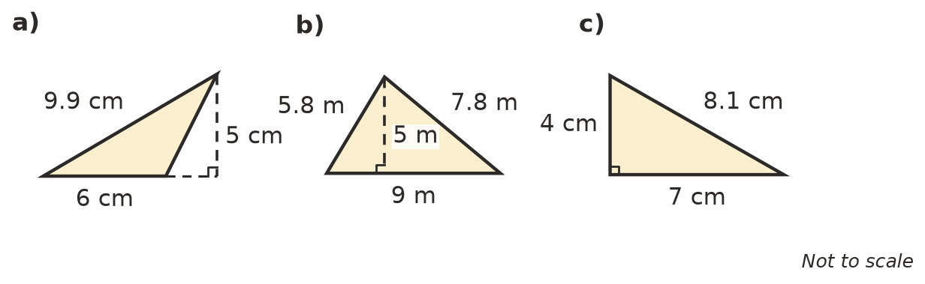
  - base = ______________ height = ______________ area = ______________
  - base = ______________ height = ______________ area = ______________
  - base = ______________ height = ______________ area = ______________
- The shaded triangle is drawn inside a dashed rectangle. The dashed line from the top corner of the triangle splits the rectangle into two smaller rectangles.
- 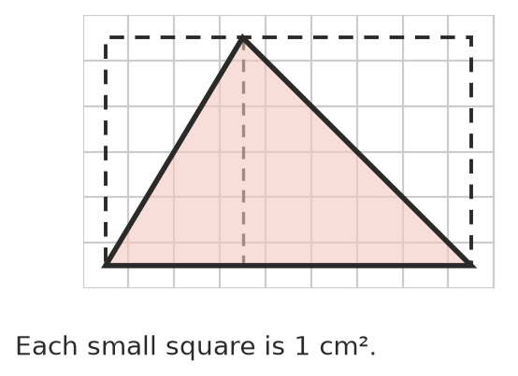
  - What is the area of the large rectangle? ______________
  - Explain why the triangle covers exactly half of the large rectangle. Then give the area of the triangle.

 Fluency
- Find the area of each triangle.
- 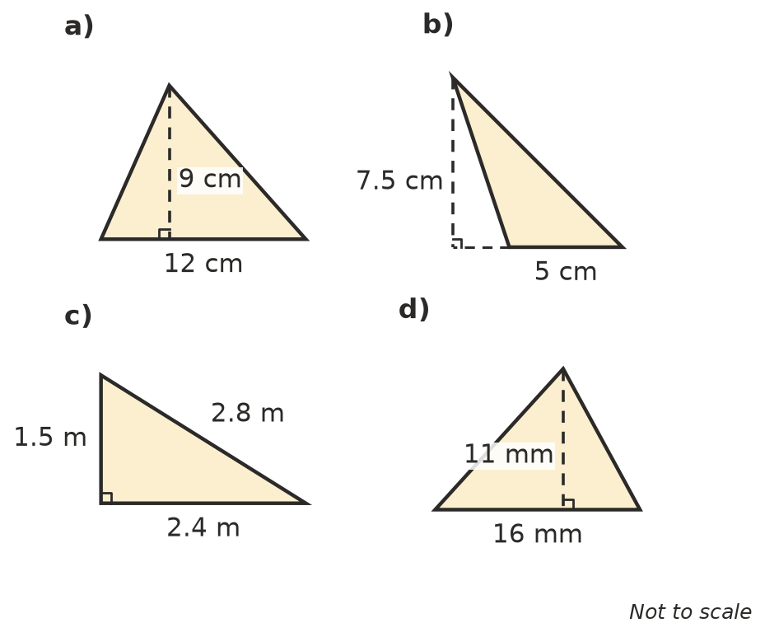
  - ______________
  - ______________
  - ______________
  - ______________
- Find the area of each triangle.
  - base 13 cm, height 6 cm ______________
  - base 4.5 m, height 8 m ______________
  - base 25 cm, height 1.2 m (answer in cm²) ______________
  - base 7 km, height 7 km ______________
- Find the missing measurement.
  - area 40 cm², base 10 cm, height = ______________
  - area 27 m², height 6 m, base = ______________
  - area 15 cm², base 12 cm, height = ______________

 Reasoning
- Triangles A, B and C all have a base of 6 cm and lie between the same two parallel lines, which are 4 cm apart.
- 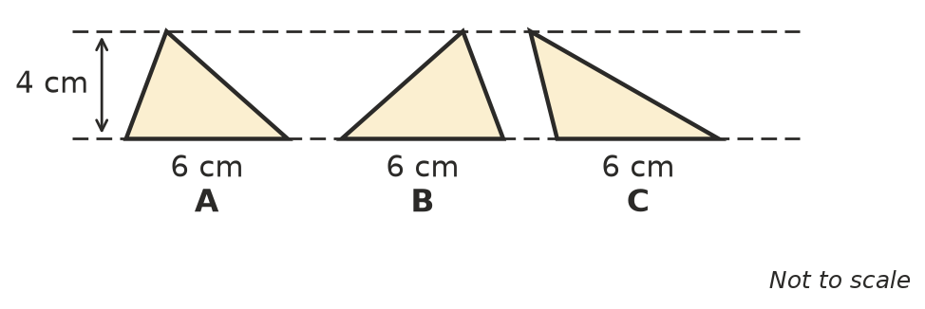
  - Find the area of each triangle. ______________
  - Explain your answer to a).

- Two students made mistakes finding these areas.
- 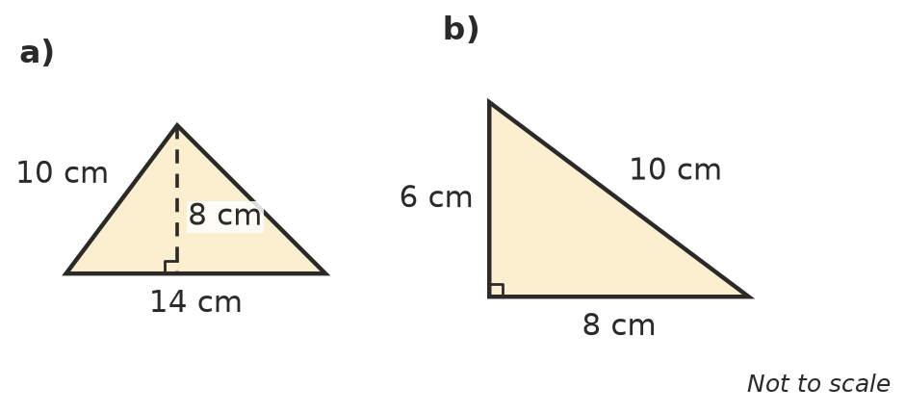
  - For triangle a), Sam worked out 14 × 10 ÷ 2 = 70 cm². Explain his mistake and find the correct area.

  - For triangle b), Kim worked out 6 × 8 × 10 ÷ 2 = 240 cm². Explain her mistake and find the correct area.

 Problem solving
- A triangular block of land has a base of 40 m and a perpendicular height of 25 m. Land in the area sells for $150 per square metre. What is the block worth? Show your working.

- A triangular road sign has a base of 90 cm and a height of 78 cm. Both sides of the sign are covered with reflective film. How much film is needed? Show your working.

- The base of a triangle is twice its height. Its area is 25 cm². Find the base and the height.

- A shaded triangle is drawn inside a rectangle. Its top corner is at the midpoint of the top side.
- 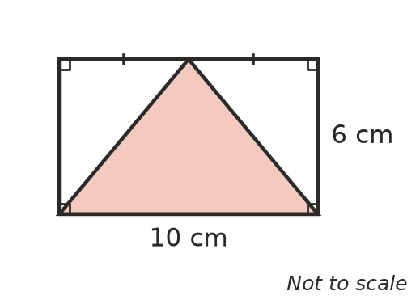
  - Find the area of the shaded triangle. ______________
  - What fraction of the rectangle is shaded? ______________
- The two triangular gable ends of a shed roof each have a base of 8 m and a height of 3 m. Find their total area.

