12.05 Area of triangles
Year 7 Maths · A5 question sheet · Level 1 · Warm-up
This worksheet practises finding the area of a triangle. Every triangle is half of a rectangle or parallelogram, so its area is $A=\frac{1}{2}×b×h$, where b is the base and h is the perpendicular height. Tip: the height is the dashed line that meets the base at a right angle (look for the small square). It is not a slanted side.

 Understanding
- The shaded triangle is drawn inside a dashed rectangle. Each small square is 1 cm².
- 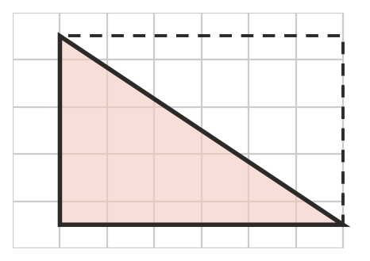
  - What is the area of the rectangle?
  - What is the area of the shaded triangle?
  - Explain how you found the area of the triangle.
- Write the base and the perpendicular height of each triangle.
- 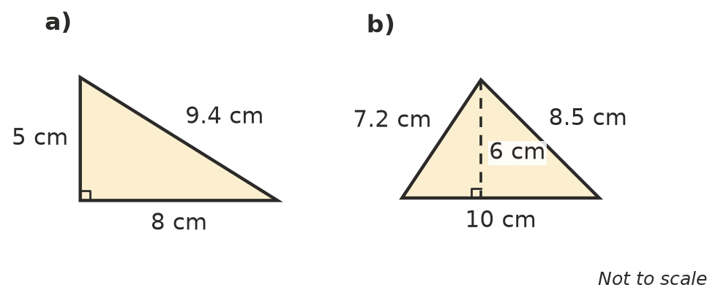
  - base = ______________ height =
  - base = ______________ height =
- Find the area of each triangle using $A=\frac{1}{2}×b×h$.
  - 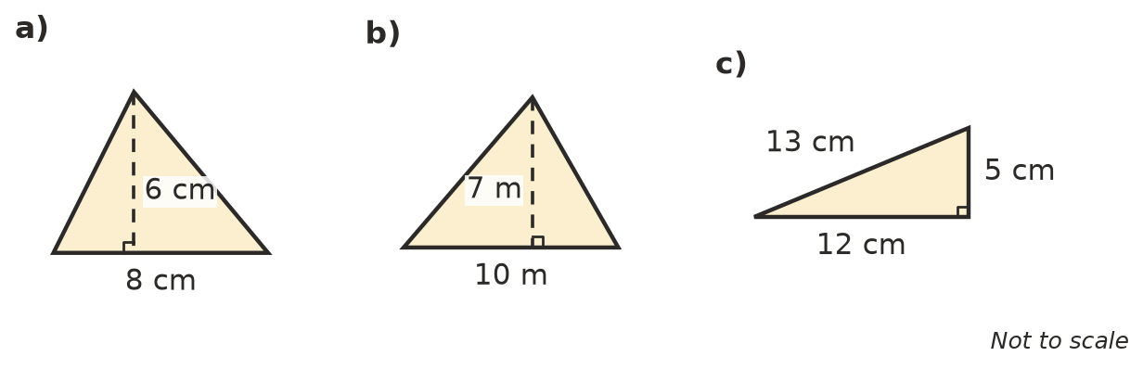

 Fluency
- Find the area of each triangle.
  - base 6 cm, height 4 cm
  - base 14 cm, height 10 cm
  - base 9 cm, height 8 cm
  - base 20 m, height 15 m
- In these triangles the height is outside the triangle. You still multiply the base by the height and halve it. Find each area.
  - 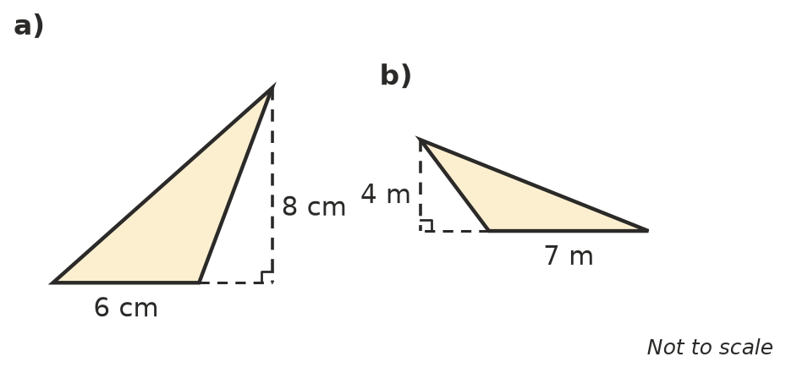

 Reasoning
- Explain why the rule for the area of a triangle has a $\frac{1}{2}$ in it. You may draw a diagram.
- Leo found the area of this triangle by working out 12 × 10 ÷ 2 = 60 cm².
- 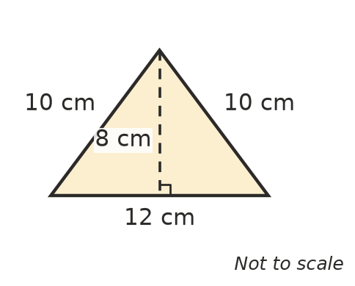
  - What mistake did Leo make?
  - What is the correct area?

 Problem solving
- A triangular sail has a base of 3 m and a height of 5 m. What is the area of the sail? Show your working.
- A triangular garden bed has a base of 6 m and a height of 4 m. One bag of mulch covers 3 m². How many bags are needed? Show your working.
- A string of bunting has 10 triangular flags. Each flag has a base of 20 cm and a height of 30 cm. What is the total area of the flags? Show your working.
- A triangle has an area of 20 cm² and a base of 8 cm. What is its height? Hint: base × height must be 40.

