12.04 Area of rectangles and squares
Year 7 Maths · Worksheet · Level 3 · Challenge
Name: ____________________ Date: ______________
This worksheet stretches your skills with converting between area units, decimal lengths, missing sides and multi-step problems. Tip: a square 1 cm long and 1 cm wide is also 10 mm long and 10 mm wide, so 1 cm² = 10 × 10 = 100 mm². Area conversions multiply twice.

 Understanding
- The large square has sides of 1 cm. It is divided into small squares with sides of 1 mm.
- 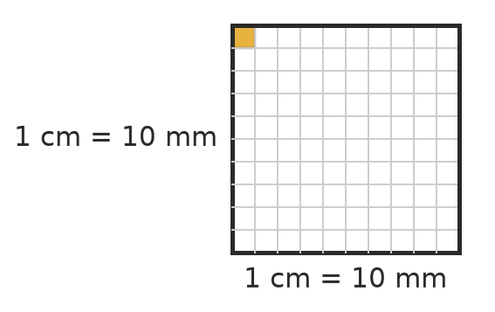
  - How many mm² are in 1 cm²? ______________
  - How many cm² are in 1 m²? Hint: 1 m = 100 cm. ______________
  - Explain why 1 m² is not equal to 100 cm².

 Fluency
- Convert each area.
  - 5 cm² = ______________ mm²
  - 3 m² = ______________ cm²
  - 45 000 cm² = ______________ m²
  - 2 km² = ______________ m²
- Find the area of each shape. Give the answer to c) in m² and the answer to d) in km².
- 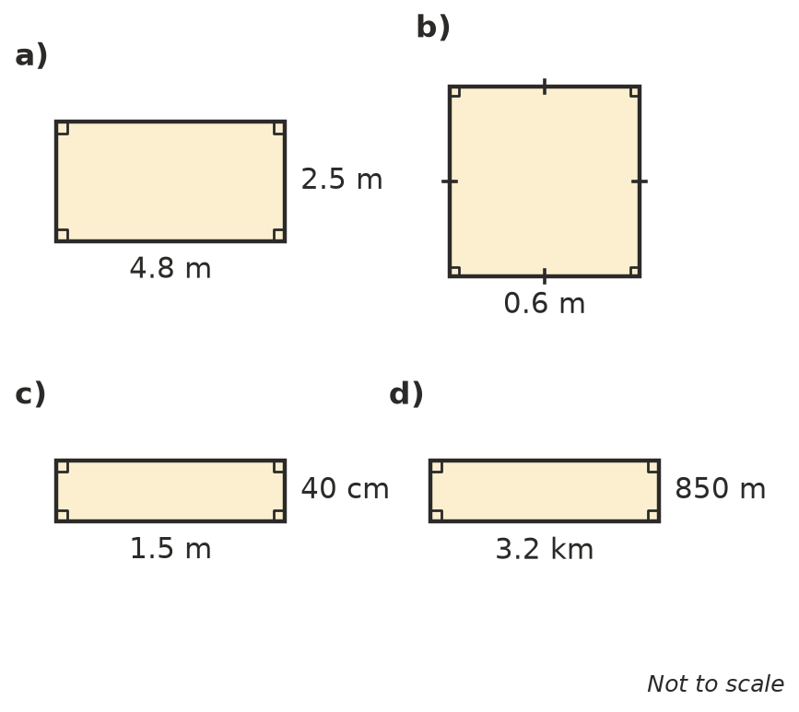
  - ______________
  - ______________
  - ______________
  - ______________
- Find the missing side length.
  - A rectangle has an area of 13.5 m² and a width of 3 m. Length: ______________
  - A square has an area of 2.25 m². Side length: ______________
  - A rectangle has an area of 1 m² and a length of 125 cm. Width in cm: ______________
  - A square has an area of 0.81 cm². Side length in mm: ______________

 Reasoning
- A square has sides of 2 cm. A second square has sides 3 times as long. How many times bigger is the area of the second square? Explain why.

- Complete the table for rectangles with whole-number sides and a perimeter of 20 cm.
Length (cm) | Width (cm) | Area (cm²)
9 | 1
8
7
6
5

  - Which rectangle has the largest area? ______________
  - What do you notice about the shape of that rectangle? ______________
- Ben says, “A rectangle 2 m long and 50 cm wide has an area of 2 × 50 = 100 m².” Explain his mistake and give the correct area in m² and in cm².

 Problem solving
- A soccer pitch is 105 m long and 68 m wide.
  - Find its area. ______________
  - A hectare (ha) is 10 000 m². Is the pitch bigger or smaller than 1 hectare? By how many square metres? ______________
- A kitchen floor is 4.2 m long and 3.6 m wide. It will be covered with square tiles that have sides of 30 cm.
  - How many tiles are needed? ______________
  - Tiles come in boxes of 10. How many boxes must be bought? ______________
  - Each box costs $42. What is the total cost? ______________
- A rectangle has a perimeter of 34 cm and an area of 60 cm². Its sides are whole numbers of centimetres. Find its length and width.

- A square has an area of 196 cm². It is cut into 4 identical rectangular strips. Find the perimeter of one strip. Show your working.

- The four walls of a room are 2.7 m high. Two walls are 5 m long and two walls are 4 m long. There is a door 2 m high and 0.9 m wide, and a window 1.5 m wide and 1.2 m high.
  - Find the area of wall that needs painting (leave out the door and window). ______________
  - The walls need two coats. One litre of paint covers 15 m². How many litres are needed? ______________
- A rectangle has an area of 48 cm². Its length is tripled and its width is halved. What is the area of the new rectangle? Explain.

