12.04 Area of rectangles and squares
Year 7 Maths · Worksheet · Level 2 · Core
Name: ____________________ Date: ______________
This worksheet practises finding the area of rectangles and squares with the rule A = l × w, working backwards to find a missing side, and solving real problems. Tip: both sides must be in the same unit before you multiply. Area units are square units: mm², cm², m² or km².

 Understanding
- Find the area of each shape. In b), two half squares make one whole square.
- 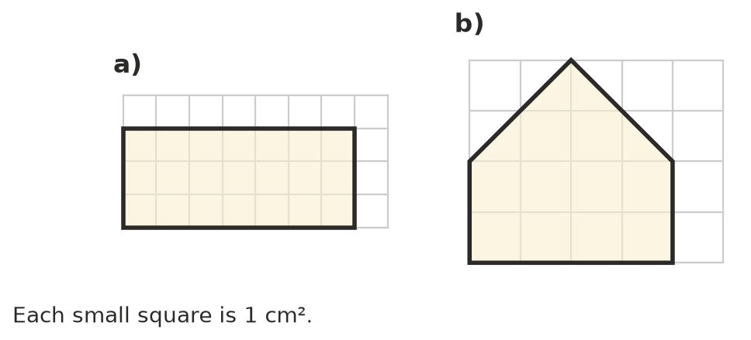
  - ______________ cm²
  - ______________ cm²
- A rectangle is 5 cm long and 3 cm wide. Explain why its area is 5 × 3 = 15 cm². You may draw a diagram.

 Fluency
- Find the area of each shape. Give the answer to c) in cm².
- 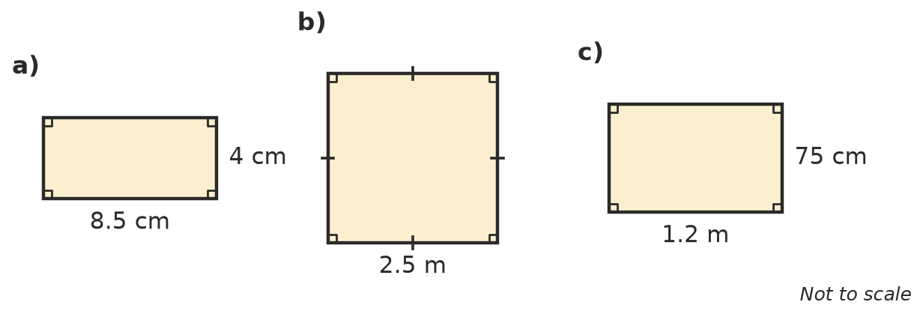
  - ______________
  - ______________
  - ______________
- Find the area.
  - a rectangle 16 cm long and 9 cm wide ______________
  - a square with sides of 13 m ______________
  - a rectangle 3.5 km long and 2 km wide ______________
  - a rectangle 250 mm long and 40 mm wide ______________
- Find the missing side length.
  - A rectangle has an area of 72 cm² and a width of 8 cm. Length: ______________
  - A square has an area of 64 m². Side length: ______________
  - A rectangle has an area of 45 m² and a length of 7.5 m. Width: ______________
  - A square has an area of 1.44 cm². Side length: ______________
- Circle the best estimate for each area.
  - the screen of a mobile phone: 90 mm² or 90 cm² or 90 m²
  - a tennis court: 260 cm² or 260 m² or 260 km²
  - the island of Tasmania: 68 000 m² or 68 000 km²

 Reasoning
- A rectangle is 5 cm long and 3 cm wide. A second rectangle is 10 cm long and 6 cm wide. How many times bigger is the area of the second rectangle? Show your working.

- Complete the table to show every rectangle with whole-number sides (in cm) and an area of 36 cm². Then circle the one with the smallest perimeter.
Length (cm) | Width (cm) | Perimeter (cm)
36 | 1

- Jo says, “A rectangle 4 cm long and 30 mm wide has an area of 4 × 30 = 120 cm².” Explain her mistake and give the correct area.

 Problem solving
- A wall is 4.5 m long and 2.4 m high. It needs two coats of paint. One tin of paint covers 8 m². How many tins are needed? Show your working.

- Turf costs $12.50 per square metre. How much does it cost to turf a lawn 9 m long and 6 m wide?

- A rectangle 16 cm long and 4 cm wide has the same area as a square. How long are the sides of the square?

- A rectangular floor is 3 m long and 2.4 m wide. It is covered with square tiles that have sides of 20 cm. How many tiles are needed? Show your working.

