12.04 Area of rectangles and squares
Year 7 Maths · A5 question sheet · Level 1 · Warm-up
Area is the amount of flat space a shape covers. It is measured in square units, such as square centimetres (cm²) and square metres (m²). This worksheet practises finding the area of rectangles and squares. Tip: area of a rectangle = length × width. A square has equal sides, so its area is side × side.

 Understanding
- Find the area of each shape by counting the squares.
- 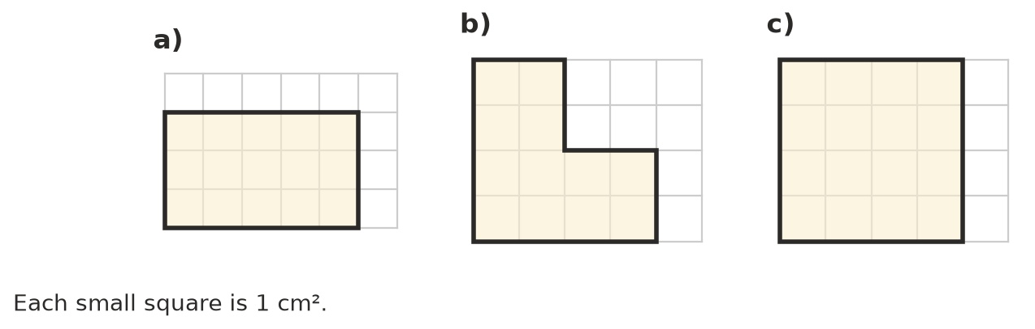
  - ______________ cm²
  - ______________ cm²
  - ______________ cm²
- Complete each sentence.
  - The area of a rectangle = length ×
  - If the sides are measured in metres, the area is measured in
- Find the area of each shape. Remember to write the units.
  - 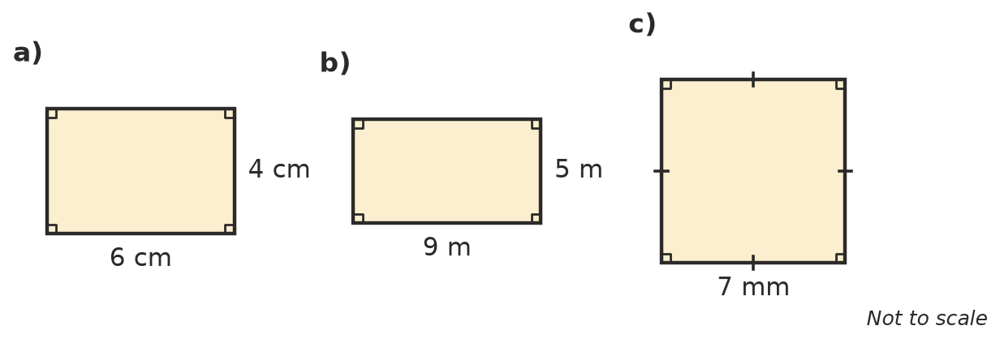

 Fluency
- Find the area of each rectangle.
  - length 12 cm, width 3 cm
  - length 20 m, width 8 m
  - length 15 mm, width 6 mm
- Find the area of each square.
  - side 5 cm
  - side 9 m
  - side 10 km
- Which unit would you use to measure the area of each of these: mm², cm², m² or km²?
  - a postage stamp
  - a classroom floor
  - Kangaroo Island
  - a page of a book

 Reasoning
- A rectangle is 6 cm long and 2 cm wide. A square has sides of 4 cm.
  - Find the perimeter of each shape.
  - Find the area of each shape.
  - Do shapes with the same perimeter always have the same area?
- A rectangle has an area of 24 cm² and a length of 6 cm. What is its width? Explain how you know.

 Problem solving
- New carpet costs $30 per square metre. How much will it cost to carpet a bedroom floor that is 5 m long and 4 m wide? Show your working.
- A garden bed is 8 m long and 3 m wide. One bag of mulch covers 2 m². How many bags of mulch are needed to cover the whole bed? Show your working.
- Square tiles have sides of 10 cm. How many tiles are needed to cover a rectangle 1 m long and 50 cm wide? Hint: how many tiles fit along each side?

