12.03 Perimeter of composite shapes
Year 7 Maths · Worksheet · Level 2 · Core
Name: ____________________ Date: ______________
This worksheet practises finding missing sides and perimeters of composite shapes, including shapes with triangles, mixed units and real plans. Tip: before you add, find every missing side, and tick each side as you add it so you don’t miss one or count one twice.

 Understanding
- Two sides of this shape are missing.
- 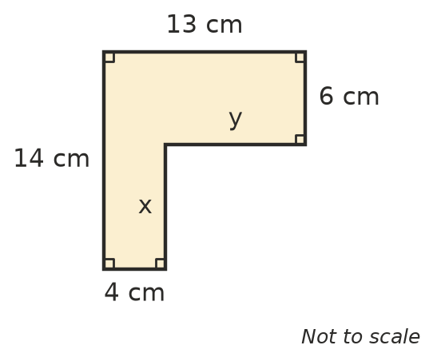
  - x = ______________
  - y = ______________
  - Perimeter = ______________
- A rectangle 10 cm long and 4 cm wide is joined to a square with sides of 4 cm, so that the square’s side touches the rectangle’s 4 cm side.
  - Find the perimeter of the rectangle and of the square before they are joined. ______________
  - Find the perimeter of the new shape. ______________
  - Explain why the answer to b) is not the two perimeters added together.

 Fluency
- Find the missing sides, then find the perimeter of each shape.
- 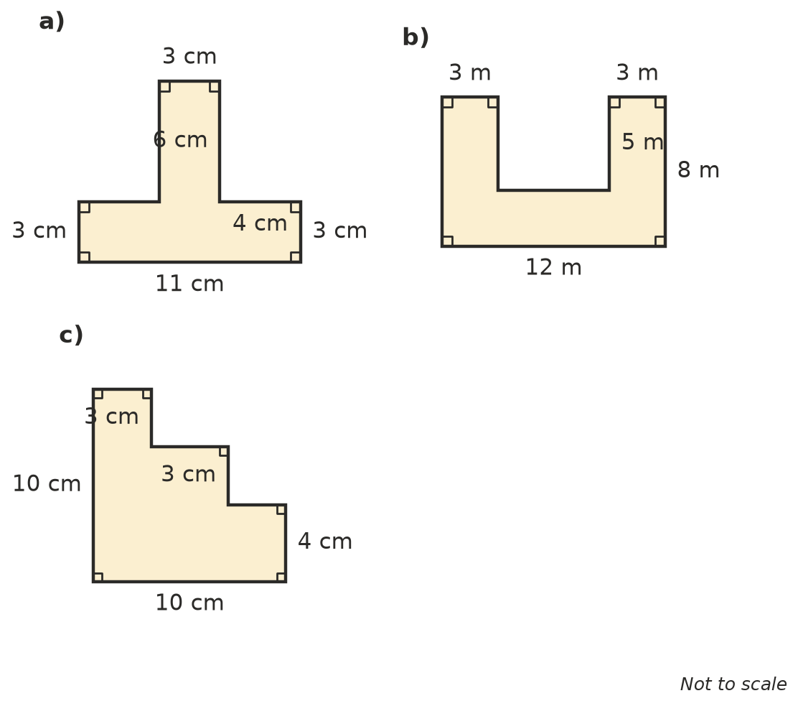
  - ______________
  - ______________
  - ______________
- Find the perimeter of each shape. Sides that meet at a corner with a small square are at right angles.
- 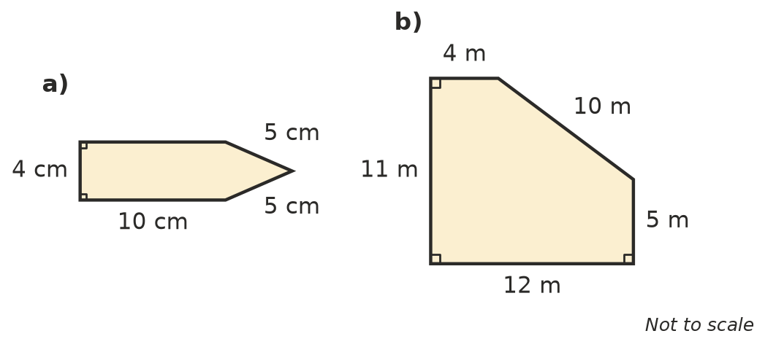
  - ______________
  - ______________
- Find the perimeter of this shape in metres.
- 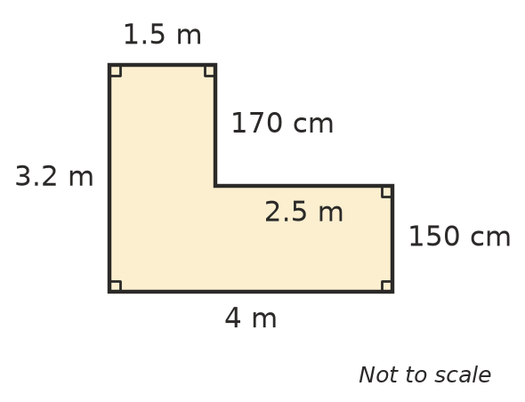
- Perimeter = ______________

 Reasoning
- Jesse says, “I can find the perimeter of this shape without finding any of the missing sides.”
- 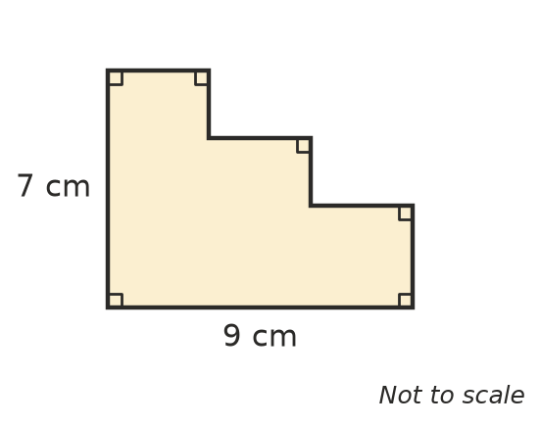
  - Explain how Jesse could do this.

  - Find the perimeter. ______________
- A notch has been cut out of the top of a rectangle.
- 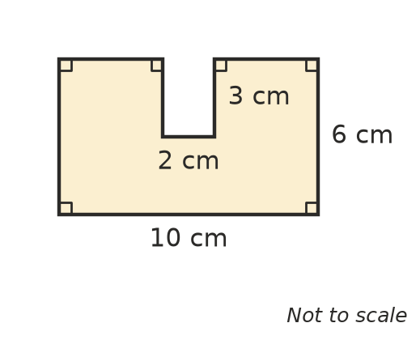
  - Find the perimeter of the shape. ______________
  - The rectangle before the notch was cut had a perimeter of 32 cm. Explain why cutting out the notch made the perimeter bigger.

- Five identical squares are joined to make a plus sign (+). The perimeter of the plus sign is 60 cm. How long is each side of one square? Show your working.

 Problem solving
- A fence is going around the outside of this garden.
- 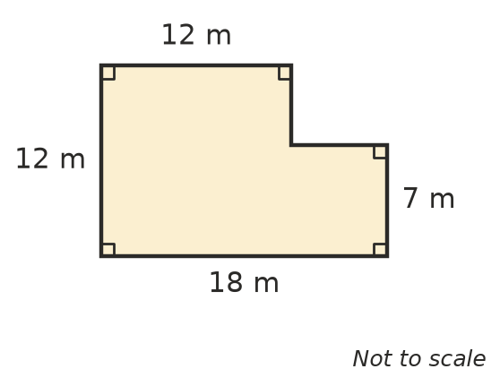
  - How many metres of fencing are needed? ______________
  - Fencing costs $14 per metre. What is the total cost? ______________
- This is the floor plan of a room. Skirting board goes around the bottom of every wall except across two doorways, which are each 0.9 m wide.
- 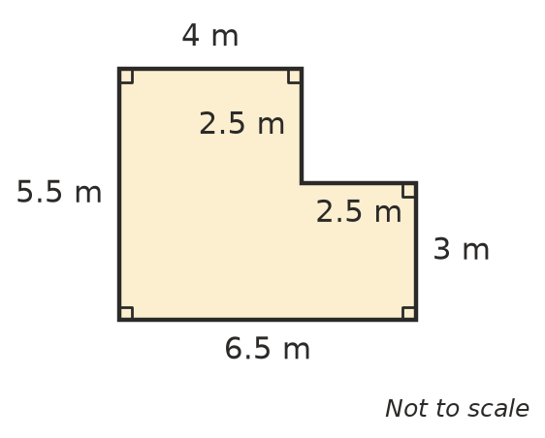
- How many metres of skirting board are needed? Show your working.

- Four rectangular tiles are each 6 cm long and 2 cm wide.
  - The tiles are placed side by side so their long sides touch. What is the perimeter of the shape? ______________
  - The tiles are placed end to end in a line so their short sides touch. What is the perimeter of the shape? ______________
- Six identical squares are arranged in 2 rows of 3 to make a rectangle. The perimeter of the rectangle is 50 cm. How long is the side of one square? Show your working.

- This is the side view of a set of 4 steps. Every step is 30 cm deep and 20 cm high. Find the perimeter of the side view, in metres.
- 