12.03 Perimeter of composite shapes
Year 7 Maths · Worksheet · Level 1 · Warm-up
Name: ____________________ Date: ______________
A composite shape is made by joining simpler shapes together. This worksheet practises finding missing side lengths and the perimeter of composite shapes. Tip: the small squares in the corners mean right angles. Opposite sides add up: the long side at the bottom is the same as the short sides across the top added together.

 Understanding
- Find the perimeter of this shape by adding all six sides.
- 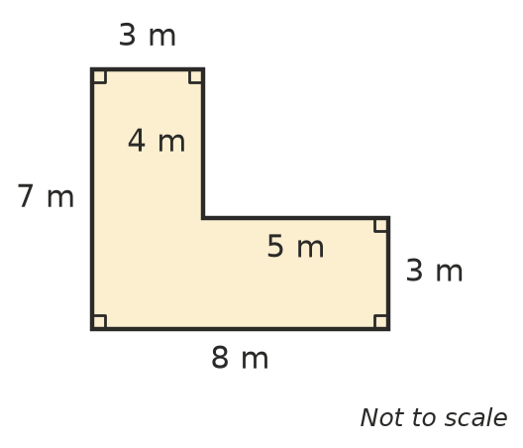
- Perimeter = ______________
- Two sides of this shape are missing.
- 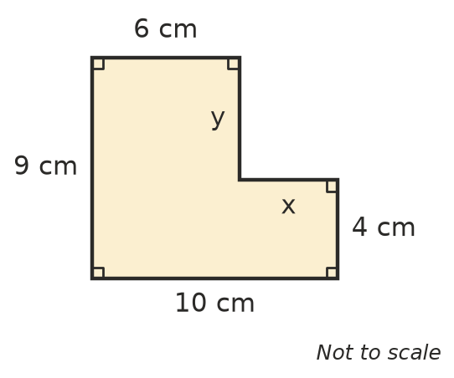
  - Find x. Hint: 10 cm along the bottom is the same as 6 cm + x along the top. x = ______________
  - Find y. Hint: 9 cm on the left is the same as 4 cm + y on the right. y = ______________
  - Find the perimeter. ______________

 Fluency
- Find the perimeter of each shape.
- 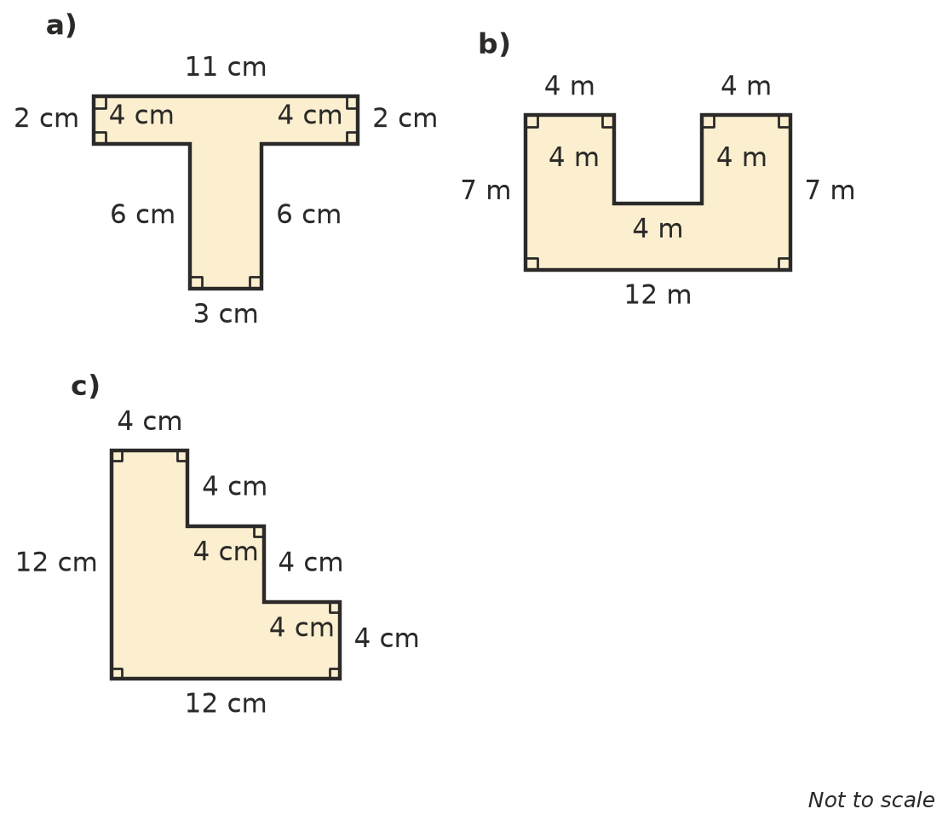
  - ______________
  - ______________
  - ______________
- Find x and y, then find the perimeter of each shape.
- 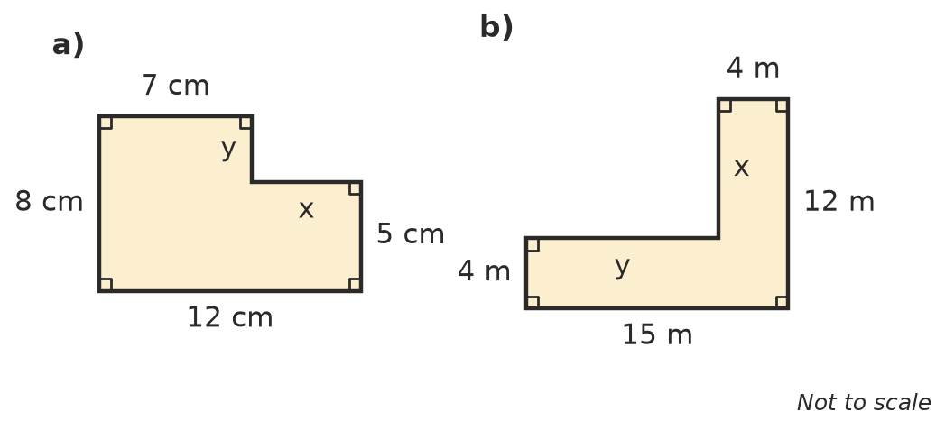
  - x = ______________ y = ______________ Perimeter = ______________
  - x = ______________ y = ______________ Perimeter = ______________

 Reasoning
- Only two sides of this shape are labelled, but you can still find its perimeter.
- 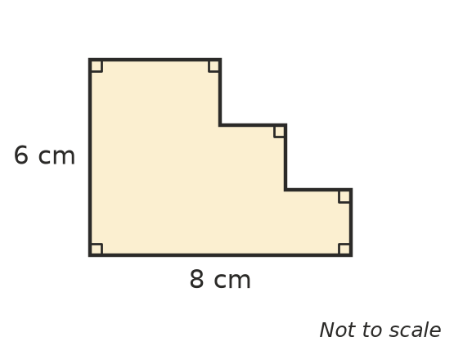
  - What do the three short horizontal sides across the top add up to? ______________
  - What do the three short vertical sides on the right add up to? ______________
  - What is the perimeter of the shape? ______________
- Two squares with sides of 5 cm are joined side by side to make a rectangle. Ruby says the perimeter of the rectangle is 4 × 5 + 4 × 5 = 40 cm. Is she right? Explain.

 Problem solving
- Here is a plan of a garden. A fence is going around the outside.
- 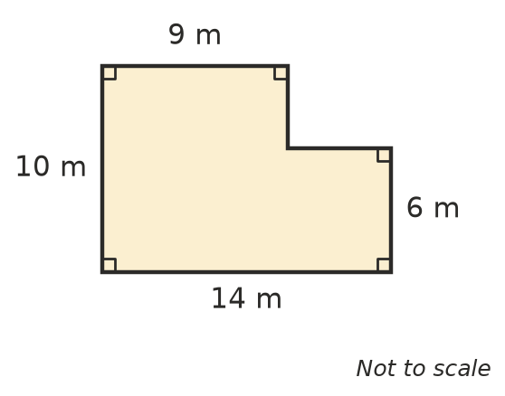
  - How many metres of fencing are needed? ______________
  - Fencing costs $12 per metre. How much will the fence cost? ______________
- A rectangular bedroom is 5 m long and 4 m wide. Skirting board goes around the bottom of every wall, except across the doorway, which is 1 m wide. How much skirting board is needed? Show your working.

- This shape is a rectangle with a triangle on top. Find its perimeter.
- 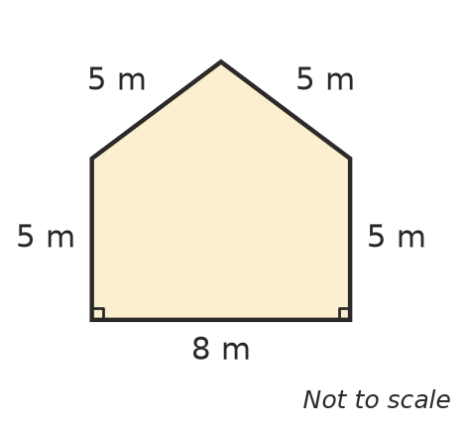
- Perimeter = ______________
- Five squares with sides of 3 cm are joined to make a plus sign (+): one square in the middle and one on each of its four sides. Draw the shape, then find its perimeter.

- Two rectangles, each 6 cm long and 4 cm wide, are put together end to end so that their 4 cm sides touch. What is the perimeter of the new shape? Show your working.

