12.03 Perimeter of composite shapes
Year 7 Maths · A5 question sheet · Level 3 · Challenge
This worksheet stretches your skills with harder composite shapes, shapes with notches cut out, algebra and multi-step problems. Tip: for a shape with only right angles, check whether every side faces outwards like a staircase. If it does, its perimeter is the same as the rectangle around it. If a notch goes into the shape, you have to add the extra sides.

 Understanding
- Find the missing sides and the perimeter of this shape.
- 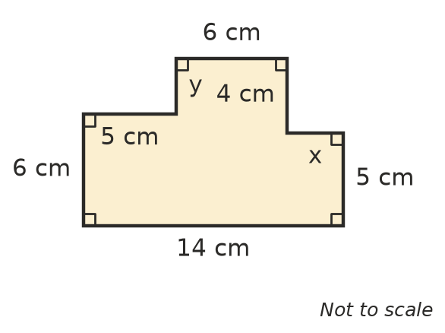
  - x =
  - y =
  - Perimeter =

 Fluency
- Find the perimeter of each shape. In b), all twelve corners are right angles and the shape has four identical arms.
  - 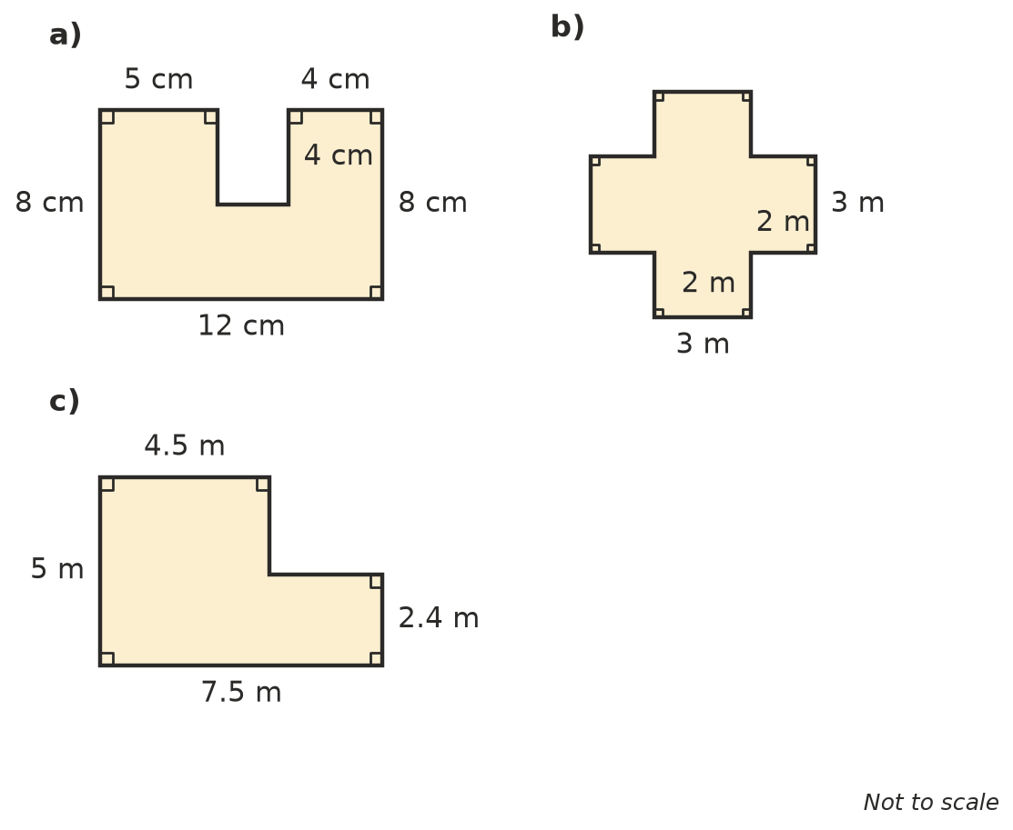

- Find the perimeter of each shape. Sides with the same dash are the same length.
  - 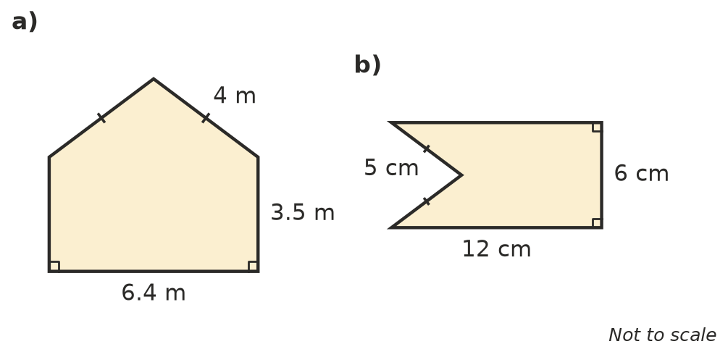

- All the corners of this shape are right angles.
- 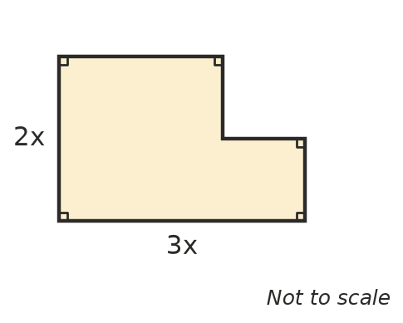
  - Write an expression for its perimeter.
  - Find the perimeter when x = 4.5 cm.

 Reasoning
- A 2 cm by 2 cm square has been cut from an 8 cm by 6 cm rectangle in two different places.
- 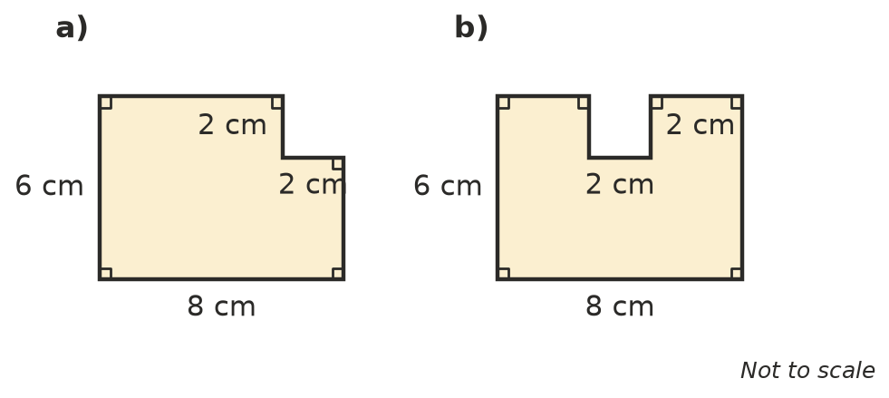
  - Find the perimeter of shape a).
  - Find the perimeter of shape b).
  - The perimeter of the whole rectangle is 28 cm. Explain why cutting out a corner does not change the perimeter, but cutting out a notch from the middle of a side does.
- Each shape is made of 5 squares with sides of 1 cm.
- 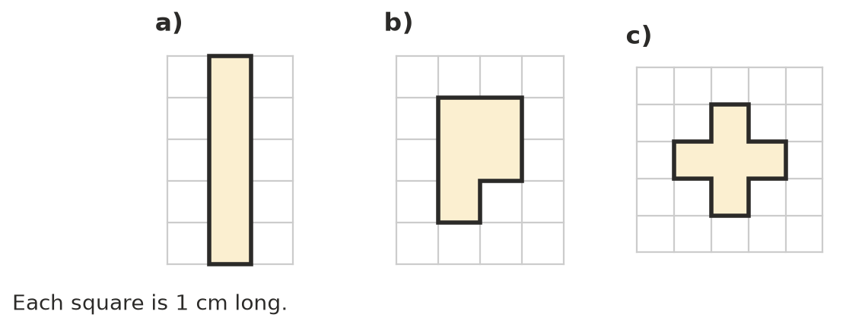
  - Find the perimeter of each shape. Shape a): ______________ Shape b): ______________ Shape c):
  - Which shape has the smallest perimeter? Explain why, using the idea of sides that are shared between squares.
- Mia found the perimeter of shape a) in Question 2 by working out 2 × (12 + 8) = 40 cm. Explain her mistake and give the correct perimeter.

 Problem solving
- A rectangular paddock is 80 m long and 50 m wide. It is fenced around the outside, and two more fences parallel to the 50 m sides divide it into three smaller paddocks. How many metres of fencing are there altogether?
- Four squares with sides of 1 cm, 2 cm, 3 cm and 4 cm are placed side by side in a row, from smallest to largest, with their bottom edges on the same line. Sketch the shape and find its perimeter.
- Twelve squares with sides of 1 cm are arranged to make a rectangle (with no gaps or overlaps).
  - What is the largest possible perimeter?
  - What is the smallest possible perimeter?
- A room is a 7.2 m by 5.4 m rectangle with a 2.4 m by 1.8 m rectangle taken out of one corner, making an L shape. Skirting board goes around every wall except two doorways that are each 0.82 m wide.
  - How many metres of skirting board are needed?
  - Skirting board is sold in 2.4 m lengths. How many lengths must be bought?
- A square is cut into 3 identical rectangular strips. The total of the perimeters of the three strips is 72 cm. How long is a side of the square? Show your working.

