12.02 Perimeter
Year 7 Maths · Worksheet · Level 3 · Challenge
Name: ____________________ Date: ______________
This worksheet stretches your skills with perimeters that use decimals, mixed units and algebra, number patterns, and problems where you work backwards. Tip: a quick sketch with every side labelled makes most perimeter problems much easier.

 Understanding
- Find the perimeter of each shape.
- 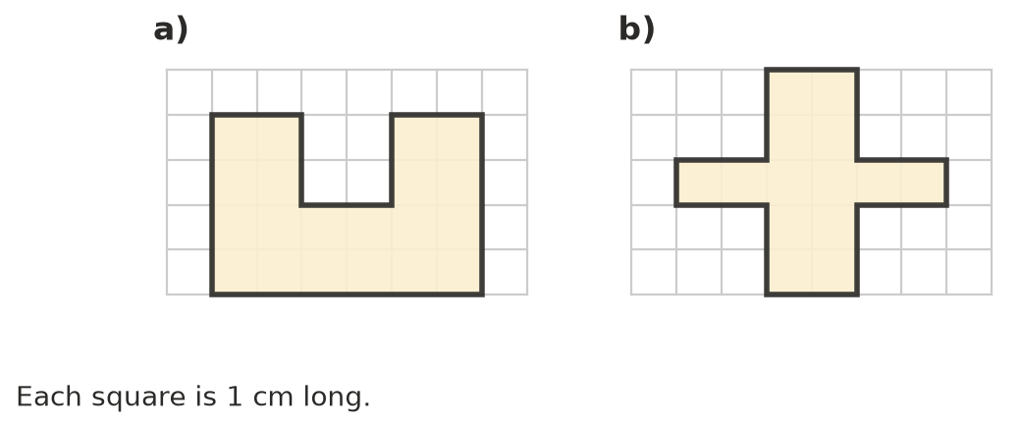
  - ______________ cm
  - ______________ cm
- Write a rule for the perimeter P of each shape.
  - a square with sides of length s: P = ______________
  - a regular pentagon with sides of length a: P = ______________
  - a rectangle with length l and width w: P = ______________
  - an isosceles triangle with two equal sides of length a and a base of length b: P = ______________

 Fluency
- Find the perimeter of each shape. Sides with the same dashes are the same length. Give the answer to c) in centimetres.
- 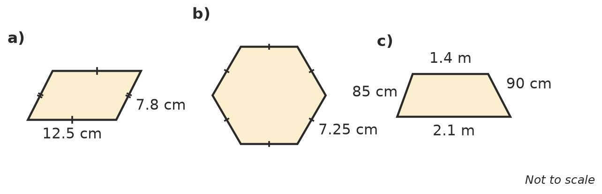
  - ______________
  - ______________
  - ______________
- Write an expression for the perimeter of each shape. Simplify it by collecting like terms.
  - a rectangle with length 3x and width x ______________
  - an isosceles triangle with two sides of 2y and a base of y + 5 ______________
  - a regular pentagon with sides of 3p ______________
- Find the missing side length.
  - A rectangle has a perimeter of 7.4 m and a width of 1.2 m. Length: ______________
  - A regular octagon has a perimeter of 1 m. Side length in cm: ______________
  - A square field has a perimeter of 3.6 km. Side length in m: ______________
- The perimeter of this isosceles triangle is 50 cm. Find x.
- 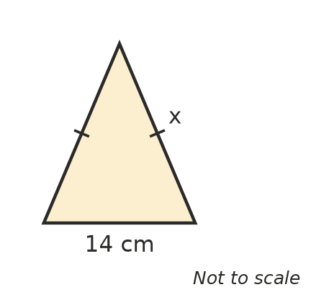
- x = ______________

 Reasoning
- Explain why a rectangle whose sides are whole numbers of centimetres always has a perimeter that is an even number. Could such a rectangle have a perimeter of 25 cm?

- Squares with sides of 2 cm are placed in a row, as shown.
- 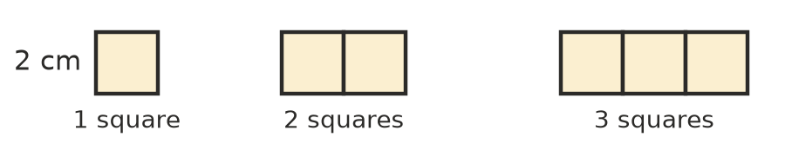
Number of squares | 1 | 2 | 3 | 4 | 10
Perimeter (cm)

  - Write a rule for the perimeter P of a row of n squares. P = ______________
  - How many squares are in a row with a perimeter of 100 cm? ______________
- Zac says, “If I double the length of a rectangle but keep the width the same, the perimeter doubles.” Use a rectangle 6 cm by 4 cm to test his claim. Is he right?

 Problem solving
- A farmer is fencing a rectangular paddock 120 m long and 75 m wide with 3 strands of wire.
  - How many kilometres of wire does she need? ______________
  - The wire comes in rolls of 500 m. How many rolls must she buy? ______________
- The length of a rectangle is 4 cm more than its width. Its perimeter is 56 cm. Find its length and width. Show your working.

- A square with sides of 10 cm is cut in half to make two identical rectangles. What is the total of the perimeters of the two rectangles? Why is it more than the perimeter of the square?

- A photo 18 cm long and 12 cm wide is placed in a frame. The frame is 3 cm wide all the way around the photo. What is the perimeter of the outside edge of the frame? Show your working.

