12.02 Perimeter
Year 7 Maths · Worksheet · Level 1 · Warm-up
Name: ____________________ Date: ______________
This worksheet practises finding the perimeter of a shape: the total distance around its outside. Tip: trace around the shape with your finger and add every side as you go. Opposite sides of a rectangle are the same length, so a rectangle has two lengths and two widths to add.

 Understanding
- Find the perimeter of each shape by counting the sides of the squares around the outside.
- 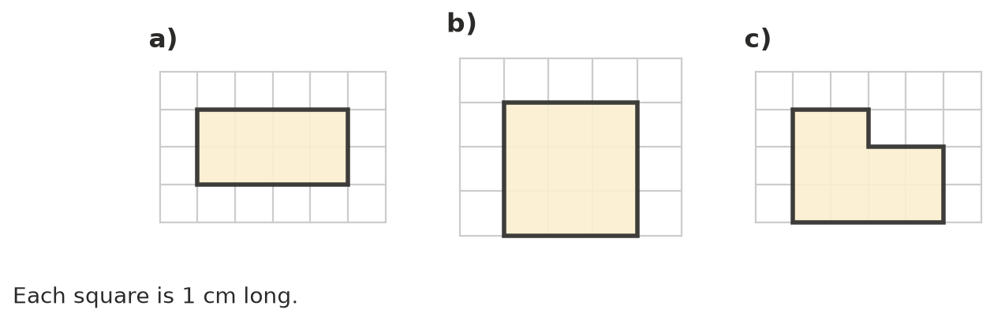
  - ______________ cm
  - ______________ cm
  - ______________ cm
- Find the perimeter of each shape. Sides with the same small dash are the same length.
- 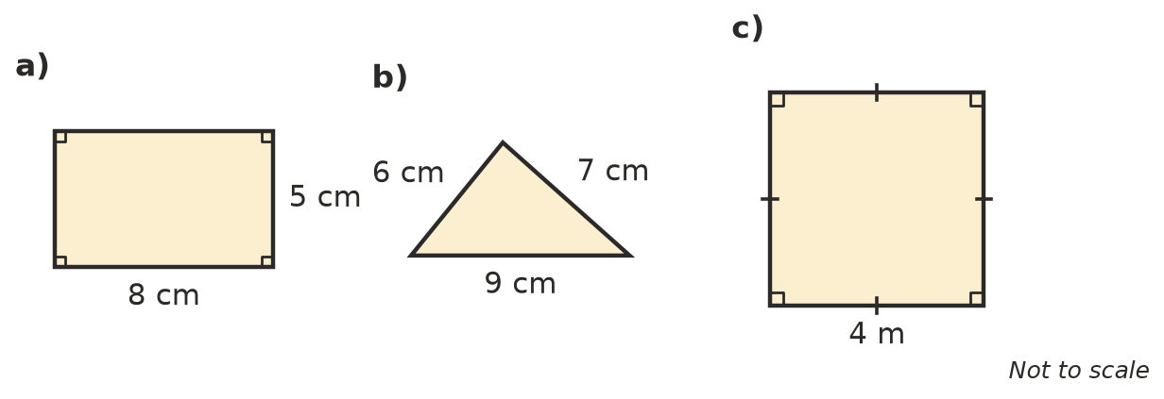
  - ______________
  - ______________
  - ______________

 Fluency
- Find the perimeter of each rectangle.
  - length 10 cm, width 3 cm ______________
  - length 12 m, width 7 m ______________
  - length 25 mm, width 15 mm ______________
- Find the perimeter of each square.
  - side 6 cm ______________
  - side 11 m ______________
  - side 20 mm ______________
- Each shape has sides of equal length marked with the same dashes. Find each perimeter.
- 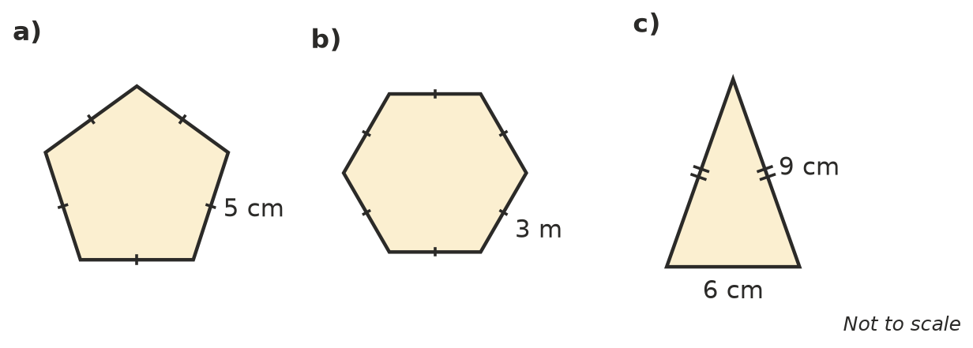
  - ______________
  - ______________
  - ______________

 Reasoning
- Kai says that a rectangle 6 cm long and 2 cm wide has the same perimeter as a square with sides of 4 cm. Is he right? Show how you know.

- A square has a perimeter of 20 cm. How long is each side? Explain how you worked it out.

 Problem solving
- A farmer wants to put a fence around a rectangular paddock that is 50 m long and 30 m wide. How many metres of fencing does she need? Show your working.

- Grace has 50 cm of ribbon. She wants to put it all the way around the edge of a square card with sides of 15 cm. Does she have enough ribbon? Explain.

- A rectangle has a perimeter of 30 cm. Its length is 9 cm. What is its width? Show your working.

- The school oval is a rectangle 120 m long and 80 m wide. Liam jogs around the edge 3 times. How far does he jog? Give your answer in metres and in kilometres.

