12.02 Perimeter
Year 7 Maths · A5 question sheet · Level 2 · Core
This worksheet practises finding the perimeter of rectangles, triangles and other shapes, using a rule for rectangles, and working backwards from a perimeter to a missing side. Tip: make sure every side is in the same unit before you add.

 Understanding
- Find the perimeter of each shape.
- 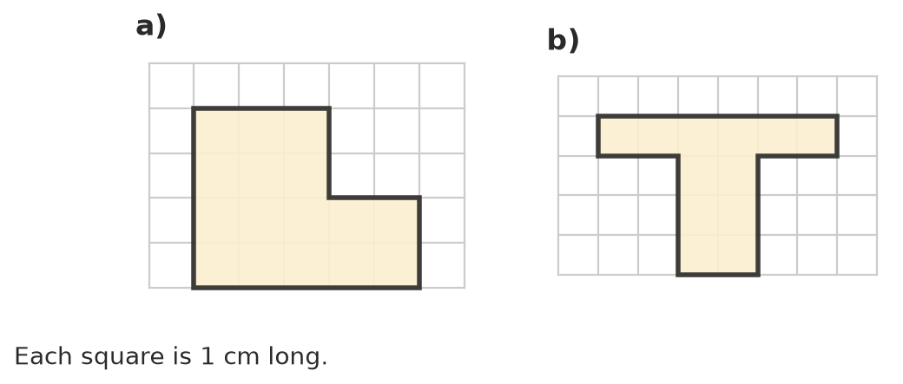
  - ______________ cm
  - ______________ cm
- A rectangle has length l and width w. Write a rule for its perimeter P.
- P =

 Fluency
- Find the perimeter of each shape. Sides with the same dashes are the same length.
  - 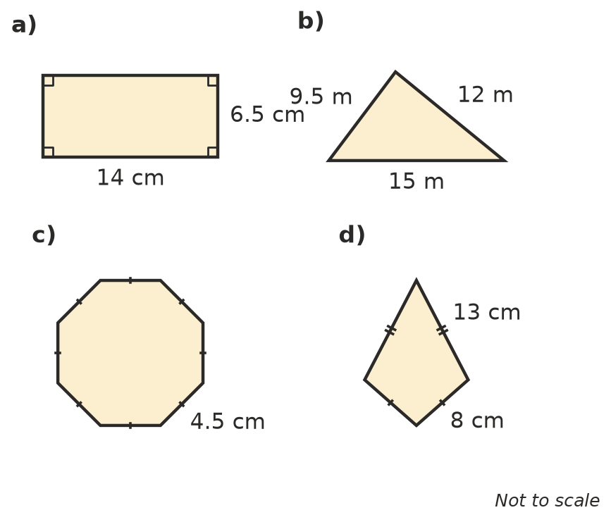

- Find the perimeter of each shape. Change to the same unit first.
  - a rectangle 2 m long and 85 cm wide (answer in cm)
  - a triangle with sides 1.2 m, 90 cm and 1500 mm (answer in m)
- Find the missing side length.
  - A square has a perimeter of 52 cm. Side length:
  - A rectangle has a perimeter of 46 m and a length of 15 m. Width:
  - An equilateral triangle has a perimeter of 39 mm. Side length:
  - A regular hexagon has a perimeter of 27 cm. Side length:
- Find the value of x in each shape.
- 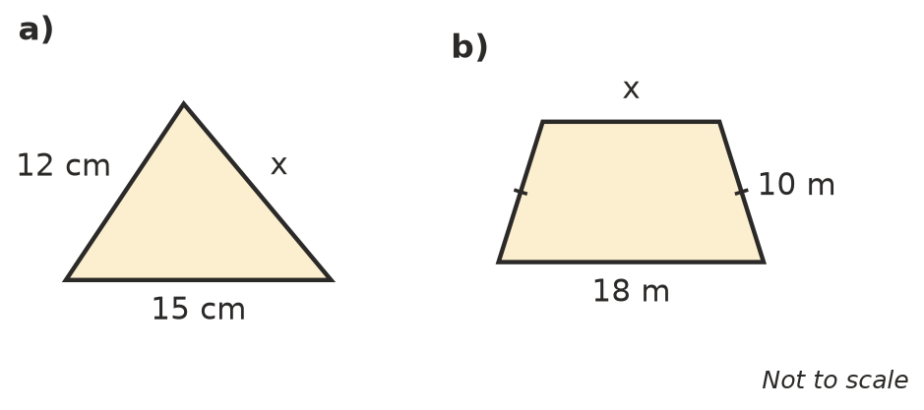
  - The perimeter of the triangle is 40 cm. x =
  - The perimeter of the trapezium is 50 m. x =

 Reasoning
- List every rectangle with whole-number sides (in cm) that has a perimeter of 24 cm. The first one is done for you.
Length (cm) | Width (cm)
11 | 1

- A rectangle is 5 cm long and 3 cm wide. Another rectangle has both sides twice as long. What happens to the perimeter when you double both sides? Show your working.
- Ava says, “The perimeter of a rectangle 7 cm long and 4 cm wide is 7 + 4 = 11 cm.” Explain her mistake and give the correct perimeter.

 Problem solving
- A square garden bed has sides of 2.4 m. Timber edging costs $6 per metre. How much will it cost to put edging all the way around the bed? Show your working.
- Ollie jogs around the edge of a rectangular park that is 350 m long and 150 m wide. How many full laps must he run to cover 5 km? Show your working.
- A square and an equilateral triangle have the same perimeter. The square has sides of 9 cm. How long is each side of the triangle? Show your working.
- A rectangle is 3 times as long as it is wide. Its perimeter is 64 cm. Find its length and width. Hint: draw it and split each long side into 3 equal parts.

