12.01 Units of length
Year 7 Maths · Worksheet · Level 2 · Core
Name: ____________________ Date: ______________
This worksheet practises choosing sensible units, reading a ruler, and converting between millimetres, centimetres, metres and kilometres, including lengths with decimals. Tip: to change to a smaller unit, multiply (× 10, × 100 or × 1000). To change to a larger unit, divide.

 Understanding
- Complete each sentence with a number.
  - To change metres to centimetres, multiply by ______________
  - To change centimetres to metres, divide by ______________
  - To change kilometres to metres, multiply by ______________
  - To change millimetres to centimetres, divide by ______________
- Circle the best estimate for each length.
  - the height of a classroom door: 2 cm or 2 m or 2 km
  - the length of a cricket pitch: 20 mm or 20 m or 20 km
  - the thickness of a $1 coin: 3 mm or 3 cm or 3 m
  - the distance by road from Sydney to Canberra: 280 cm or 280 m or 280 km
- Look at the strips above the ruler.
- 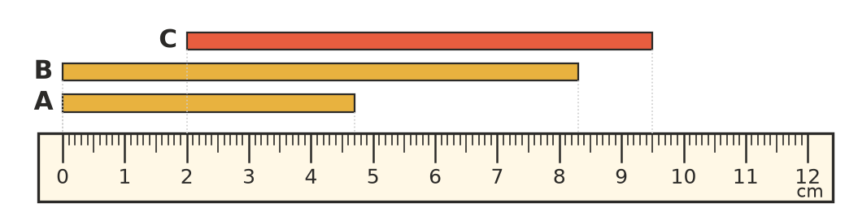
  - How long is strip A in millimetres? ______________
  - How long is strip B in centimetres? ______________
  - Strip C does not start at 0. How long is it in centimetres? ______________

 Fluency
- Change to the smaller unit.
  - 7.5 cm = ______________ mm
  - 3.2 m = ______________ cm
  - 4.25 km = ______________ m
  - 2.6 m = ______________ mm
  - 0.8 km = ______________ m
  - 1.5 km = ______________ cm
- Change to the larger unit.
  - 450 mm = ______________ cm
  - 375 cm = ______________ m
  - 6800 m = ______________ km
  - 920 mm = ______________ m
  - 85 cm = ______________ m
  - 12 500 m = ______________ km
- Fill in the missing unit (mm, cm, m or km).
  - 4 m = 400 ______________
  - 3500 ______________ = 3.5 km
  - 65 ______________ = 6.5 cm
  - 2 km = 200 000 ______________

 Reasoning
- Write these lengths in order from shortest to longest: 1.2 m, 135 cm, 1090 mm, 0.9 m, 1 m 25 cm.

- Ella changed 2.4 km to metres and got 240 m. Explain her mistake and give the correct answer.

- Is each statement true or false? Write True or False in each empty box.
Statement | True or false
1 m = 1000 mm
50 cm = 0.5 m
3 km = 300 m
25 mm = 2.5 cm
0.07 m = 7 mm

 Problem solving
- A builder has a plank of wood 3.6 m long. He cuts it into pieces that are each 45 cm long. How many pieces does he get? Show your working.

- Noah walks 1.4 km to the shop, then 650 m to the park, then 900 m home. How far does he walk altogether? Give your answer in kilometres.

- A stack of 40 exercise books is 32 cm tall. How thick is one book, in millimetres? Show your working.

- A garden snail crawls 6 cm every minute. How many minutes would it take to cross a path that is 1.2 m wide? Show your working.

