12.01 Units of length
Year 7 Maths · Worksheet · Level 1 · Warm-up
Name: ____________________ Date: ______________
This worksheet practises the metric units of length (millimetres, centimetres, metres and kilometres), reading a ruler and changing from one unit to another. Tip: 1 cm = 10 mm, 1 m = 100 cm and 1 km = 1000 m. When you change to a smaller unit, the number gets bigger, so multiply.

 Understanding
- Complete each fact.
  - 1 cm = ______________ mm
  - 1 m = ______________ cm
  - 1 km = ______________ m
  - 1 m = ______________ mm
- Which unit would you use to measure each of these: mm, cm, m or km?
  - the length of an ant ______________
  - the height of a classroom door ______________
  - the distance from Perth to Broome ______________
  - the length of a pencil ______________
- Look at the strips above the ruler.
- 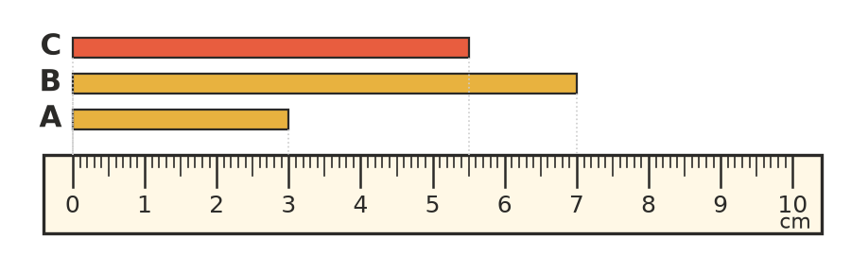
  - How long is strip A in centimetres? ______________
  - How long is strip B in centimetres? ______________
  - How long is strip C in millimetres? ______________

 Fluency
- Change these centimetres to millimetres (× 10).
  - 6 cm = ______________ mm
  - 14 cm = ______________ mm
  - 30 cm = ______________ mm
- Change these metres to centimetres (× 100).
  - 3 m = ______________ cm
  - 12 m = ______________ cm
  - 40 m = ______________ cm
- Change these kilometres to metres (× 1000).
  - 5 km = ______________ m
  - 9 km = ______________ m
  - 21 km = ______________ m
- Change to the larger unit. This time divide.
  - 80 mm = ______________ cm
  - 600 cm = ______________ m
  - 7000 m = ______________ km
  - 2500 cm = ______________ m

 Reasoning
- Jack says that 4 m is the same as 40 cm. Explain his mistake and write the correct number of centimetres.

- Write these lengths in order from shortest to longest: 2 m, 190 cm, 2100 mm, 150 cm. Hint: change them all to centimetres first.

 Problem solving
- A roll of ribbon is 5 m long. Mia cuts off 120 cm to wrap a present. How many centimetres of ribbon are left? Show your working.

- The school fun run is 3 km long. One lap of the oval is 500 m. How many laps of the oval make up the fun run? Show your working.

