12.01 Units of length
Year 7 Maths · A5 question sheet · Level 3 · Challenge
This worksheet stretches your skills with harder conversions, calculations with mixed units and multi-step problems. Tip: before you add, subtract or compare lengths, change them all to the same unit.

 Understanding
- Complete: 1 km = ______________ m = ______________ cm = ______________ mm
- Write the most sensible unit (mm, cm, m or km) in each sentence.
  - A grain of rice is about 5 ______________ long.
  - A footy oval is about 160 ______________ long.
  - Hobart to Launceston is about 200 ______________ by road.
  - A school ruler is 30 ______________ long.
- Look at the strips above the ruler. Neither strip starts at 0.
- 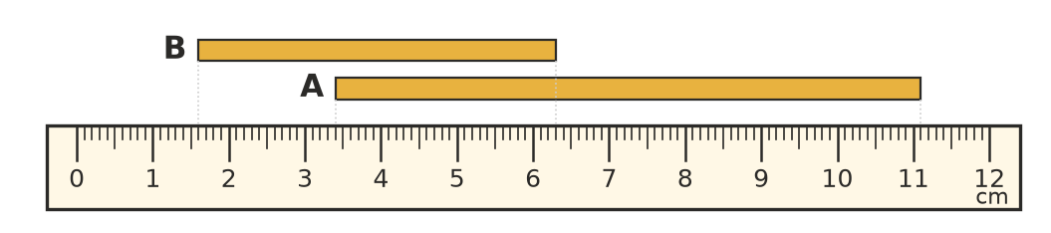
  - How long is strip A in millimetres?
  - How long is strip B in centimetres?
  - How much longer is strip A than strip B, in millimetres?

 Fluency
- Change to the smaller unit.
  - 0.035 km = ______________ m
  - 4.7 m = ______________ mm
  - 0.6 km = ______________ cm
  - 2.05 m = ______________ cm
  - 0.4 cm = ______________ mm
- Change to the larger unit.
  - 78 mm = ______________ m
  - 4060 cm = ______________ km
  - 250 000 mm = ______________ km
  - 9 cm = ______________ m
  - 1 km 75 m = ______________ km
- Work these out. Give each answer in the unit shown.
  - 3.2 m + 85 cm = ______________ cm
  - 2 km − 740 m = ______________ km
  - 1.5 m − 36 mm = ______________ mm
  - 4 × 2.75 m = ______________ cm

 Reasoning
- Write these lengths in order from shortest to longest: 0.45 km, 4500 cm, 440 000 mm, 4.5 m, 405 m.
- When you change 6 m into centimetres, the number gets bigger (600). Explain why the number gets bigger even though the length stays the same.
- Sam says, “To change 3.5 m to millimetres, you just add three zeros, so 3.5 m = 3.5000 mm.” Explain what is wrong and give the correct answer.
- A paperclip is 2.5 cm long. How many paperclips laid end to end would stretch 1 km? Show your working.

 Problem solving
- A straight fence is 24 m long. It has a post at each end and a post every 1.5 m along it. How many posts are there altogether? Show your working.
- Hair grows about 1.2 cm each month.
  - How many millimetres does hair grow in one year?
  - How many months would it take hair to grow 30 cm?
- A sheet of printer paper is 0.1 mm thick. A packet (called a ream) has 500 sheets.
  - How tall is one ream, in centimetres?
  - How many reams would you need to stack to make a pile 1 m high?

